.

**OPG vs CBCT in Evaluating Difficulty Index of Impacted Mandibular Third Molar Extraction in South Indian Population**

**Dr.Tharanikumar Sivakumar 1,** **Dr.Abinaya C 2 Dr. Abdul Ajees Meeran M2, Dr.Nachiappan S 3,Dr. Ashok Prasanna R 4 , Dr.ELAVEYINI U 5 ,**

**ABSTRACT:**

Aim: This study aimed to compare cone beam computed tomography (CBCT) and orthopantomogram (OPG) in assessing mandibular third molar impactions and their relationship with the inferior alveolar nerve (IAN) canal in South Indian population. Methods: The study compared OPG & CBCT images from 254 individuals aged 18-45 years with unilateral or bilateral mandibular third molar impaction, was evaluated for the effectiveness in identifying key parameters, including mandibular height, second molar angulation, and canal placement. Result: CBCT demonstrated higher accuracy than OPG, particularly for assessing mandibular canal position and cases in specific angulation ranges (70-79 degrees). CBCT also identified more cases of distal cusp coverage and available space for impacted teeth compared to OPG. While root morphology and follicular diameters showed no significant differences between imaging methods, a statistically significant association was found between mandibular height and canal location (p-value <0.05). CBCT achieved a mean score of 4.58, reflecting its enhanced precision in complex cases such as impacted third molars. The findings emphasize CBCT’s superiority in providing detailed anatomical information essential for surgical planning, reducing the risk of iatrogenic damage to critical structures like the IAN during mandibular third molar extractions. Conclusion: The study concludes that CBCT is a more effective diagnostic tool than OPG for preoperative assessment, particularly in cases where precise anatomical relationship visualization is necessary, and recommends further research to improve preoperative assessments and reduce extraction complications.

Keywords: Mandibular Third Molar Impaction, Cone Beam Computed Tomography (CBCT), Orthopantomogram (OPG), Inferior Alveolar Nerve (IAN), Preoperative Assessment

**INTRODUCTION:**

An impacted tooth is a tooth that remains fully or partially unerupted, positioned against another tooth, bone, or soft tissue, making its future eruption uncertain [7]. Factors influencing the eruption of third molars include genetic inheritance, diet-related attrition, decreased mesiodistal crown diameter, and the use of masticatory apparatus [2]. Studies suggest women are more likely than men to experience mandibular third molar impaction[3].

Third molar extractions pose a risk of iatrogenic injury to the inferior alveolar nerve (IAN). The nerve’s complex anatomy—its path, shape, and direction—often complicates assessments, making precise preoperative planning challenging [4]. Understanding the proximity of impacted third molars to the inferior alveolar canal is crucial to prevent nerve injury during surgery [5].

While the anatomy of the IAN and surrounding structures has been studied, certain limitations exist. Cadaveric studies may not generalize to living patients due to differences in age or pathology. Skull-based studies often lack demographic data or rely on inconsistent anatomical landmarks. Additionally, two-dimensional imaging modalities and conventional CT scans have inherent limitations, including poor accuracy in assessing nerve positioning [6].

This study aimed to fill the gap in research on the South Indian population by investigating the relationship between the inferior alveolar canal (IAC) and mandibular molars. Specifically, it examined the proximity of the canal to molar periapices, assessed cortical thickness, and compared these parameters for second and third molars using cone beam computed tomography (CBCT) and OPG.

CBCT offers superior visualization of the mandibular canal compared to OPG, making it a valuable tool for reducing nerve injury risks during odontectomy procedures.

**Study Objectives**

-Investigate the relationship between the IAC and mandibular molar periapices.

-Assess buccal and lingual cortical bone thickness around the IAC.

-Compare anatomical parameters between second and third molars on both sides of the mandible.

-Evaluate the utility of CBCT versus OPG in preoperative planning for impacted third molar extractions.

CBCT provides more detailed and accurate visualization of the IAC compared to OPG, especially in cases of cortical decortication where nerve injury risks are higher. This study aims to support the safer extraction of impacted mandibular third molars by emphasizing the need for advanced imaging techniques in preoperative evaluation.

**MATERIALS AND METHODS:**

This observational study was conducted in the dental clinic of Sathyabama University, Chennai. Patients with a strong correlation between impacted third molars and the IAC on digital OPG were selected for further analysis using CBCT. The study spanned one year from its approval by the Ethical Committee of Sathyabama University Dental College and Hospital.

The sample size calculation was based on a study by [1], used an effect size of 0.418, α = 0.05, and power = 0.90. Using G*Power software (3.1.9.3, Heinrich Heine Universität Düsseldorf, Germany), the required minimum sample size was 254 participants.

The inclusion criteria included patients of male and female participants aged 18–45 years with unilateral or bilateral mandibular third molar impaction who were randomly selected. The study targeted individuals of South Indian descent residing in the specified region.

Exclusion Criteria included individuals with systemic diseases or unwillingness to participate, patients with a history of mandibular injuries or surgeries, cases with diseases affecting jaw structure or development, incomplete clinical records or medical histories, mandibular third molars with incomplete root development.

Cone beam computed tomography (CBCT) scans were performed using the **Carestream CS 9300** and **CS 3D Imaging** software to ensure consistency in imaging procedures. Linear measurements were calibrated using a millimetre-based set of known dimensions.

Orthopantomograms (OPG) were conducted using the **Sinora ORTHOPHOS XG** system with **SIDEXIS** imaging software.

* Exposure Parameters: 64–73 kV, 8–15 mA
* Exposure Time: 14.1 seconds

All participants underwent both OPG and CBCT imaging, with CBCT serving as the reference standard for evaluating impacted mandibular third molars. Unless otherwise noted, measurements were taken at the midpoint of the inferior alveolar nerve (IAN) canal in figure 1, 2 & 3

Measured Parameters include

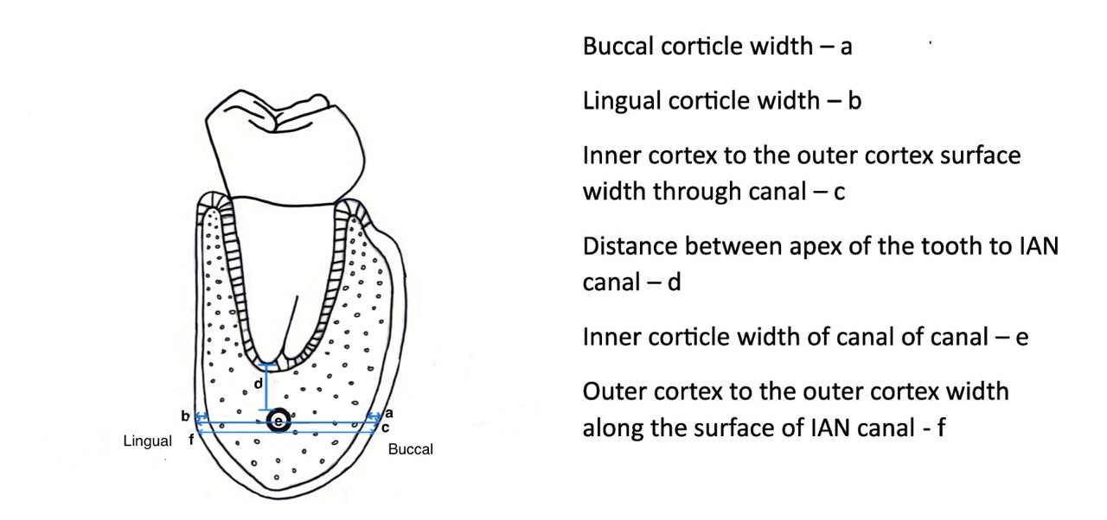

FIGURE - 1

a)BuccalWidth,b)Lingual Widthc)Mesiodistal Width of the Crown

d)Depth of the Tooth

e)Outer Cortex to Outer Cortex

f)Periapex to Canal

g)Canal Width

h)Second Molar Angulation

i)Height of the Mandible

Additional assessments include patient Details such as age, gender, molar angulation (left or right), Winter’s Classification: Horizontal, vertical, disto-angular, mesio-angular impactions, Wharfe Assessment like Height of the mandible, third molar angulation, root shape, follicle size, and path of exit. This study compared CBCT with OPG, focusing on parameters critical for preoperative evaluation and surgical planning.

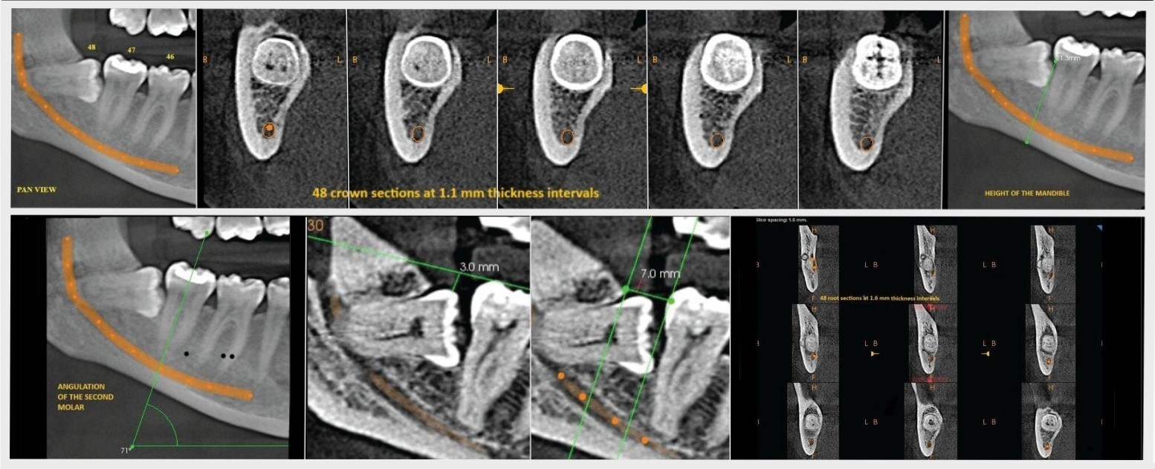

FIGURE - 2

Fresr54w543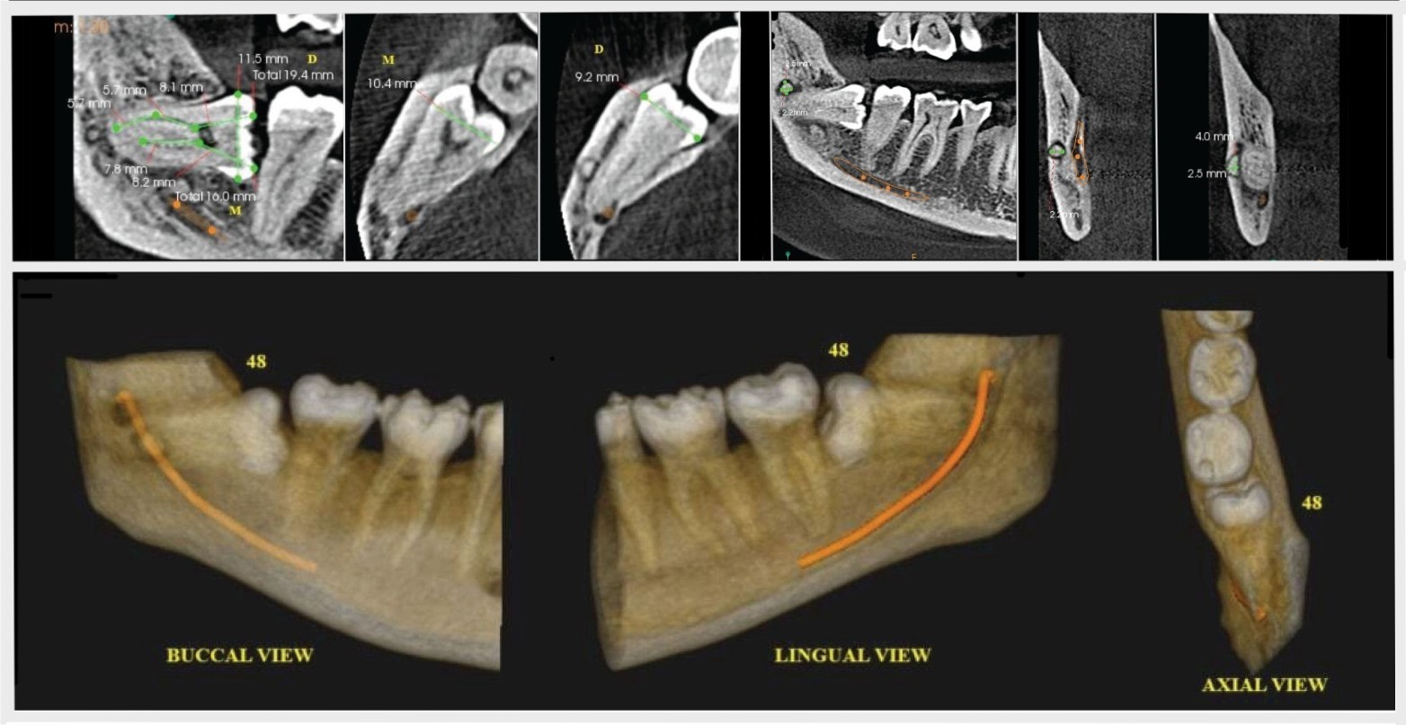

FIGURE-3

**DATA ANALYSIS:**

The Software used for statistical analysis is IBM SPSS version 21 (SPSS version 21.0; IBM corporation, Armonk, NY, USA). P-value of 0.05 thresholds of statistical significance was used. Normality test resulted in p-value less than 0.05. As a result, non-parametric tests were utilized for statistical analysis. Intergroup comparisons were conducted using the Mann-Whitney U test, while the Spearman rank correlation was applied to evaluate relationships between variables

**RESULTS:**

There were 254 people in the study who took part in the Wharfe assessment and comparative analysis of two imaging techniques: orthopantomogram (OPG) and cone beam computed tomography (CBCT). Statistical analysis showed that CBCT had a significantly higher mean score of 4.58 (SD 1.47) compared to OPG, as detailed in Table 1.

**Table 1: Comparison between OPG & CBCT**

Above table shows the mean total score for CBCT (4.58) is higher than that for OPG (3.89), with standard deviations of 1.47 and 2.174, respectively, indicating lower variability in CBCT measurements. The statistical test yielded a **Z-value of -7.919** and a **P-value of 0.001**, which is statistically significant (P < 0.05). This suggests that CBCT provides significantly better performance in this evaluation compared to OPG, reinforcing its higher accuracy and consistency in clinical assessments

**Table 2: Comparison of variables of Wharfe assessment**

(*p-value<0.05 considered statistically significant)

Table 2 demonstrates CBCT’s superiority over OPG in assessing impacted third molars, particularly in **mandibular height measurement, second molar angulation, and path of exit evaluation,** with statistically significant differences (P < 0.05). CBCT identified more cases within the **0–30 mm height range (97.6%),** detected a higher percentage of **70–79 degree second molar angulation cases (62.2%),** and provided better visualization of **eruption space (27.6%).** While CBCT and OPG showed no significant differences in **Winter’s classification, root shape, or follicle size (P > 0.05),** CBCT’s enhanced imaging capabilities allow for more precise assessments crucial for surgical planning. These findings reinforce **CBCT’s role as a preferred diagnostic tool** for impacted third molar evaluation.

**Table 3: Correlation of Age & Gender against Wharfe assessment**

Table 3 presents the **Spearman's rank correlation coefficients** to assess the relationship between **age, gender**, and the **total score** based on the Wharfe assessment. The correlation between **age and total score** shows a **significant positive relationship (r² = 0.187, P = 0.005),** indicating that as age increases, the total score tends to increase as well, with a moderate strength of association. However, the **correlation between gender and total score** (r² = 0.001, P = 0.992) is **negligible** and statistically insignificant, suggesting no meaningful association between gender and the total score. Additionally, the **correlation between age and gender** (r² = 0.097, P = 0.146) is also weak and not statistically significant. Overall, age has a moderate and statistically significant correlation with the total score, while gender has no significant impact on the results.

**Table 4: Position of the canal and Winter’s classification**

Table 4 presents the distribution of canal positions (buccal, central, and lingual) across different Winter’s classifications (distoangular, horizontal, mesial, mesioangular, vertical) in a total sample of 254 observations. The buccal position was most commonly associated with horizontal impactions (33.3%) and mesioangular impactions (29.2%), while the central position showed a higher frequency of vertical impactions (42.1%). The lingual position had the greatest frequency of mesioangular (38.9%) and vertical (28.2%) impactions. These findings suggest that the position of the canal is closely linked to the type of impaction, with the lingual position being the most common overall, contributing to 58.4% of the total sample. This distribution provides insights into the relationship between canal position and impaction types, which can help in surgical planning for tooth extractions. And, there were significant association seen between position of canal and winter’s classification with Pearson Chi-square value of 36.59, df (8) with p-value <0.05.

**Table 5: Position of the canal and Height of mandible**

Table 5 presents the relationship between the **position of the canal** (buccal, central, and lingual) and the **height of the mandible** (categorized into 0–30 mm and 31–34 mm). The **buccal position** was exclusively associated with **0–30 mm height** cases (100%), while the **central position** showed a majority in the **0–30 mm range (93%),** with a small percentage (7%) in the **31–34 mm range**. The **lingual position** was predominantly found in the **0–30 mm height range (98.7%),** with only 1.3% of cases falling into the **31–34 mm range**. Overall, the majority of cases (97.6%) were in the **0–30 mm range**, highlighting that the **lingual position** is the most common canal position across both mandible height categories. This distribution is significant for understanding the anatomical variations in impacted molars and can aid in treatment planning, especially for surgical extractions. Also there were significant association seen between position of canal and height of mandible with Pearson Chi-square value of 7.189, df (2) with p-value <0.05.

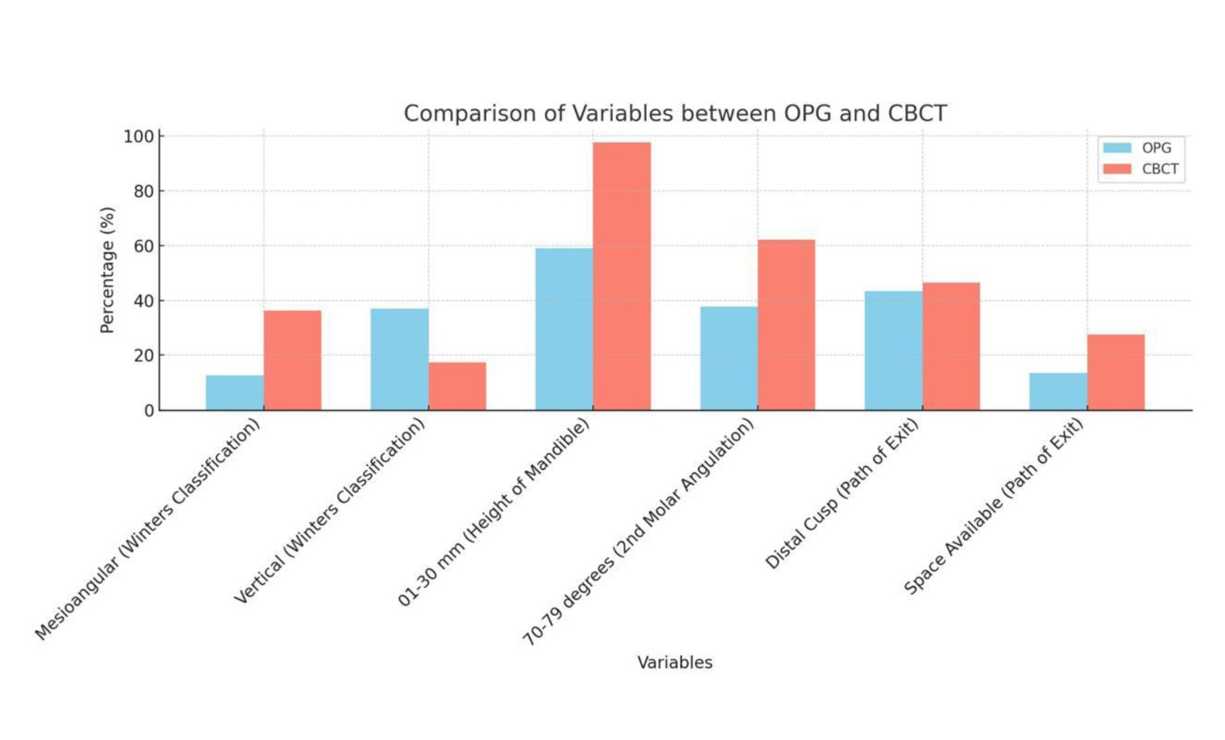

FIGURE - 4

**DISCUSSION:**

Various imaging modalities, such as periapical, panoramic, occlusal, conventional radiography, and computed tomography, are employed to pre-assess surgical sites. However, each technique has limitations. For posterior mandibular procedures, more precise diagnostic information may be needed to avoid critical structures like the IAN-MM complex, even though periapical radiographs of the anterior jaw often provide sufficient information. The front section of panoramic views is prone to overlap, and two-dimensional radiography cannot determine the exact location or thickness of vital structures in the buccolingual direction. Cross-sectional imaging techniques like magnetic resonance imaging (MRI) and various computed tomography (CT) modalities (spiral, linear, and hypocycloidal) have been used [8]. However, the high cost and radiation risks associated with these methods have drawn criticism [4]. As a result, CBCT was selected for this study over other techniques.

Reports suggest that CBCT is effective for imaging the craniofacial region. The primary goal of this study was to assess how CBCT compares to OPG in improving our understanding of risk factors. The mandibular canal typically appears as a well-defined radiolucent zone with radiopaque borders on CBCT. The radiographic density of this lucent structure varies, and the presence of a radiopaque outline depends on the canal's cortication [9].

The main focus of this study is to compare the accuracy of CBCT with OPG. CBCT’s three-dimensional nature allows more precise measurements of impacted teeth than OPG, improving the localization of the mandibular third molar in relation to the inferior alveolar nerve canal. Previous studies have found no significant differences between OPG and CBCT regarding parameters like mandibular height[22,23], second molar angulation[24,25], and the path of exit[26,27].

In comparing the Wharfe assessment variables between CBCT and OPG, the following findings were observed (Table 3):

* **Winter’s Classification:** Mesioangular impaction was most commonly found in CBCT (36.2%) and vertical impaction was more frequently detected in OPG (37%), although no significant difference was found between OPG and CBCT (P = 0.097).
* **Mandibular Height:** CBCT (97.6%) identified more cases in the 0–30 mm range compared to OPG (59.1%), with a statistically significant difference (P < 0.001).
* **Second Molar Angulation:** CBCT detected a higher percentage of patients (62.2%) with angulation in the 70–79 degree range compared to OPG (P < 0.001).
* **Follicle Size and Root Shape:** No statistically significant differences were observed (P > 0.05).
* **Path of Exit:** A significant difference was noted (P = 0.005). CBCT detected more instances of distal cusp coverage (46.5%) and available space (27.5%) compared to OPG (43.3% and 13.4%, respectively).

Additionally, we correlated gender and age with the Wharfe assessment. Previous studies have noted gender-specific trajectories in the relationship between tooth eruption and jaw expansion[10]. Understanding gender differences related to impacted teeth is important. Research has shown a female predominance in the occurrence of impacted third molars[11,12,13,14], although some studies report no gender differences[15,16], which aligns with the findings of this study. Conversely, other studies have noted a male preponderance[17].

The Spearman’s rank correlation coefficient between gender and the Wharfe assessment is 0.146, indicating a very weak correlation. The significance level (Sig. 2-tailed) for this correlation is 0.992, which is much higher than the conventional threshold of 0.05 for statistical significance. Therefore, we conclude that there is no significant correlation between gender and Wharfe assessment in this study. These results indicate that gender does not have a statistically significant impact on Wharfe assessment outcomes.

Prior research has documented a relationship between age and Wharfe assessment, with impaction typically occurring in the second half of the third decade of life [18,19,20,21]. In this study, the results suggest a mild correlation between age and the Wharfe score.

While CBCT offers improved imaging capabilities, some studies suggest that it does not significantly correlate the position of the inferior alveolar canal (IAC) with Winter's classification, highlighting the need for further study to improve preoperative evaluation techniques[28,29]. On the other hand, other studies emphasize that understanding the significant associations between Winter’s classification and canal positioning through advanced imaging like CBCT can greatly enhance surgical planning and reduce risks associated with third molar extractions[35,36,37].

In our research, the distribution of cases by canal position (basal, central, lingual) and Winter’s classification (mesial, mesioangular, vertical, distoangular) is shown in Table 4. A Pearson Chi-square test reveals a significant correlation between the canal’s location and Winter’s classification, with a Pearson Chi-square value of 36.59, degrees of freedom (df) = 8, and a p-value <0.05. This suggests that in our study, the canal’s location is significantly correlated with Winter’s classification.

Some studies have found no significant spatial correlation between the IAC and mandibular height, suggesting that changes in mandibular height do not correlate with changes in the IAC position on CBCT [30]. However, other research has shown that mandibular height and the location of the IAC are significantly correlated, with CBCT proving more useful than OPG for accurately visualizing and determining these anatomical relationships .

In this study, the distribution of cases by mandibular height (01-30mm, 31-44mm) and canal position (lingual, buccal, or central) is shown in Table 5. The results demonstrate a significant correlation between mandibular height and canal location, with a Pearson Chi-square value of 71.89, df = 2, and a p-value <0.05. This indicates a substantial relationship between the canal’s location and the height of the mandible.

**Clinical Implications:**

The notable variations in key parameters emphasize the benefits of CBCT over OPG, providing comprehensive details for complex surgical and dental procedures. CBCT is the preferred imaging method for accurate assessments, as it offers clear visualization of bone structures, tooth angles, and spatial relationships.

**Conclusion:**

In conclusion, this study highlights CBCT’s superior diagnostic accuracy over OPG in assessing key parameters of impacted third molars, particularly mandibular height, second molar angulation, and path of exit evaluation (P < 0.05). CBCT identified significantly more cases within the 0–30 mm mandibular height range (97.6% vs. 59.1%, P < 0.001), allowing for more precise bone height measurements essential for surgical planning. It also detected a greater number of cases with significant second molar angulation (62.2% vs. 37.8%, P < 0.001), particularly in the 70–79 degree range, enhancing preoperative assessment for extractions. Additionally, CBCT provided improved visualization of distal cusp coverage (46.5%) and open space (27.5%) in the path of exit analysis (P = 0.005), aiding in predicting eruption patterns and surgical challenges. While no significant differences were found in root form or follicle size (P > 0.05), CBCT’s advanced imaging capabilities allow for more detailed anatomical assessments, including the correlation between canal position, mandibular height, and Winter’s classification. These findings strongly support the use of CBCT as a preferred imaging modality in clinical settings, as it provides highly accurate measurements and detailed three-dimensional visualization, ultimately improving treatment planning and patient outcomes.

**REFERENCES:**

1. **Balaji SM, Krishnaswamy NR, Kumar SM, Rooban T: Inferior alveolar nerve canal position among South Indians: A cone beam computed tomographic pilot study. Ann Maxillofac Surg. 2012, 2:51-5. 10.4103/2231-0746.95319.**
2. **Hattab FN, Alhaija ES: Radiographic evaluation of mandibular third molar eruption space. Oral Surg Oral Med Oral Pathol Oral Radiol Endod. 1999, 88:285-91. 10.1016/s1079-210470029-6.**
3. **Kruger E, Thomson WM, Konthasinghe P: Third molar outcomes from age 18 to 26: findings from a population-based New Zealand longitudinal study. Oral Surg Oral Med Oral Pathol Oral Radiol Endod. 2001, 92:150-5.**
4. **Levine MH, Goddard AL, Dodson TB: Inferior alveolar nerve canal position: a clinical and radiographic study. J Oral Maxillofac Surg. 2007, 65:470-4. 10.1016/j.joms.2006.05.056.**
5. **Smith AC, Barry SE, Chiong AY, Hadzakis D, Kha SL, Mok SC, Sable DL: Inferior alveolar nerve damage following removal of mandibular third molar teeth. A prospective study using panoramic radiography. Aust Dent J. 1997, 42:149-52. 10.1111/j.1834-7819.1997.tb00111.x.**
6. **Gerlach NL, Meijer GJ, Maal TJ, Mulder J, Rangel FA, Borstlap WA, Bergé SJ: Reproducibility of 3 different tracing methods based on cone beam computed tomography in determining the anatomical position of the mandibular canal. J Oral Maxillofac Surg. 2010, 68:811-7. 10.1016/j.joms.2009.09.059.**
7. **Janakiraman EN, Alexander M, Sanjay P: Prospective analysis of frequency and contributing factors of nerve injuries following third-molar surgery. J Craniofac Surg. 2010, 21:784-6. 10.1097/SCS.0b013e3181d7f29a.**
8. **Peker I, Alkurt MT, Michcioglu T: The use of 3 different imaging methods for the localization of the mandibular canal in dental implant planning. Int J Oral Maxillofac Implants. 2008, 23:463-70.**
9. **Carter RB, Keen EN: The intramandibular course of the inferior alveolar nerve. J Anat. 1971, 108:433-40.**
10. **Glowacki J, Christoph K: Gender differences in the growing, abnormal, and aging jaw. Dent Clin North Am. 2013, 57:263-80. 10.1016/j.cden.2013.01.005.**
11. **Eshghpour M, Nezadi A, Moradi A, Shamsabadi RM, Rezaei NM, Nejat A: Pattern of mandibular third molar impaction: A cross-sectional study in northeast of Iran. Niger J Clin Pract. 2014, 17:673-7.**
12. **Bishara SE: Impacted maxillary canines: a review. Am J Orthod Dentofacial Orthop. 1992, 101:159-71.**
13. **Al-Anqudi SM, Al-Sudairy S, Al-Hosni A, Al-Maniri A: Prevalence and Pattern of Third Molar Impaction: A retrospective study of radiographs in Oman. Sultan Qaboos Univ Med J. 2014, 14:388-92.**
14. **Bamgbose BO, Akinwande JA, Adeyemo WL, Ladeinde AL, Arotiba GT, Ogunlewe MO: Effects of co-administered dexamethasone and diclofenac potassium on pain, swelling and trismus following third molar surgery. Head Face Med. 2005, 7:11-10.**
15. **Anjum R, Naseem N, Nagi AH: Age, genderand pattern distribution of impacted third molar among patients attending teaching hospital of Lahore. 2014, 8:562-565.**
16. **Gbotolorum OM, Arotiba GT, Ladeinde AL: Assessment of factors associated with surgical difficulty in impacted mandibular third molar extraction. J Oral Maxillofac Surg. 2007, 65:1977-1983. 10.1016/j.joms.2006.11.030**
17. **Yuasa H, Kawai T, Sugiura M: Classification of surgical difficulty in extracting impacted third molars. Br J Oral Maxillofac Surg. 2002, 40:26-31. 10.1054/bjom.2001.0684**
18. **Santamaria J, Arteagoitia I: Radiologic variables of clinical significance in the extraction of impacted mandibular third molars. Oral Surg Oral Med Oral Pathol Oral Radiol Endodontol. 1997, 84:469-473. 10.1016/S1079-2104(97)90259-6**
19. **Renton T, Smeeton N, McGurk M: Factors predictive of difficulty of mandibular third molar surgery. Br Dent J. 2001, 190:607-610. 10.1038/sj.bdj.4801052**
20. **Choudhary, Anand; Kesarwani, Pallavi1; Verma, Saumya; Srikrishna, K.; Nandi, Devarshi; Srishti: Comparative Study of Implant Site Assessment Using CBCT, Tomography and Panoramic Radiography. Journal of Indian Academy of Oral Medicine and Radiology 33(3): p 266-270, Jul-Sep. 2021, 10.4103/jiaomr.jiaomr_102_21**
21. **Goran Markic, Lukas Muller, Raphael Patcas, et al.: Assessing the length of the mandibular ramus and the condylar process: a comparison of OPG. CBCT, CT, MRI, and lateral cephalometric measurements, European Journal of Orthodontics, Volume. 2015:13-21.**
22. **Tang, Z., Liu, X. & Chen, K: Comparison of digital panoramic radiography versus cone beam computerized tomography for measuring alveolar bone. Head Face Med 13, 2.**
23. **Markic G, Muller L, Patcas R, et al.: Assessing the length of the mandibular ramus and the condylar process: a comparison of OPG, CBCT, CT, MRI, and lateral cephalometric measurements. Eur J Orthod. 2015, 37:13-21. 10.1093/ejo/cju008.**
24. **Shahidi S, Zamiri B, Abolvardi M, Akhlaghian M, Paknahad M: Comparison of Dental Panoramic Radiography and CBCT for Measuring Vertical Bone Height in Different Horizontal Locations of Posterior Mandibular Alveolar Process. J Dent (Shiraz. 2018, 19:83-91.**
25. **Issrani R, Prabhu N, Sghaireen M, et al.: Comparison of Digital OPG and CBCT in Assessment of Risk Factors Associated with Inferior Nerve Injury during Mandibular Third Molar Surgery. Diagnostics (Basel. 2021, 6:2282. 10.3390/diagnostics11122282.**
26. **Vidya KC, Pathi J, Rout S, Sethi A, Sangamesh NC: Inferior alveolar nerve canal position in relation to mandibular molars: A cone-beam computed tomography study. Natl J Maxillofac Surg. 2019, 10:168-174. 10.4103/njms.NJMS_53_17.**
27. **Resha Jameel, Areej Ahmed Najm, Firas Abdulameer: Visibility of mandibular canal on CBCT cross-sectional images in comparison with panoramic radiograph (Retrospective study). J Res Med Dent Sci. 2021, 9:290-294.**
28. **Saha N, Kedarnath NS, Singh M: Orthopantomography and Cone-Beam Computed Tomography for the Relation of Inferior Alveolar Nerve to the Impacted Mandibular Third Molars. Ann Maxillofac Surg. 2019, 9:4-9. 10.4103/ams.ams_138_18**
29. **Patel, Purv Shashank; Shah, Jigna S1; Dudhia, Bhavin B; Butala, Purva Bharat2; Jani, Yesha V; Macwan, Roseline S: Comparison of Panoramic Radiograph and Cone Beam Computed Tomography Findings for Impacted Mandibular Third Molar Root and Inferior Alveolar Nerve Canal Relation. Indian Journal of Dental Research 31(1): p 91-102, Jan-Feb. 2020, 10.4103/ijdr.IJDR_540_18**
30. **Maglione M, Costantinides F, Bazzocchi G: Classification of impacted mandibular third molars on cone-beam CT images. J Clin Exp Dent. 2015, 1:224-31. 10.4317/jced.51984.**