Morpho-functional Characteristics of the Cartilaginous Elements of the Stifle Joint in Adult Dogs (Canis familiaris)
Authors:
1- Prof. Dr./ Tarek Omar Mohamed El Mahdy
Prof. of Anatomy & Embryology, Faculty of Veterinary Medicine
Suez Canal University
+2001003921138
tarekelmahdy58@yahoo.com

2- Prof. Dr./ Eid Ali Mohamed Moussa
Prof. of Anatomy & Embryology, Faculty of Veterinary Medicine
Suez Canal University
+2001119818597
moussaaa57@gmail.com

3- Amira Mohamed Mokhtar Mohamed El Nahla
M.V. Sc., Fac. of Veterinary Medicine, Suez Canal University, (2020).
+2001207284534
princesselnahla@yahoo.com
Authors' contribution:
- The idea of the manuscript was given by the 1st author.
- The anatomical dissection, gross description, and scanning electron microscopic examination were performed by the 1st and 3rd authors.
- Statistical analysis of the obtained morphometric data was done by the 3rd author.
- The dissected specimens were photographed by the 3rd author.
- Gathering the literatures required for accomplishing the manuscript was a responsibility of all mentioned authors.

Morpho-functional Characteristics of the Cartilaginous Elements of the Stifle Joint in Adult Dogs (Canis familiaris)

El Mahdy, T.O., Moussa, E.A., and Amira, M.M.
Department of Anatomy and Embryology, Faculty of Veterinary Medicine, Suez Canal University, Egypt

Key words: Dog, Menisci, Morphometry, Articular cartilage, SEM
Correspondent Author: Tarek omar Mohamed El Mahdy
e-mail: tarekelmahdy58@ yahoo.com
Introduction
The stifle joint in humans (knee), dogs, and other domestic mammals is a complex joint due to both morphological and functional considerations ^{[28]} It is a highly movable joint, and it is very important clinically. ^{[17]} Changes in the functional load strongly influence the morpho-mechanical characteristics and adaptive properties of the connective tissue elements of the stifle joint.
The canine stifle joint is frequently subjected to many problems that necessitate surgical interference, including fractures, patellar luxation, gonitis, cruciate ligament injury, and meniscal tears. ^{[4]} Also, the joint is a common location for lameness in equines ^{[31]}, canines ^{[21]}, and cruciate ligament sprain in bovines. ^{[31]}
Recently, it is very important to preserve the menisci during surgical treatment of meniscal injuries in patients to avoid complications such as osteoarthritis. ^{[20]} There are multiple techniques of meniscal repair with suturing, bioabsorbable implants, and more recently the use of meniscal allografts. ^{[26, 27]}
Detailed information about the normal structure of the stifle joint helps to choose the most suitable treatment of the joint affections to preserve normal joint movement and to prevent increased degeneration of the joint. ^{[4]}
Computed tomography (CT) in canine stifles was also used to diagnose the meniscal injury. ^{[30]} However, the gross description of the normal stifle menisci, their associated ligaments, and the various morphometric measurements of the menisci as well as the tibial plateau width in each limb and in both male and female adult dogs were not available.
Therefore, the objectives of this study were to understand the morphology of the stifle menisci and to correlate these dimensions with the sex in healthy adult dogs, as representatives of the family “Canidae.” Also, dogs are considered as one of the most frequently used models to know more about surgery of the stifle joint in animals ^{[5]}, to evaluate the degree of success of curing injured menisci, and to test meniscal implants in humans. ^{[7, 18]}
The study also aimed to provide new, essential knowledge for students and anatomists and to help veterinary surgeons and clinicians in the field of proper diagnosis and successful treatment of the stifle joint injuries, especially meniscal tears.
Numerous scanning electron microscopic studies analyzing the arrangement of the collagenous fibers of the extracellular matrix in human articular cartilage have been published. However, few studies have been carried out in domestic animals, and particularly in canines. Therefore, our study also characterized the specific structural organization of the surface of the femoral condylar articular cartilage to assess how it adapted to its function in permitting free articulation and painless movement ^{[13]} as well as to describe the gross structure of the parapatellar fibrocartilages which play a significant role in preventing patellar luxation in canines. ^{[4]}
Materials and methods
The current work was performed on twelve apparently normal adult dogs of both sexes (8 males and 4 females) with their body weights ranged from 10 to 15 kg.
The animals showed no evidence of any obvious bone or joint abnormalities. The animals were euthanized using an intravenous injection of thiopental sodium and the pelvic limbs were then separated after euthanasia.
All experimental animal techniques used in the present work were in accordance with the rules of the Local Animal Care and Ethical Committee of the Faculty of Veterinary Medicine, Suez Canal University, Egypt .
1) Gross anatomic description:
Gross dissection of twenty freshly separated pelvic limbs (obtained from 7 male and 3 female dogs) was carried out to describe the normal gross structure of the parapatellar fibrocartilages as well as the medial and lateral menisci with their associated ligaments.
2) Macro-morphometric study:
The length of each meniscus was measured as the distance between its most cranial and most caudal peripheral edges.
The width of each meniscus was measured as the distance between the peripheral convex edge of the meniscus and the insertion points at the respective tubercle of the tibial intercondyloid spine.
The total width of the tibial proximal articular surface (tibial plateau width, TPW) also was measured as the distance between the outer borders of the tibial condyles at the level of the tibial tubercles.
All dimensions were taken according to ^{[19]} and ^{[3]} and illustrated in Figure (1).
The thickness of the convex peripheral edge of each meniscus at the level of the corresponding intercondyloid tubercles of the tibial spine was also measured.
The previous measurements were taken from all dissected right and left joints in both sexes using Vernier′s caliber and the Image-J analysis system. The recorded measurements were calculated as means± standard error, and the statistical differences were determined using the Independent sample T-test. The obtained results were considered statistically significant at P ˂ 0.05.
3) Scanning electron microscopic examination:
Small pieces (approximately 2x2x2 mm) from the femoral condylar articular cartilage with the subchondral spongy bone were taken from the remaining four joints.
The tissue specimens were preserved in 4% glutaraldehyde solution overnight at 4°C. Then, they were washed in 0.1M phosphate buffer (PH 7.2-7.4) for 4 hours, followed by immersion in 1% osmic acid for 24 hours as a second fixation step. Thereafter, the specimens were put in ascending grades of ethyl alcohol solutions for 15 minutes in each for dehydration. Then, they were put in t-butyl alcohol for dryness, and finally frozen at -20°c.
The specimens were then mounted on aluminum stubs with double-sided adhesive tape and coated with gold. ^{[15]}
The tissue samples were examined using a QUANTA FEG 250 scanning electron microscope.
4) Nomenclature:
The terminology used in this work was adopted according to the ^{[23]} and ^{[24]} as needed.
Results
A) Gross anatomic characteristics:
The stifle joint (Articulatio genus) in dogs was a complex synovial joint. It included the femoropatellar, bicondylar femorotibial, and proximal tibiofibular articulations, in addition to the joints between the femur and the paired gastrocnemius fabellae and the joint between the popliteal sesamoid bone and the lateral tibial condyle. These articulations were contained within a strong common articular capsule. The cartilaginous elements of the stifle joint involved the fibrocartilaginous menisci, the winged parapatellar fibrocartilages, and the hyaline articular cartilage which covered both the femoral and tibial condyles, as well as that covered the articular surface of the patella and the head of the fibula.
Fibrocartilagines parapatellares medialis et lateralis:
The femoropatellar articulation was constructed from the deep groove in the femoral trochlea and the patellar articular surface with its parapatellar fibrocartilages. The patella appeared somewhat elliptical with nearly rounded proximal and distal ends. It was approximately 1.68 cm long and 0.96 cm wide and embedded in the deep face of the insertion tendon of the m. quadriceps femoris. The patellar articular surface (facies articularis patellae) was smooth and convex both longitudinally and transversely.
The opposing bony articulating surfaces were not quite similar to each other, since their transverse diameters were unequal. Therefore, the medial and lateral borders (margo medialis et lateralis) of the patella were covered by two elongated fibrocartilaginous bars representing the medial and lateral parapatellar fibrocartilages which met together proximal to the patella and articulated with the corresponding ridges of the femoral trochlea. The medial parapatellar fibrocartilage was much broader and thicker compared to the lateral one and measured approximately 3-4 mm in width. It was about twice as extensive as the lateral parapatellar fibrocartilage (Figs. 2, 3).
Menisci articulares medialis et lateralis:
Gross observation revealed that both menisci were in the form of C-shaped fibrocartilaginous plates which intervened between the femoral and tibial condyles to provide congruence between them. Each meniscus had an outer (peripheral) thick convex attached border and an inner (central) much thinner concave free border (Figs. 4, 5). The peripheral edge of the medial meniscus was firmly connected by multiple fine fibrous strands with the tibial portion of the fibrous articular capsule and with the medial collateral femorotibial ligament (Fig. 6). The peripheral edge of the lateral meniscus was loosely connected with the capsule and separated from the lateral collateral femorotibial ligament by the origin tendon of the m. popliteus (Fig. 7). Therefore, the medial meniscus appeared less mobile compared to the lateral one. Each meniscus possessed a proximal (femoral) concave surface adapted to the convex femoral condyle and a distal (tibial) surface that adapted to the nearly flat tibial condyles.
Also, each meniscus had two horns, cranial and caudal (cornu cranialis et caudalis) that attached by a group of meniscal ligaments with the tibia and femur. The caudal horns of both menisci were thicker than their cranial ones. At the same time, it was observed that the lateral meniscus was slightly wider caudally than cranially. However, the medial meniscus was markedly broader caudally than it was cranially (Figs. 4, 5). The lateral meniscus occupied a slightly larger area of the respective tibial condyle than that of the medial tibial condyle, which was occupied by the narrower medial meniscus. Consequently, the area of direct contact between the lateral femoral and tibial condyles was slightly smaller compared to that occurring between the medial femoral condyle and the medial tibial condyle.
Ligaments of the menisci:
A set of small fibrous ligaments connected the menisci with the femur and tibia. These ligaments were composed of two meniscotibial ligaments for each meniscus, a single meniscofemoral ligament for the lateral meniscus, and a transverse (intermeniscal) ligament.
(1) Lig. tibiale craniale ad meniscus medialis:
The cranial tibial ligament of the medial meniscus (Fig. 4) attached the cranial horn of the medial meniscus with the lateral margin of the cranial intercondyloid area of the tibial plateau, just in front of the transverse ligament.
(2) Lig. tibiale craniale ad meniscus lateralis:
The cranial tibial ligament of the lateral meniscus (Fig. 5) extended between the cranial horn of the lateral meniscus and the lateral tubercle of the tibial intercondyloid eminence, close to the cranial cruciate ligament.
(3) Lig. tibiale caudale ad meniscus medialis:
The caudal tibial ligament of the medial meniscus (Fig. 5) connected the caudal horn of the medial meniscus with the medial tubercle of the intercondyloid eminence as well as with the caudal intercondyloid area of the tibia, slightly cranial to the point of attachment of the caudal cruciate ligament.
(4) Lig. tibiale caudale ad meniscus lateralis:
The caudal tibial ligament of the lateral meniscus (Fig. 6) began from the caudal horn of the lateral meniscus and terminated at the lateral margin of the popliteal notch of the tibia as well as the caudal intercondyloid area, just behind the point of attachment of the caudal cruciate ligament.
(5) Lig. transversum genus:
The transverse (or intermeniscal) ligament (Figs. 5, 8) was characteristic of the femorotibial articulation in dogs and described as a small fibrous band that extended between the cranial horns of both menisci, just in front of the cranial cruciate ligament.
(6) Lig. meniscofemorale ad meniscus lateralis:
The fascicles of the meniscofemoral ligament (Figs. 5, 6, 7) passed obliquely from the caudal horn of the lateral meniscus, directed cranially, medially and proximally within the femoral intercondyloid fossa, then terminated at the upper portion of the inner surface of the medial femoral condyle.
B) Morphometric findings: (Tables 1, 2, 3 and Figs. 9, 10)
Generally, the length, width, and thickness of the peripheral edge of the medial and lateral menisci of the same joint in an individual animal of both sexes showed significant statistical differences. However, evaluation of these dimensions in both limbs of the same animal showed no significant difference.
Thus, the thickness of the lateral meniscal peripheral edge measured 0.32±0.02 cm and was significantly larger (P ˂ 0.05) compared to the medial meniscus, which measured 0.22±0.02 cm.
The lateral meniscal length was 1.53±0.07 cm, whereas that of the medial meniscus was 1.73±0.05 cm. Also, the lateral and medial meniscal widths of the same joint were 1.25 ± 0.05 cm and 1.06 ± 0.04 cm, respectively. However, the meniscal length and width as well as the thickness of the peripheral edge for each meniscus in the right and left joints of the same animal were nearly identical. The total tibial plateau width (TPW) in the right and left femorotibial joints of an individual animal was not significantly different, and measured 3.23 ± 0.03cm and 3.22 ± 0.03cm, respectively.
Statistical analysis of the current morphometric data established a correlation between the various meniscal body dimensions as well as total tibial plateau width and the sex of the animal.
The right and left medial menisci in male dogs measured 1.77 ± 0.20 cm and 1.78 ± 0.18 cm in length, while 1.13 ± 0.13 cm and 1.11± 0.12 cm in width. At the same time, these dimensions for the right and left lateral menisci were 1.53± 0.22 cm in length, while 1.34 ± 0.15 cm and 1.31 ± 0.18 cm in width, respectively.
On the other hand, the meniscal dimensions in female dogs were 1.63 ± 0.02 cm and 1.62 ± 0.02 cm long, while 0.90± 0.02cm and 0.91 ± 0.02cm wide for the right and left medial menisci, respectively. While the right and left lateral menisci measured 1.53 ± 0.04 cm and 1.51 ± 0.04 cm in length as well as 1.13 ± 0.03cm and 1.08 ± 0.08 cm in width. Such results revealed that male dogs generally presented significantly larger dimensions (P ˂ 0.05) compared to female dogs.
Also, the average thickness of the lateral and medial meniscal peripheral edge of the right and left joints in female dogs measured opposite to the level of the respective tibial intercondyloid tubercles was 0.27 ± 0.02 cm and 0.17 ± 0.01cm, respectively. However, such measurements in male dogs were significantly larger (P ˂ 0.05) and were about 0.32 ± 0.06 cm and 0.23±0.04 cm, respectively. Therefore, the lateral meniscus in both male and female dogs was significantly shorter, but broader and thicker compared to the medial meniscus.
Concerning the width of the proximal tibial articular surface (TPW) of both right and left joints, it was also proportionally correlated with the sex of the animal, being significantly greater (P ˂ 0.05) in males (~ 3.45 ± 0.31cm) when compared to females (~ 2.70 ± 0.02 cm). At the same time, the values of the TPW (Tables 1, 2) indicated that it had a more rapid growth rate when compared to the corresponding meniscus.
There were no significant differences between the various meniscal dimensions and the TPW that were obtained with the use of Vernier′s caliber or the Image-J system.

C) Scanning electron microscopic findings:
The femoral condylar articular cartilage (Cartilago articularis
condylus femoris):
Scanning electron microscopy (SEM) of the surface morphology of the articular cartilage obtained from the femoral condyle of healthy adult dogs showed primarily the presence of flattened or oval chondrocytes with their sides oriented almost parallel to the surface of the cartilage. However, some cartilage cells appeared round (Fig.11).
The chondrocytes of the cartilage surface, unlike those of the underlying layers, were separated from each other and did not form isogenic groups. They were tightly packed among the collagen fibers of the extracellular matrix and exhibited considerable variation in size.
The small chondrocytes gave a granular appearance to the articular cartilage surface (Figs. 11, 12).
Scanning electron micrographs revealed the highly organized and condensed collagen fibers and fascicles that passed in a longitudinal direction and displayed an almost parallel orientation to the cartilage surface as well. At the same time, these collagen fibers possessed an undulating course and had several apparent elevations, which varied in diameter and height and bulged into the joint cavity.
These elevations or prominences were separated from each other by deep grooves and depressions in which the chondrocytes were located. Meanwhile, some of the undulated collagen fibers appeared devoid of chondrocytes (Fig. 11).
Discussion
The anatomy of the canine stifle joint has attracted the attention of many previous authors. However, a more detailed morphometric and gross anatomical description of its cartilaginous elements, in addition to the scanning electron microscopic examination of the femoral condylar articular cartilage were presented in this study
A) Gross anatomic characteristics:
The different subdivisions of the stifle joint in dog were in an agreement with those mentioned by ^{[8]} in canines.
The dog patella in our study appeared elliptical in form, measured approximately 1.68 cm in length and 0.96 cm in width and was incorporated into the insertion tendon of the quadriceps femoris muscle. However, the patella was triangular in the goat, ^{[12]} quadrangular in the horse, ^{[8]} elongated and triangular in the donkey, ^{[2]} and oval in the fox.^{[9]} The lateral area of the articular surface of the patella in the donkey measured about 3 cm long and 1.5 cm wide, while the medial area was about 3.5 cm long and 2 cm wide. ^{[2]}
The medial parapatellar fibrocartilage in the dog, as revealed in the present study was much broader and thicker compared to the lateral one, confirming the findings of ^{[8]} ,who found that the medial parapatellar fibrocartilage was exceptionally well developed in large dogs. These winged or alar patellar cartilages helped to prevent patellar luxation. ^{[4]}
A suprapatellar fibrocartilage was observed incorporated in the insertion tendon of the m. rectus femoris in rabbits ^{[11]} and foxes.^{[9]} However, the site of union observed in our study between the medial and lateral parapatellar fibrocartilages proximal to the patella in dogs might represent the suprapatellar fibrocartilage discovered in rabbits and foxes by the previous authors.
The femoral and tibial condyles in dogs, other domestic animals, and humans didn′t conform to each other. Therefore, the two menisci were located to provide the structural integrity to the stifle joint, and thus permitting wider range of movement. They also protect the articular surfaces, provide the joint stability and diminish concussion.^{[26, 16, 5, 8, 27, 12]}
Our findings revealed that both menisci in dogs were C-shaped, the observation which agreed with ^{[1]} in the same animal. However, the latter authors stated that the medial meniscus was crescentic in donkey and semicircular in goat, whereas the lateral meniscus was semicircular in donkey and resembled an elongated kidney in goat.
It was noted that the lateral meniscus in dogs covered a slightly larger area of the corresponding tibial condyle compared to the medial one, which was covered by the medial meniscus. This finding agreed with that given by ^{[14]} in humans, where the lateral meniscus occupied a larger portion (~ 80%) of the articular surface compared to the medial one (~ 60%).
Accordingly, our results revealed that the area of direct contact between the femoral condyle and the corresponding tibial condyle on the lateral side of the joint was slightly smaller than that on the medial side. In our opinion, this might be attributed to the presence of a small articular facet for the popliteal sesamoid bone in the caudal aspect of the lateral tibial condyle, and the increased width of the lateral meniscus compared to the medial meniscus as well.
Furthermore, the portion of the lateral tibial condyle covered by the lateral meniscus in humans was smaller when compared with that of the cow, pig, sheep, goat, dog, and rabbit. ^{[25]}
The present work reported that the lateral meniscus in the dog was increasingly mobile compared to the medial one, since the tendon of the popliteus muscle intervenes between it and the lateral collateral femorotibial ligament and the outer convex edge of the lateral meniscus has a loose attachment with the articular capsule as well. At the same time, the medial meniscus in the dog was less mobile due to the presence of multiple fine fibrous strands attaching it with the medial collateral femorotibial ligament and the joint fibrous capsule. Such fibrous strands were named as the coronary ligaments in humans. ^{[14]} The firm attachment of the medial meniscus to the capsule and lack of such attachment for the lateral meniscus was also observed by ^{[2]} in donkeys.
Regarding the ligaments attaching the menisci with the femur and tibia in dogs, they were nearly similar in their arrangement with those in other animals and humans. However, few specific species characteristics have been reported.
The extension of the meniscofemoral ligament described here in dogs between the caudal horn of the lateral meniscus and the upper portion of the internal surface of the medial femoral condyle was in agreement with that observed in cattle and buffalo. ^{[10]} Additionally, the point of attachment of the meniscofemoral ligament into the medial femoral condyle in humans was in a more inferior level compared to the dog, pig, cow, sheep, goat, and rabbit. ^{[25]}
Moreover, cranial and caudal meniscofemoral ligaments were observed extending between the lateral meniscus and the medial condyle of the femur in humans. ^{[14]}
The intermeniscal ligament was a specific structure in the canine stifle ligamentous apparatus extending between the cranial horns of both menisci as observed in our study. However, it connected the cranial horn of medial meniscus with the cranial ligament of the lateral meniscus as given by ^{[1]} in the same animal. This ligament was also present in foxes, ^{[9]} cattle and buffalo, ^{[10]} as well as in humans. ^{[14]}
However, the intermeniscal ligament was absent in goats, ^{[12]} and marsh deer. ^{[29]}
Our findings clearly observed the presence of the cranial tibial ligament of the medial meniscus, contrary to ^{[1]} in the same animal who stated that this ligament was absent.
B) Morphometric characteristics:
Regarding the meniscal dimensions in different animals, there were few available previous studies. In this respect, the thickness of the outer edges of the lateral and medial menisci (at their middle part) in adult cattle were about 1.27 cm for the lateral meniscus and 0.85 cm for the medial meniscus, while the distance between the convex and concave borders at their middle part measured about 2.58 cm and 2.31 cm, respectively. ^{[17]} In addition, the medial meniscus in donkey was approximately
3 cm long and 0.9 cm wide, being larger than the lateral one, which measured approximately 2.5 cm long and 0.5 cm wide, whereas the lateral meniscus in dog and goat was the largest, more concave, and thicker. ^{[2]}
Therefore, several measurements were taken from the right and left stifle joints of adult male and female dogs in the current study, including the maximum cranio-caudal length and medio-lateral width of both menisci as well as the thickness of the meniscal peripheral edges, in addition to the total tibial plateau width. The obtained measurements might be considered as evaluation criteria for the physiological status of the animal body, and in particular, the growth and development of the musculoskeletal system.
In this connection, the tibial plateau widths were proportionally correlated with the true meniscal body dimensions in relation to the animal sex, where these dimensions were significantly larger in male dogs compared to female ones, confirming the findings of ^{[3, 22]}, who also found such a correlation in relation to the age and gender of humans. Moreover, the faster rate of growth of the tibial plateau width compared to that of the menisci might be important in the surgery of menisectomies not only in adult dogs, but also in younger ones.
At the same time, the medial meniscus in both sexes of an adult dog was significantly higher in length compared to the lateral one. However, the medial meniscus was narrower and thinner when compared to the lateral meniscus.
C) Scanning electron microscopic characteristics of the articular cartilage:
Many authors have elucidated the functions of the articular cartilage to permit painless movement and to transmit forces through the skeleton as it is devoid of blood vessels, lymph vessels, and nerves and its degeneration leads to loss of joint mobility. ^{[13]} The articular cartilage also facilitates weight-bearing and is important in shock absorption. ^{[6]}
High magnification scanning electron micrographs revealed that the collagenous fibers of the extracellular matrix in the femoral condylar articular cartilage surface in dogs appeared highly undulated, with several apparent elevations, which were separated from each other by deep grooves and depressions, and the chondrocytes were primarily flat.
In this respect, the collagen fibers of the tibial plateau articular cartilage had a leaf- like arrangement in humans, pigs, and dogs. In contrast, those in cattle, sheep, rabbits, and, rats have a columnar arrangement. ^{[13]}
Also, the collagen structure of the articular cartilage in pigs was mostly resembled that of humans. ^{[13]}
Conclusions
• Borders of the patella in dogs were covered by the parapatellar fibrocartilages which might help to prevent patellar luxation.
• The meniscal ligaments were six in number, including the transverse meniscal ligament which was specific to the dog′s stifle ligamentous apparatus.
• The lateral meniscus was increasingly mobile than the medial one.
• The tibial plateau width and the meniscal dimensions increased significantly in male dogs compared to female ones.
• The faster rate of growth of the tibial plateau width compared to the menisci might be important in the surgery of menisectomies not only in adult dogs, but also in younger ones.
• SEM of the articular cartilage surface revealed the form, size of its chondrocytes, and the orientation of the extracellular collagen fibers.

Conflict of interest: The authors declare that they have no conflicts of interest.

Acknowledgement:
The authors would like cordially to thank and greatly appreciate Prof. Dr. Louise C. Abbott, Department of Veterinary Integrative Biosciences, College of Veterinary Medicine, Texas A&M University, U.S.A. for the linguistic correction and final proof of this study.
References
[1] Abumandour MMA, Fathi BN, El Gendy S, Karkoura A, El Bakary R. Comparative Morphological Studies of the Stifle Menisci in Donkeys, Goats, and Dogs. J. Morphological Sciences. 2019; 36 (2): 72-84.
[2] Abumandour MMA, Fathi BN, El Gendy S, Kaekoura A, El Bakary R. Cross-anatomical, radiographic, and computed tomographic study of the stifle joint of donkeys (Equus africanus asinus). Anat. Histol. Embryol. 2020; 49 (3).
[3] Bedoya MA, Barrera CA, ChauvinNA, Delgado J, Jaramillo D, Ho-Fung VM. “Normal meniscal dimensions at different patient ages―MRI evaluation”. Skeletal Radiology. 2019; 48:595-603.
[4] Carpenter DH, Cooper RC. “Mini Review of Canine Stifle Joint Anatomy”. Anat. Histol. Embryol. 2000; 29:321-329.
[5] Chevrier A, Nelea M, Hurtig MB, Hoemann CD, Buschmann MD. Meniscus structure in human, sheep, and rabbit for animal models of meniscus repair. J Orthop Res, 2009; 27(9): 1197-1203.
[6] Darling EM, Hu JCY, Athamsiou KA. Zonal and topographically differences in the articular cartilage gene expression. J Ortho Res. 2004; 22:1182-1187.
[7] Deponti D, Di Giancamillo A, Scotti C, Peretti GM, Martin I.
Animal models for meniscus repair and regeneration. J Tissue Eng Regen Med. 2015; 9 (5):512-27.
[8] Dyce KM, Sack WO, Wensing CJG. A textbook of veterinary anatomy. 4th ed. 2010; 453-461. W.B. Saunders Company. Philadelphia, London, Toronto, Montreal, Sydney, Tokyo.
[9] El Bably S, Noor N. Anatomical, Radiological, and Magnetic Resonance Imaging on the Normal Stifle Joint in Red Fox (Vulpes vulpes). Int. J. Anat. Res. 2017; 5 (4.3):4760-4769.
[10] El Hanbaly RA. Why the incidence of the upward fixation of the patella is higher in buffalo than in cattle? M.V. Sc.Thesis, Assiut University, Egypt. 2011.
[11] El Nady F. Gross anatomical study of the articulatio genus (stifle joint) of the rabbit. Vet. Med. J. Giza.2004; 52.
[12] Fathi N, El Bakary RA, Karkoura AA et al. Advanced morphological and radiological studies on the stifle joint of Egyptian Baladi goat (Capra hircus). AJVR. 2016; 51 (2):199-210.
[13] Fellows CR, Csaba Matta C, Zakany R, et al. Adipose, Bone marrow and synovial joint-Derived Mesenchymal Stem Cells for Cartilage Repair. www.ncbi.nlm.nih.gov. 2016.
[14] Fox AJS, Bedi A, Rodeo SA.The Basic Science of Human Knee Menisci Structure, Composition and Function. Sports Health. 2012; 4 (4):340-351.
[15] Fujioka R, Aoyama T, Takakuwa T. The layered structure of the articular surface. Osteoarthritis and Cartilage. 2013; 21: 1092 -1098.
[16] Goldblatt JP, Richmond JC, 2003: Anatomy and biomechanics of the knee. Operative techniques in sports medicine, 11:172-186.
[17] Hifny A, Abdalla KEH, Abdel Rahman YA et al. Morphometric Studies on the Femorotibial joint in cattle. Int. J. Adv. Biomed. 2017; 2 (3):73-85.
[18] Huangfu X, Zhao J. Tendon-bone healing enhancement using injectable tricalciun phosphate in a dog anterior cruciate ligament reconstruction model. Arthroscopy. 2007; 23 (5): 455-462.
[19] Kevin RS, Abhi Freyer BAS, Thomas, et al. Meniscal Sizing Based on Gender, Height, and Weight. J. Arthroscopic and Related Surgery. 2007; 23 (5): 503-508.
[20] Makris EA, Hadidi P, Athanasiou KAT. The knee meniscus: structure-function, pathophysiology, current repair techniques, and prospects for regeneration. Biomaterials. 2011; 32:7411–7431.
[21] Marino DJ, Loughin CA. Diagnostic Imaging of the Canine Stifle: A Review. Veterinary Surgery. 2010; 39 (3):284–295.
[22] McDermott ID, Sharifi F, Bull AMJ, Gupte CM, Thomas RW, Amis AA. “An anatomical study of meniscal allograft sizing”.
Knee Surg, Sports Traumato, Arthrosc. 2004; 12:130-135.
[23] Nomina Anatomica Veterinaria. Prepared by the International Committee on Veterinary Gross Anatomical Nomenclature (ICVGAN). 6th ed. Published by the Editorial Committee. Hanover (Germany), Ghent (Belgium), Columbia, MO (U.S.A.), Rio de janeiro (Brazil). 2017.
[24] Nomina Histologica Veterinaria. Submitted by the International committee on Veterinary Histological Nomenclature (ICVHN). 2017.
[25] Proffen B L, McElfresh M, Fleming B C, et al. A comparative anatomical study of the human knee and six animal species. The Knee. 2012; 19 (4):493–499.
[26] Rath E, Richmond JC. The menisci: basic science and advances in treatment. Br J Sports Med. 2000; 34(4): 252-257.
[27] Riboh JC, Tilton AK, Cvetanovich GL, et al. Meniscal allograft transplantation in the adolescent population. Arthroscopy. 2016; 32: 1133–1140.
[28] Sabanci SS, Ocal MK. Lateral and medial tibial plateau angles in normal dogs: An osteological study. Vet Comp Orthop Traumatol. 2014; 27:135-140.
[29] Shigure DA, Rahal SC, Schimming BC, et al. Evaluation of the Marsh Deer Stifle Joint imaging studies and gross anatomy. Anat. Hist. Embryol. 2014; 4:468-474.
[30] Tivers M, Mahoney P, Corr SA. Canine Stifle Positive Contrast Computed Tomography Arthrography for Assessment of Caudal Horn Meniscal Injury: A Cadaver Study. Veterinary Surgery. 2008; 37 (3): 269-277.
[31] Weaver A. Bovine medicine diseases and husbandry of cattle. In Andrews A, Blowey R, Boyd H, Eddy R, 2nd ed. Oxford: Blackwell Science Ltd. 2004; 435-465.

Table (1): showing the dimensions (cm) of the meniscal length (L), width (W), thickness (Th) of the meniscal peripheral edge, and the tibial plateau width (TPW) in male (M) and female (F) adult dogs using “Vernier′s caliper“
No. | Sex | Right femorotibial articulation |  |  |  |  |  |  | Left femorotibial articulation
 |  | Medial meniscus |  |  | Lateral meniscus |  |  | TPW | Medial meniscus |  |  | Lateral meniscus |  |  | TPW
 |  | L | W | Th | L | W | Th |  | L | W | Th | L | W | Th
1 | M | 1.58 | 1.16 | 0.18 | 1.28 | 1.29 | 0.26 | 3.22 | 1.60 | 1.14 | 0.19 | 1.30 | 1.22 | 0.28 | 3.24
2 | M | 1.65 | 1.17 | 0.21 | 1.32 | 1.35 | 0.25 | 3.42 | 1.67 | 1.08 | 0.19 | 1.33 | 1.36 | 0.24 | 3.41
3 | M | 1.71 | 1.10 | 0.22 | 1.52 | 1.24 | 0.27 | 3.31 | 1.72 | 1.12 | 0.23 | 1.54 | 1.29 | 0.29 | 3.32
4 | M | 1.98 | 1.26 | 0.28 | 1.66 | 1.32 | 0.37 | 3.22 | 1.97 | 1.24 | 0.26 | 1.64 | 1.31 | 0.38 | 3.20
5 | M | 1.63 | 0.92 | 0.25 | 1.42 | 1.28 | 0.33 | 3.42 | 1.65 | 0.94 | 0.27 | 1.44 | 1.05 | 0.34 | 3.43
6 | M | 1.78 | 1.01 | 0.22 | 1.57 | 1.28 | 0.38 | 3.47 | 1.77 | 0.98 | 0.20 | 1.55 | 1.29 | 0.36 | 3.44
7 | M | 2.11 | 1.28 | 0.27 | 1.96 | 1.68 | 0.39 | 4.11 | 2.10 | 1.26 | 0.28 | 1.94 | 1.66 | 0.38 | 4.09
8 | F | 1.65 | 0.92 | 0.17 | 1.56 | 1.15 | 0.28 | 2.72 | 1.64 | 0.93 | 0.17 | 1.55 | 1.14 | 0.27 | 2.71
9 | F | 1.63 | 0.91 | 0.19 | 1.55 | 1.14 | 0.28 | 2.70 | 1.61 | 0.90 | 0.20 | 1.52 | 1.12 | 0.28 | 2.69
10 | F | 1.61 | 0.89 | 0.16 | 1.48 | 1.10 | 0.25 | 2.68 | 1.62 | 0.90 | 0.17 | 1.47 | 0.99 | 0.26 | 2.67
Mean±SE |  | 1.73±  0.05 | 1.06±0.04 | 0.22±0.02 | 1.53±0.07 | 1.25±0.05 | 0.32±0.02 | 3.23±0.03 | 1.74±0.05 | 1.05±0.04 | 0.22±0.02 | 1.51±0.07 | 1.24±0.06 | 0.31±0.02 | 3.22±0.03

Table (2): showing the dimensions (cm) of the meniscal length (L), width (W), and thickness (Th) of the meniscal peripheral edge as well as the tibial plateau width (TPW) in male (M) and female (F) adult dogs using the “Image-J system“
No. | Sex | Right femorotibial articulation |  |  |  |  |  |  | Left femorotibial articulation
 |  | Medial meniscus |  |  | Lateral meniscus |  |  | TPW | Medial meniscus |  |  | Lateral meniscus |  |  | TPW
 |  | L | W | Th | L | W | Th |  | L | W | Th | L | W | Th
1 | M | 1.57 | 1.15 | 0.13 | 1.26 | 1.19 | 0.17 | 3.19 | 1.59 | 1.13 | 0.11 | 1.29 | 1.20 | 0.18 | 3.22
2 | M | 1.63 | 1.05 | 0.12 | 0.98 | 1.33 | 0.21 | 3.40 | 1.65 | 1.06 | 0.13 | 1.01 | 1.34 | 0.22 | 3.39
3 | M | 1.69 | 0.98 | 0.20 | 1.50 | 1.12 | 0.25 | 3.29 | 1.70 | 1.10 | 0.21 | 1.52 | 1.13 | 0.27 | 3.30
4 | M | 1.96 | 1.24 | 0.24 | 1.64 | 1.10 | 0.38 | 3.20 | 1.95 | 1.22 | 0.23 | 1.62 | 0.99 | 0.36 | 3.18
5 | M | 1.61 | 0.90 | 0.24 | 1.41 | 1.37 | 0.31 | 3.40 | 1.64 | 0.93 | 0.26 | 1.43 | 1.38 | 0.33 | 3.42
6 | M | 1.77 | 0.99 | 0.10 | 1.58 | 1.27 | 0.37 | 3.46 | 1.76 | 0.97 | 0.13 | 1.54 | 1.28 | 0.35 | 3.43
7 | M | 2.11 | 1.28 | 0.37 | 1.96 | 1.68 | 0.39 | 4.11 | 2.09 | 1.24 | 0.32 | 1.93 | 1.65 | 0.37 | 4.08
8 | F | 1.64 | 0.91 | 0.25 | 1.53 | 1.14 | 0.36 | 2.71 | 1.64 | 0.93 | 0.25 | 1.55 | 1.14 | 0.36 | 2.71
9 | F | 1.63 | 0.91 | 0.24 | 1.55 | 1.14 | 0.35 | 2.70 | 1.60 | 0.89 | 0.21 | 1.50 | 1.11 | 0.34 | 2.67
10 | F | 1.60 | 0.88 | 0.21 | 1.47 | 1.09 | 0.30 | 2.66 | 1.62 | 0.90 | 0.23 | 1.47 | 0.99 | 0.33 | 2.67
Mean±SE |  | 1.72±  0.05 | 1.03±  0.04 | 0.21±  0.02 | 1.5±  0.08 | 1.24±  0.05 | 0.30±  0.02 | 3.21±  0.13 | 1.72±  0.05 | 1.04± 0.04 | 0.21±  0.02 | 1.49±  0.07 | 1.22±  0.06 | 0.31± 0.02 | 3.2±  0.10

Table (3): showing the dimensions (cm) of the meniscal length , width, thickness of the meniscal peripheral edge, and the tibial plateau width in male and female adult dogs
Left medial meniscus
Female | Male
1.62 ± 0.02 | 1.78 ± 0.18 | Length (cm)
0.91 ± 0.02 | 1.11 ± 0.12 | Width (cm)
0.18 ± 0.02 | 0.23 ± 0.04 | Thickness (cm)
Left lateral meniscus
Female | Male
1.51 ± 0.04 | 1.53 ± 0.22 | Length (cm)
1.08 ± 0.08 | 1.31 ± 0.18 | Width (cm)
0.27 ± 0.01 | 0.32 ± 0.05 | Thickness (cm)
Left tibial plateau width (TPW)/ cm
Female | Male
2.69 ± 0.02 | 3.44 ± 0.30

Rigjt medial meniscus
Female | Male
1.63 ± 0.02 | 1.77 ± 0.20 | Length (cm)
0.90 ± 0.02 | 1.13 ± 0.13 | Width (cm)
0.17 ± 0.02 | 0.23 ± 0.04 | Thickness (cm)
Right lateral meniscus
Female | Male
1.53 ± 0.04 | 1.53 ± 0.22 | Length (cm)
1.13 ± 0.03 | 1.34 ± 0.15 | Width (cm)
0.27 ± 0.02 | 0.32 ± 0.06 | Thickness (cm)
Right tibial plateau width (TPW)/ cm
Female | Male
2.70 ± 0.02 | 3.45 ± 0.31

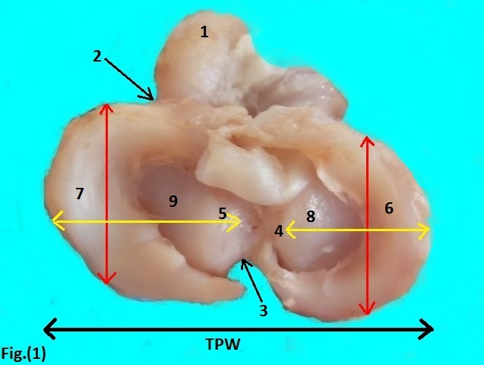

Plate I
Fig. (1): A photograph of the dog tibial proximal articular surface (tibial plateau) showing:
1- Tuberositas tibiae
- Sulcus extensorius
- Incisura poplitea
- Tuberculum intercondylare mediale
- Tuberculum intercondylare laterale
- Meniscus medialis
- Meniscus lateralis
- Condylus medialis tibiae
- Condylus lateralis tibiae
•Vertical red arrows indicate the meniscal length
• Transverse yellow arrows indicate the meniscal width
• TPW: Tibial plateau width

Fig. (2): A photograph of the cranial view of an adult dog knee joint showing:

- Lig. Patellae
- M. quadriceps femoris (reflected downwards)
- Caput fibulae
- Corpus fibulae
- Facies articularis patellae
- Fibrocartilagineus parapatellaris medialis
- Fibrocartilagineus parapatellaris lateralis

Fig. (3): A photograph of the dog knee joint (lateral aspect) showing:

- Facies articularis patellae
- Fibrocartilaginous parapatellaris medilais
2ʼ. Fibrocartilaginous parapatellaris lateralis
- Trochlea ossis femoris (lateral ridge)
- Corpus ossis femoris
- Tuberositas tibiae
- Corpus tibiae
- Condylus lateralis femoris
- Caput fibulae
- Corpus fibulae
- Lig. collaterale laterale (fibulare)
- M. quadriceps femoris (tendinous insertion)
- M. gastrocnemius (caput laterale)
- M. gastrocnemius (caput mediale)

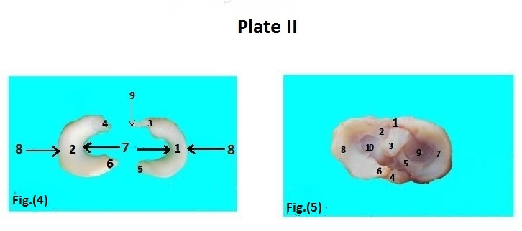

Plate II
Fig. (4): A photograph of the isolated menisci in adult dogs showing :

  - Meniscus medialis (femoral surface)
  - Meniscus lateralis (femoral surface)
  - Meniscus medialis (cornu cranialis)
  - Meniscus lateralis (cornu cranialis)
  - Meniscus medialis (cornu caudalis)
  - Meniscus lateralis (cornu caudalis)
  - Meniscus medialis et lateralis (margo internus or margo centralis)
  - Meniscus medialis et lateralis (margo externus or margo peripheralis)
  - Lig . tibiale craniale ad meniscus medialis

Fig. (5): A photograph of the menisci and their associated ligaments in adult dogs:

- Lig. transversum genus
- Lig . tibiale craniale ad meniscus lateralis
- Lig.cruciatum craniale
- Lig.cruciatum caudale
- Lig . tibiale caudale ad meniscus medialis
- Lig. meniscofemorale ad meniscus lateralis
- Meniscus medialis
- Meniscus lateralis
- Condylus medialis tibiae
- Condylus lateralis tibiae

Plate III
Fig. (6): A photograph of the tibial proximal articular surface of adult dogs showing:
- Lig. meniscofemorale
- Lig. cruciatum craniale
- Lig. cruciatum caudale
- Lig. capitis fibulae craniale
- Lig. capitis fibulae caudale
- Lig. tibiale caudale ad meniscus lateralis
- Meniscus medialis
7ʼ.Meniscus lateralis (Margo peripheralis)
- Caput fibulae
- Corpus fibulae
- Corpus tibiae
- Condylus lateralis tibiae
- Facies articularis os sesamoideum m. poplitei

N.B: Arrows indicate the fine fibrous strands that attach the medial meniscus with the tibial portion of the fibrous capsule and the medial femorotibial ligament.

Fig.(7): A photograph of the dog femorotibial articulation (caudal aspect) showing:

- Corpus ossis femoris
- Condylus lateralis femoris
- Condylus medialis femoris
- Caput fibulae
- Corpus fibulae
- Corpus tibiae
- Meniscus lateralis
- Meniscus medialis
- Condylus lateralis tibiae
- Condylus medialis tibiae
- Os sesamoideum m. gastrocnemii lateralis
- Os sesamoideum m. gastrocnemii medialis
- Os sesamoideum m. poplitei
- M. gastrocnemius (caput laterale) (reflected upwards)
- M. gastrocnemius (caput mediale) (reflected upwards)
- M. Popliteus (displaced)
- Lig. meniscofemorale ad meniscus lateralis
- Lig. cruciatum caudale
- Lig. collaterale mediale (tibiale)

Fig. (8): A photograph of the distal extremity of the dog femur showing:
- Facies patellae ossis femoris
- Trochlea ossis femoris (medial ridge)
- Trochlea ossis femoris (lateral ridge)
- Condylus medilais femoris
- Condylus lateralis femoris
- Lig. cruciatum caudale
- Lig. cruciatum craniale
- Lig. transversum genus
- Patella (reflected downwards)
- Epicondylus lateralis femoris
- Lig. collaterale laterale
- Meniscus medialis
- Meniscus lateralis
- Condylus lateralis tibiae

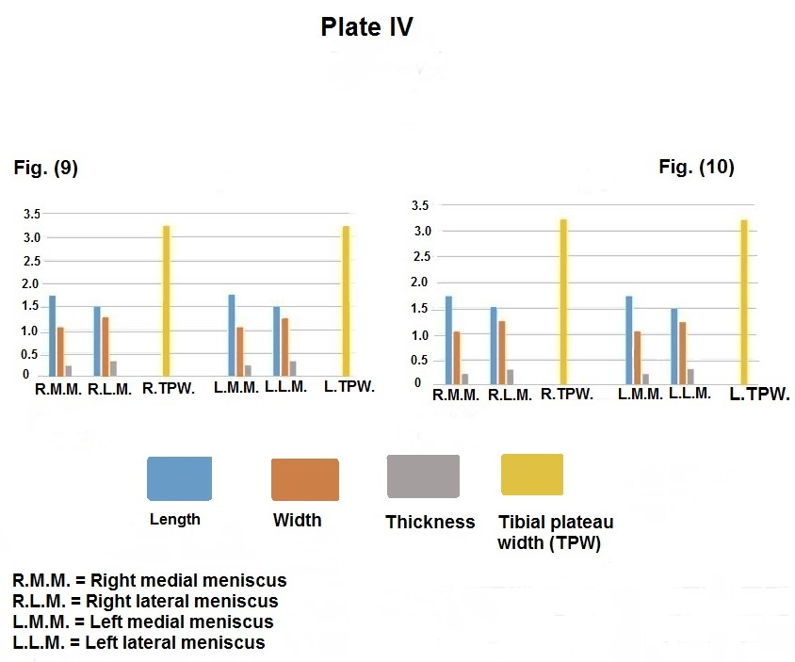
Plate IV
Fig. (9): A histogram showing the dimensions (cm) of the meniscal length (L), width (W), and thickness (Th) of the peripheral edge as well as the tibial plateau width (TPW) in the right and left adult dog femorotibial articulations using “Vernier′s caliper“
Fig. (10): A histogram showing the dimensions (cm) of the meniscal length (L), width (W), and thickness (Th) of the peripheral edge as well as the tibial plateau width (TPW) in the right and left adult dog femorotibial articulations using the “Image- J system“
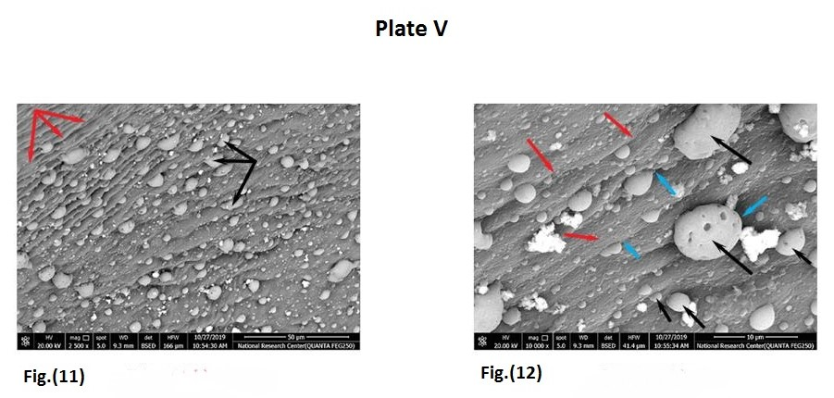

Plate V
Fig. (11): A magnification scanning electron micrograph of the surface of the femoral condylar articular cartilage in adult dogs showing its granular appearance
• Flattened chondrocytes (black arrows)
• Chondrocytes-free collagen fibers (red arrows) (X 2,500)

Fig. (12): A high magnification scanning electron micrograph of the surface of the femoral condylar articular cartilage surface in adult dogs showing:
• Prominences and undulations of the collagen fibers (red arrows)
• Deep grooves and depressions among the collagen fibers (blue arrows)
• Chondrocytes located in these grooves and depressions (black arrows)
(X 10,000)

