Mapping the Forces Driving Inbound Tourism Trends on the African Economy: A key focus of Senegal

Celine Nadji¹, Papa Elimane FAYE², Yin Ping³

^{1,3}Beijing Jiaotong University, Faculty of Management, Department of Tourism, China, 0000-0001-74994915, celinenadji88@gmail.com

²Iba der Thiam, university of Thies, UFR of Économic and Social Science, Department of Management of Organisation, Section of Tourism, papaelimane.faye@univ-thies.sn

Abstract: Senegal has a diversified culture, a favorable climate to tourism with 3000 hours of sunshine per year, more than 700 km of coastline and 530 km of beaches. Several parks and animal reserves classified as World Heritage by UNESCO, representative of African fauna, are a source of attraction for wild animal lovers in central and in eastern Senegal. That gives Senegal a comparative advantage over other sectors since the inbound tourist’s expenditure has a flow-through effect across the country’s economy in terms of productivity and job creation. In Senegal, tourism accounted for 7% of total GDP and 11% of exports in 2017 and nearly 105,000 direct jobs in 2018 (i.e. 2.5% of jobs in the country). Tourism appears therefore as the most promising sector in the country's economy after fishing. It recruits enormously and is expanding into other sectors such as the environment, culture, arts and crafts. Yet Senegal is still struggling to reach the 3 million inbound tourists predicted by government policies. Data show that the hotel sector is the main provider of tourism jobs in 2018. This study poses the problem of inbound tourism in Senegal through this following question: what are the forces driving inbound tourism in Senegal? The aim of the paper led us to map the international tourists who choose to stay in Senegal and to investigate the structure of their travel motivations. The method we used to perform this paper is the grounded theory method, documentary research including the exploitation of reports, and field surveys with a large part reserved for participant observation. The documentary research enabled us to review the main sources of knowledge on the subject. We also had access to a number of reports, including the strategic plan for promotion initiated by the Senegalese Agency for Tourism Promotion. The results of this research show three basic elements: Firstly, we can see the continuing Europeanisation of inbound tourists and the lack of promotion observed in some parts of the world. Secondly, the absence of Senegal in the major tourist-generating countries. Countries such as China, Japan, Germany and the United States send almost no tourists to Senegal. Endly, the results indicate a total absence of promotion of Senegalese tourism in some parts of the world that are being courted by all the tourist offices.
Keywords: Inbound tourism, Senegal, Tourism poles, Seaside, Tourist-generating countries

Introduction
The coronavirus crisis is proving to be incompatible with the imagination associated with travel and tourism because of its rate of spread (WHO, 2020a). It continues to be a daily ordeal since its appearance. No field of activity has been spared since its appearance, especially tourism (UNWTO, 2020b). In Senegal, the COVID-19 pandemic has disrupted and slowed down the efforts of public authorities to develop tourism (Diombera, 2021). In these conditions, as uncertain as the situation may seem, the pandemic has also offered opportunities to certain hotel structures. Senegalese inbound tourism has recovered after two years of disruption caused by the Covid 19 pandemic. As a result, the economic and financial report published in 2023 showed a growth rate of 3.2% in 2021, compared to a decline of 19.8% in 2020. For illustrative purposes, the report announced that 836,784 tourists were registered in 2021, compared to 454,450 tourists in 2020. It further informed that the growth of accommodation and food services figures is established at 6.2% , against 3.1% in 2021. Finally, he specified that all these elements sufficiently show the recovery that has been initiated in the sector after Covid-19.
Inbound tourism remains a leading foreign currency exchange earner on the African continent (UNWTO, 2014). This industry is key in contributing to Gross Domestic Product and job creation. Inbound tourism in Africa is still among the fundamental pillars. Scholastic studies reveal that before the end of 2020, African economies such as Senegal will have potential of developing into a central cultural and leisure site and a tourism destination with international appeal.
Lately, the number of inbound visitors to Senegal from the United States and Europe is on the rise, attracted by the historic slave trading post of Goree Island among other key tourist spots. Major cities such as the capital, Dakar; Saint-Louis, an old colonial town; and the Mouride holy centre of Touba, Goree Island, formerly a center of the slave trade in West Africa and a UNESCO World Heritage Site, draws many overseas travelers. A study by Crompton & Christie (2003) reveals that Senegal has experienced augmented growth in global tourist arrivals in the past two decades and this is largely credited to demand from the French market. French tourists, who constitute 50% of all tourists, increased at an annual rate of 7% during the 1996 to 2000 era compared to the decade rate of 2.7%. African visitors constitute 25% of Senegal’s arrivals, but appear to be mainly business visitors as they are concentrated in Dakar and have a short stay. There was a 10% growth in arrival figures of African travelers for the decade, which decelerated to 7.6% for the five years ending in 2000. Despite the predominant weaknesses by various tourism authorities combined with ever emerging threats, recent statistics reveal a stable growth rate of the overall tourism and travel sector.
Majority of inbound visitors from outside Africa are Europeans. The Senegalese hotel and resort industry revolves around enclosed beach resorts, most at resort towns like Saly on the Petite Cote south of Dakar have been developed to appeal to this clientele since the early 1980s. Senegal therefore remains one of those West African states with overwhelming potential of attracting foreign tourists not only from the neighboring African countries but also from big nations with strong outbound tourism potential such as France, China, Germany, United Kingdom, USA and China. This will enhance the country’s move towards achieving its sustainable tourism goals hence transforming Senegal into a middle income state. Similarly, Villalon (2011) stated that Senegal has for decades been considered a political success in Africa and efforts to diversify, develop and transform other key sectors like fishing, phosphate mining, and transport and communication have for long been ongoing. Each of these sectors has had some limited success, but also suffers from inherent limitations. A research done by (Celine, Ping and Sebata, 2018) highlighted that Senegal is recently further embarking strategic measures to attract more visitors from other top new markets, such as the United States, Australia, Japan, Singapore, Taiwan, Canada, Thailand and South Korea.
However much Senegal is endowed, the rate at which the inbound tourism sector is developing compared to several other African countries including Kenya, Tanzania, and Egypt is still not as fast as many tourism experts have always anticipated. This left out a huge gap about the actual internal and external forces influencing the inbound tourism. This induced the researcher into carrying out a comprehensive analysis of the inbound tourism in Senegal.

Fig 1: Travel and Tourism Competitiveness Report, 2015
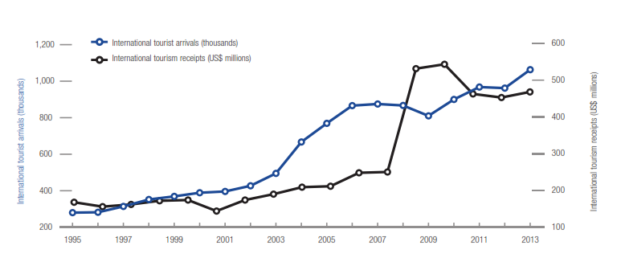
Source: WTTC (2015)
1. Literature Review
World over, tourism is a powerful vehicle for both economic growth and job creation. This sector is directly and indirectly for 8.8% of the world’s employment opportunities (258 million); 9.1% of the world’s Gross Domestic Product (US$6 trillion); 5.8% of the world’s exports (US$1.1 trillion); and 4.5% of the world’s investment (US$652 billion). (World Tourism and Travel Council [WTTC], 2011). The World Travel & Tourism Council estimates that 3.8 million jobs (including 2.4 million indirect jobs) could be generated from tourism in Sub Saharan Africa (SSA) over the following decades. (World Bank, 2013)
During the last decade of the 20th century, the Senegalese tourism sector experienced sustained growth: international arrivals rose from 246,000 in 1990 to 427,000 in 2002. With more than US$210 million in 2003 (compared to US$167 million in 1990), tourism has become the second largest provider of income after fishing; its revenues are now ahead of those of phosphates and groundnuts. The steady growth of this sector benefits mainly the Petite Côte area (Dehoorne and Diagne, 2008).
According to the (United Nations World Tourism Organization [UNWTO], 2014) the value for International tourism, the number of inbound tourism arrivals in Senegal was 1,006,600 as of 2015. As the graph below shows, over the past 20 years this indicator reached a maximum value of 1,063,000 in 2013 and a minimum value of 280,000 in 1995. This implies that Senegal is at present dedicated to attracting more visitors from overseas as pointed out by (Celine, Ping and Sebata, 2018) that the country is now shifting its focus to providing high-quality experiences especially in its hotel industry to pave way to the increasing number of tourism arrivals. In the same line, Sebata (2014) suggests that developing economies Senegal inclusive need to pay more attention to festival tourism which involves touristic elements like art, music, drama, dance, fashion, culture entertainment and other related creative and artistic display in their bid to improve their international inbound tourism figures.
Recent research states that international inbound tourists (overnight visitors) are the number of tourists who travel to a destination or country other than that in which they have their normal residence, but outside their normal environment, for a period not beyond one year and whose main motive in visiting is other than an activity remunerated from within the country visited. When data on the number of tourists are not obtainable, the number of visitors, which includes tourists, same-day visitors, cruise passengers, and crew members, is shown instead. Sources and collection methods for arrivals differ across countries. In some cases data are from border statistics (police, immigration, and the like) and supplemented by border surveys. In other cases data are from tourism accommodation establishments. In certain countries, the number of arrivals is limited to arrivals by air and for others to arrivals staying in hotels as stated in several studies. Some countries include arrivals of nationals residing abroad while others do not. Caution should thus be used in comparing arrivals across countries. By and large, the data on inbound tourists refer to the number of arrivals, not to the number of people traveling. Thus a person who makes several trips to a country during a given period is counted each time as a new arrival (UNWTO, 2014).
Senegal is known for its beach industry which is its main product. African visitor arrivals and family/friend visits are the mainstay of tourism demand in Senegal. So in simple words, the country mostly receives family-oriented tourists and visitors from Africa (MTTA 2018).
The 14 regions of Senegal each have their own cultural specificities, products and tourist sites. This diversity makes it possible to meet the expectations of all travelers looking for authenticity and unique experiences. It is also known from the literature that tourists mainly come from Europe and Africa.

- 1 Africa’s Inbound Tourism Trends
According to World Bank (2013), although the African continent Senegal inclusive was badly hit by the global crisis, the continent avoided an even worse growth shortfall in 2009, the inbound tourism figures were not significantly affected since prudent macroeconomic policies by governments and financial support from multilateral agencies, and rebounded in 2010. Economies such as Senegal have continued to pursue tourism as a dynamic development option. Africa’s private sector is gradually drawing investment from the United States and Europe yet even China, India and others also are investing heavily on the African continent. Private capital flows are higher than official development assistance and foreign direct investment is higher than in India. Returns to investment in Africa are among the highest in the world. These have helped countries like Senegal to develop major tourism infrastructures such as hotels, airports, major roads all of which are a backbone in attractive foreign visitors in any country. The public sector in most of the African economies has set the conditions for the exponential growth of information and communications technology (ICT), this could is helping tremendously in transforming Senegal and the continent at large. With incomes rising, the poverty rates of African countries dropped from 59% in 1995 to 50% in 2005 and is still dropping given the contribution of the tourism sector. Research findings by the World Bank conclude that Africa could be on the cusp of an economic takeoff, much like China was 30 years ago, and India was 20 years ago. This is partially due to the international inbound tourism subdivision.
- 2 Inbound Tourists Origin
Crompton & Christie (2003) research shows that nearly 75% of foreign tourists to Senegal are from Europe and 50% of all tourists and over 193,000, come from France. Africa supplies most of the remaining 25%, with USA and Canada accounting for 3%. In addition to a shared language, the French also share a relatively contemporary, mutual history and still maintain close ties with Senegal, which makes the country accustomed and an ideal destination. The impact of international French tourists is even more dramatic when bed nights are considered, for instance the French accounted for more than 60% of all annual bed nights in 2000, indicating the high dependence of Senegal on a single market for its tourism.
Given its assorted assets, good accessibility, proximity, Senegal has strong appeal for a wider range of supplier markets in Europe and beyond. German tourists dropped from 1999 to 2000 to just over 8,000 and Germany is the main tourist supplier market in the world. The United Kingdom (UK), which is among the largest source markets world over, provides less than 1% of Senegal’s tourists on average in a year. Usually, birding in Senegal attracts the United Kingdom’s active birding community that is used to traveling abroad, but many of the birds that exist in Senegal are also more easily observed in The Gambia’s smaller territory, which also happens to be English-speaking. Nevertheless, if Senegal is to expand its inbound tourism domain, there is an urgent need to draw tourists from fresh markets in Europe, Asia and South America, while at the same time continuing to promote itself deeper into the French market.
Further studies also reveal that African visitors to Senegal account for approximately 25% of all visitors, but only 15% of bed nights, indicating that they usually consider short stays. 96% of African tourists spend their leisure time in Dakar, with a small sum (1677 people) visiting St. Louis and only a slightly higher sum distributed around Senegal’s other popular tourism regions. This suggests that many of the African guests travel to Dakar mainly for business reasons, but also that this demand may perhaps upsurge as regional treaty arrangements draw neighbors nearer together. The city of Dakar provides good access to the Ile de Gorée, which is of utmost interest to African visitors, though statistics are not readily available to validate the number of inbound tourists who visit the island or whether Gorée is a prime impetus for travel to Dakar. Conferences and conventions provide openings to display other tourist attractions in Senegal and have huge potential of boosting the rate of return, with their family, of foreign delegates. Senegal could also explore offering various incentives which include but not limited to reduced prices for regional visitors at top hotels and other accommodation during the low and shoulder seasons. This may further hike the figure of inbound visitors from various fresh destinations.

- Methods
For this study, we opted for the grounded theory method, documentary research including the exploitation of reports, and field surveys with a large part reserved for participant observation. The documentary research enabled us to review the main sources of knowledge on the subject. We also had access to a number of reports, including the strategic plan for promotion initiated by the Senegalese Agency for Tourism Promotion. Thus, we have read articles, looked at statistics, conducted interviews and even watched documentaries on YouTube. It is important to add that statistical data is difficult to obtain due to the lack of data in the tourism sector. These are scarce, sporadic and use variable indicators which nevertheless allowed us to estimate the extent of the consequences on the tourism activity. Thus, one of the limitations of our study and the methods used lies in the lack of documentation. As for the observations made in the field, they enabled us to grasp the extent of the effects of tourism on the Senegalese economy, so we conducted surveys among professionals directly or indirectly involved in tourism. Field surveys in Dakar, Mbour (Saly), Tambacounda (Goudoury) and Casamance (Ziguinchor and Cap Skirring) enabled us to trace the links between tourism and other areas of the cluster (culture, art and crafts).

Analyses were carried out on the research question using a methodological approach combining qualitative and quantitative data. All these methods are used to trace the links between tourism and other sectors in the cluster (culture, arts and crafts). In this respect, it should be noted that the surveys helped us to identify statistical data on the economic flows closely linked to tourism and to understand the reasons for traveling, as well as the mapping of the tourist-generating countries and of the reasons for traveling.

- Results and findings

3. 1 Macroeconomic profile of Senegalese tourism
Senegal has a diversified culture, a suitable climate for tourism with 3000 hours of sunshine per year, more than 700 km of coastline and 530 km of beaches. Numerous parks and animal reserves classified as World Heritage by UNESCO, representative of the African fauna, are a delight for wild animal enthusiasts in the Sine Saloum and in Eastern Senegal.

3. 1. 1 Investors in Senegal's tourism sector

According to a report by W Hospitality Group, the number of hotel projects to the African continent has more than doubled since 2009, when "Africa was just beginning to become the focus of hotel chains." Thus from 30,000 rooms for only 144 hotels on the continent in 2009, the number of hotel projects in Africa has increased to about 73,000 rooms for 417 hotels in 2017.

East and Southern African destinations have long been the leaders in terms of investment and qualitative development of the offer, but over the past five years, West African countries have taken the lead in the battle between investors and other players in the sector. Nigeria, a regional power, is at the top of preferred destinations, with 60 hotels, just over 10,000 rooms. On the French-speaking side, Senegal and Côte d'Ivoire remain the main destinations of interest for the penetration of investors and hotel groups.

Who are investing in the tourism sector and where do they come from?
Our study shows a big presence of european people and particularly french people. They are in the hospitality industry and are mostly found on the Petite Côte, precisely in Mbour and Saly. We can notice the emergence of Spanish investment with the establishment of the Rui Baobab hotel. Hotel Riu Baobab'' is one of the 4 hotels of the international hotel chain Riu Hotels & Resorts, in Africa (Morocco, Senegal, Cape Verde and Tanzania with 15 hotels). It has a capacity of 522 rooms for an investment of 66 billion CFA francs and is built on 7.5 hectares. Today, the main international hotel brands are multiplying their announcements on the continent: In West Africa, Ivory Coast seems to be in the front line however, Senegal attracts large international hotel groups. In the wake of Accor, Riu Baobab and Radisson, it is next up for the American group Marriott International, which specializes in luxury hotels, to strengthen its offer in Africa, particularly in Senegal, with two new hotels in the pipeline. So far, the destination is struggling to accommodate the major hotel brands and this is the case with Marriott International, the world's leading hotel group, which is preparing to strengthen its offer in Senegal.
In line with the Youth Olympic Games (YOG) Dakar 2026, Senegal’ capital city is preparing to see the opening of a Sheraton (5 stars) with 250 rooms as well as an Aloft hotel (3 stars) with 150 rooms in Ngor, on the former site of Club Med of Dakar, in the district Almadies. Investors often come from Europe, the Maghreb and the Near and Middle East.

3. 2 Job offer in Senegal hospitality industry

Fig 2: Distribution of jobs by accommodation type
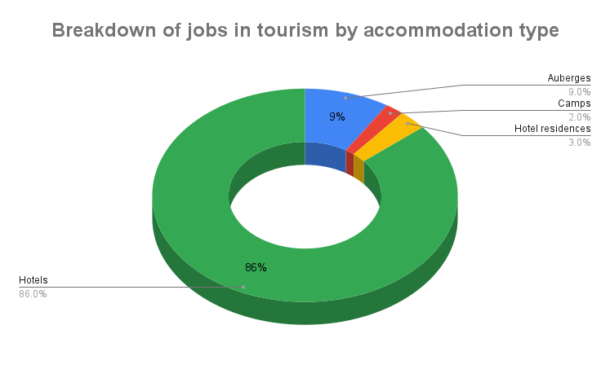
Source: (MTTA 2018)

Tourism is still seen as a sector with great potential for growth, job creation and poverty reduction (Diombéra, 2021). In Senegal, tourism accounted for 7% of total GDP and 11% of exports in 2017 and nearly 105,000 direct jobs in 2018 (i.e. 2.5% of jobs in the country). Recent growth in tourism to Senegal is effective and has been very significant in terms of revenue, because it generated 710 billion FCFA in 2018, i.e. +25% compared to 2016 but international arrivals are still lagging.
Tourism is therefore the most promising sector in the country's economy after fishing. It recruits enormously and is expanding into other sectors such as the environment, culture, arts and crafts. Yet Senegal is still struggling to reach the 3 million inbound tourists predicted by government policies. Data show that the hotel sector is the main provider of tourism jobs in 2018.
Although tourism creates many jobs, it should be noted that the largest number of workers is in the hotel sector. As we can notice in the above chart, the hotel sector is hiring 80% of people working in senegalese hospitality industry. It can therefore be seen through this chart that the Senegalese tourism sector has an extraordinary capacity for resilience; in fact, it stands out for its rapid growth and its ability to generate jobs.
The hotel and cafe, bar and restaurant sector, with 50,000 jobs, accounts for almost 90% of the workforce in the tourism industry in Saly, or 50% of the total number of workers in the country's tourism sector (MTTA, 2020). Basically, for the last ten years, the average growth in employment in tourism has been around 1,000 jobs per year, which makes this sector a strong provider of jobs (ANSD, 2020).
This means a real lack of workers in other tourism sectors such as travel agencies and airline companies. We can understand the difficulty to diversify tourism job distribution because Senegal owns only one airline company and not so many airports. The restaurants are hiring in some tourism stations such as Saly Dakar and Ndagane in the Île du Saloum but in small numbers because other restaurants in some cities are too small to hire a big number of people. We notice as well that beach activities, zoo activities and attractions are not developed enough to attract many workers so there are very few jobs in these areas.

3. 3 Presentation of the Senegalese tourism products

Fig 3: Map of senegal tourism poles
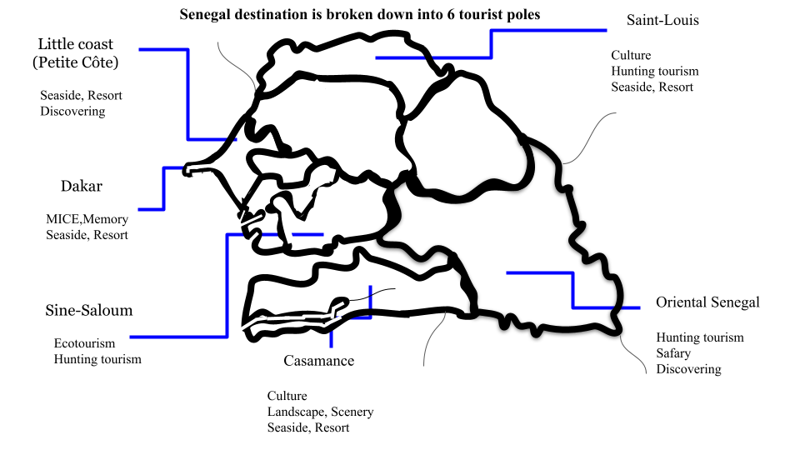
Source: authors assembling data, map design from authors, ASPT, 2022

According to the map above, we identify 6 poles as described in the map:
The tourist pole of the Petite Côte, which extends over 70 kilometers south-east of Dakar, covers the regions of Thiès and Diourbel. This area of seaside tourism and discovery contains natural and cultural sites, as well as the seaside resorts of Saly Portudal and Pointe Sarène and the future tourist resort of Mbodiène. The new Senegalese international airport AIBD is located in this area.
Located 120 km south of Dakar, the estuary of the Saloum and Sine rivers, north of the Gambia, forms one of the most formidable ecosystems on the planet: a maze of more than 200 islands covered with mangrove swamps, mangrove trees, baobabs trees, forming a network of innumerable bolongs where saltwater and freshwater meet. More than 200 species of birds totalling more than 120,000 individuals are counted annually in the Saloum Delta Park including the royal tern, which has one of the largest colonies on the planet.
Casamance has a long history and culture, this part of Senegal has a great potential for tourism.
The region of Saint-Louis can be considered as the capital of the North Tourist Pole. Saint-Louis is located at the mouth of the Senegal River, 264 km north of the Senegalese capital city, Dakar. The Northern Tourist Pole of Senegal covers the three regions of Saint-Louis, Louga and Matam.
Culturally, the city of Saint-Louis usually hosts many meetings such as the International Jazz Festival, the Regatta, the Fanal, etc. On the outskirts of Saint-Louis, the river delta area includes several natural sites (Djoudj National Bird Park, Langue de Barbarie National Park, Guembeul Special Wildlife Reserve), which are full of a wide variety of animal (especially bird) and plant species and provide a favorable setting for nature observation, hunting, hiking and river walks. All these natural sites are surrounded by an exceptional environment of ecosystems and water bodies crossed by the Senegal River. This river also offers important tourist opportunities such as river cruises, passing through stopover towns with heritage, cultural and environmental potential to be exploited (Ricard-Toll, Dagana, Podor, Matam). The Louga region has many sites with strong tourist potential along the coast of the Grande Côte. It is also in the region of Louga that one finds the magnificent and fascinating small desert of Lompoul which extends over some twenty kilometers to the sea, bathed in a landscape of dunes suitable for nights in bivouac.

3. 4 Most of tourists visiting Senegal are from Africa

Fig 4: Distribution tourists by region of origin
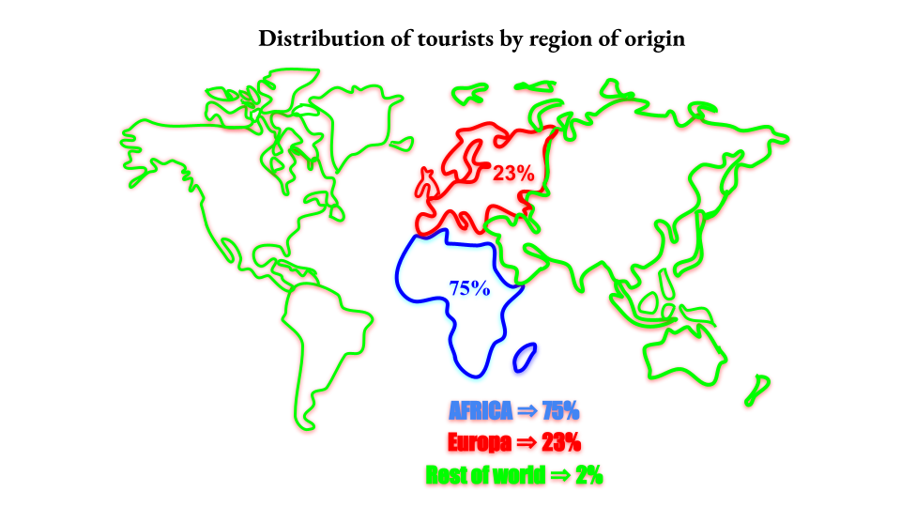
Source: authors assembling data, map design from authors, ASPT, 2022

The arrivals by air represent 65% of foreigners and 35% of Senegalese. Tourists arriving in Senegal are mostly from Africa. At least that is what surveys show, the African continent sends more than 75% of tourists, this is emphasized by the number of seminars, congresses and other activities. Among the Africans who travel to Senegal we can also count students who come for studies and a large number who come to work. On the other hand, tourists from Europe are the real leisure-based visitors, they are the ones who go to the regions and to the tourist attractions. These travelers usually stay 2 to 3 weeks and do not stay in hotels. Tourists from Europe come mainly from France. France is the main source market for Senegal in Europe. With the crisis in Ukraine, oil and freight prices have increased fivefold, which means that there are problems that can change people's consumption habits.
Are we witnessing a reinvention of the European presence in Senegal inbound tourists? Based on the old model of attracting foreign tourists, which only emphasized the seaside tourism, it is possible to notice that this unique way of attracting international tourists seems to have had its day, as we can see other European presences at the local level.
At first, Saly, the main seaside resort, like many destinations in developing countries, used to receive and continue to receive retired French people who came to spend the "warm winter". For single retirees, these long stays are sometimes associated with the desire to live as a couple in Senegal, preferably with a younger partner. These steps are quite frequent and fully assumed despite the disapproving gaze of local populations, who sometimes see it as an immoral practice considering the great differences in age and resources.

3. 5 Absence or lack of presence in the major outbound tourists countries

Fig 5. Map of the tourist-generating countries

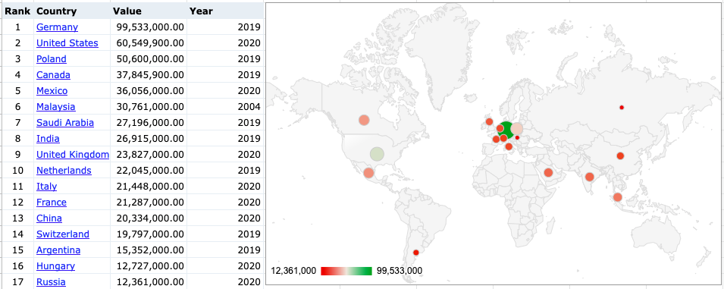
Source: authors assembling data, map design from authors

This Table and map show a non presence of Senegal in some major tourist-generating countries. 98% of International tourists visiting Senegal are coming from Africa and Europe. and most of those coming from Europe are from France. In the table above, Germany, the United States, Poland, and Canada are sending many tourists around the world. And before covid some asian countries as China, Japan and South korea also send many tourists, however, few of those tourists are coming to Senegal.

3. 6 What are the forces driving inbound tourism in Senegal

Fig. 6: Main motive that arise the travel experience is family reasons

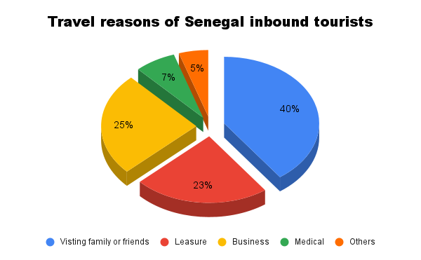
Source: ASPT, 2022

Senegal has 5 main tourism segments: seaside tourism, by far the most developed with a strong seasonality (majority of stays during the November-February period) and a strong concentration on the small coast; eco-tourism and cultural tourism, which are weak and whose potential needs to be developed; business tourism, which is booming (11% average annual growth between 2006 and 2013).
However, despite being the major destination (the first in West Africa), Senegal is experiencing relatively weak growth in its tourism, compared to that of the other main African destinations (Morocco, Kenya, Tunisia, etc.). Destination Senegal has certainly made progress in its performance. Performances which remain however timid.
Business tourism and MICE are the second trip motivation for tourists visiting Senegal but the stay is still short. People coming for meetings or congress or other business are staying about 5 days and spend 53041 FCFA per day or 265 205 FCFA per stay.
This result shows that the majority of Senegal inbound tourists are Senegalese themselves who return to the country after a stay abroad. These people are either students who have gone abroad to study or economic migrants commonly known as Modou Modou in Senegal. Their particularity is that they are mostly in Europe and only come to Senegal for the clear reason of family visits. They therefore do not stay in hotels and do not frequent tourist restaurants. We also note in this chart that 7% of tourists come for medical reasons, and these tourists generally come from the sub-region (Cape Verde, Gambia, Mali, Guinea and Mauritania).

3. 7 A hospitality industry from abroad

Table 1: Distribution of hotels by owner's country of origin

Hotels | owner’s origin
Filaos | France
Palm Beach | Senegal
Savana Koumba | France
Savana Saly | Turkey
Teranga | France
Saly Hotel | France
Neptune | No data
Bougainvillées | France-Senegal
Royan | France
Espadon | France
Source: authors assembling data

In Senegal, tourism investment has so far been under the control of foreigners. Despite hotel credit (offered by the government), Senegalese are struggling to invest in the industry. Therefore, we can say that the scale of investments required by international tourism now constitutes the main reason for the exclusion of national investors. These foreign capitals seize our tourism to the tune of several billions. Other constraining and/or limiting factors are the heaviness of taxation on products intended for tourism, the high cost of technical factors of production (water, electricity, telephone, labor, etc.) which very often exceed 15% of the turnover for nationals while foreigners benefit from an exemption. Added to this are the difficulties of access to credit due to non competitive interest rates, the difficulties of financing the required personal contribution (equity), etc. Only the bank loan can help investors, but the too high repayment rate often deters nationals.
France appears as the main tourism investor in Senegal, we can identify other countries as Lebanon, Belgium and Luxembourg. People from those countries are among owners of some tourism businesses such as travel agencies, restaurants and hotels.

- Discussion

The problem of this study is mainly focused on the issue of international tourism in Senegal. In other words, the main objective of this paper was to map the international tourists who choose to stay in Senegal and to investigate the structure of their travel motivations. The results are significant in that we can accurately identify the countries of origin of foreign tourists visiting Senegal, despite the outbreak of the coronavirus disease.

Senegalese tourism has recovered after two years of disruption caused by the Covid 19 pandemic. As a result, the economic and financial report published in 2023 showed a growth rate of 3.2% in 2021, compared to a decline of 19.8% in 2020.
According to the 2023 social and economic report, it has, in this respect, returned to the previous situation by taking as a reference the year 2012, when Senegal had recorded 980,000 tourists. With the ten-year strategy of the Pse, covering the period 2014-2023, the Minister revealed that this number had been raised to 1,600,000 tourist entries in 2019.
The results of this research show three basic elements:
Firstly, we can see the continuing Europeanisation of inbound tourists and the lack of promotion observed in some parts of the world. At the same time, we note that the overwhelming majority of tourists coming from Europe are French people. This poses the problem of diversifying the target in the promotion of Senegal as a destination.
This could also be explained by tourist investment in Senegal, as our results show that investors in hotels, tourist restaurants and even in some attractions come from Europe and mostly from France. Thus, Senegalese tourism is fundamentally linked to the French-speaking country of Europe and therefore the country has difficulty to break away from its dependence on its French-speaking tradition.
What the results reveal which seems more convincing in this study is the absence of Senegal in the major tourist-generating countries. Countries such as China, Japan, Germany and the United States send almost no tourists to Senegal. The results indicate a total absence of promotion of Senegalese tourism in some parts of the world that are being courted by all the tourist offices.
After finding a lack of promotion of Senegal's destination in the major sending countries such as those in Asia and North America, it is difficult to access information on the specific reasons why Senegalese tourism may not be promoted in some major tourist-generating countries, however, we have some possible explanations from our investigations.

One reason could be a lack of funding and resources to promote Senegalese tourism in the major outbound tourism countries. Tourism promotion campaigns can be costly and often require large budgets to reach a global audience. If financial resources are limited, it may be difficult to effectively promote Senegalese tourism in major sending countries.
In this light, we notice the small budget of the organization that should promote inbound tourism from all over the world. Actually, 2,976,898 FCFA are the financial resources dedicated to the Agence Sénégalaise de Promotion Touristique, compared to Morocco which spends 44,269,699,981 FCFA on the promotion of its inbound tourism (Strategic plan, 2022)

Another reason could be a lack of media visibility or effective public relations to promote Senegal as a tourist destination. Large sending countries have very competitive tourism markets, and Senegal may find it difficult to stand out among other popular tourist destinations due to a lack of visibility and publicity. Visiting some countries' travel agencies and tour operators like Japan, Canada, China, Australia and the United States, we find out a serious lack of communication materials that could sell Senegal as a destination. At a time when we can see posters, pamphlets and leaflets selling other African countries, Senegal did not appear on any media support.

Finally, factors such as political stability, security, tourism infrastructure and quality services can also play an important role in promoting tourism. If these factors are not perceived as sufficiently satisfactory by potential travelers, this may also affect the promotion and attractiveness of Senegalese tourism in major tourist-generating countries.

This brings us back to the attachment of Senegal as a destination to the circle of the French-speaking world, but these results also enable to establish some correlations between the profiles of travelers, the reasons for travel and the countries of origin or even the nationalities of the visitors.
Actually, Senegalese from abroad are very present among the inbound tourists, at least that is what the results reveal. It is clear that these Senegalese are mostly established in Europe and Africa. Another correlation is that most of the investors are European and French in majority, so it goes without saying that their promotion can only be done in Europe. In this respect, we can observe two elements of analysis: one is related to the promotion done by investors as we can see nowadays with the Riu Baobab hotel oriented directly towards Europe. The other element of analysis is the lack of promotion policy by public decision-makers.
We also noticed in the results the lack of diversity in the tourist offer and this has an impact on the motivations of travel because the visits of family and friends hold an important place in the forces that lead to the choice of Senegal as a holiday destination.
Conclusion
At a period when the West African region is establishing solid foundations, there is an ever-growing need for economic diversification, and when international tourism continues to expand globally including in Africa, the region could seek to become relevant inside global tourist networks. Things are already changing. In 2014, West Africa was the second-largest proportion in the hotel chain development pipeline in Africa, with more than 13,500 new rooms planned (34.1% of the African total). Senegal has already shown its ambition by setting the goal of attracting 3 million tourists by 2025, and so has other West African countries such as Ghana, which recently adopted a comprehensive tourism development plan for 2013 to 2027 despite the factor that threatening factors such as increasing global temperatures and competition for international visitors with other African countries such as Nigeria, Egypt, Cameroon, Kenya are still at large

There are numerous factors that can drive a country’s inbound tourism, these range from rich and beautiful scenic tourism spots, cultural fascinations, strategic geographical location, good hospitality and potential to host of major international sporting events among others. Just like it has been done in majority of the developed countries, Senegal should embark on deliberate policies aimed at investing in the development of modern transport systems especially airports, express highway that connect to major tourism destinations and cities such as Dakar, Thiès, Saint Louis, Touba, Mbour, Richard Toll and Ziguinchor. This can improve connectivity of international tourists especially from Europe, North America and Asia. Similarly, key policy makers and tourism stakeholders in Senegal should capitalize on factors such as service quality improvement, tourism destination marketing and modern tourism infrastructure development so as to develop destination Senegal into the most Attractive place for international visitors hence ultimately reducing on the level of direct competition for international travelers with are top tourism African countries such as Egypt, Kenya, Zambia and Uganda.
The mapping of incoming tourism thus reveals a massive presence of tourists coming mainly from Africa and Europe, among whom we count a large number of Senegalese who return to the country. In addition, there is a lack of Senegalese tourism promotion in the major tourist-generating countries.

References

Crompton, D. E., & Christie, I. T. (2003). Senegal tourism sector study (Africa Region Working PaperNo. 46). (pp. 1–8). Senegal: World Bank. Retrieved on September 27, 2020 from https://knoema.com/atlas/Senegal/topics/Tourism/Inbound-Tourism-Indicators/Inbound tourism-travel.
Diombera, M.. (2014) Tourisme et développement local : vers une redéfinition des relations au niveau de la Petite-Côte sénégalaise ?. Études caribéennes. DOI: 10.4000/etudescaribeennes.6736
Diombera, M. (2017) Le développement touristique et l’occupation des espaces littoraux : quelles enjeux pour les territoires de la Petite Côte sénégalaise ?. Études caribéennes. DOI: 10.4000/etudescaribeennes.10778
Eugène I. B. (2020) Exploitation touristique des ressources naturelles et développement durable. Cas du site touristique des Cascades de Karfiguéla au Burkina Faso. Études caribéennes. DOI: 10.4000/etudescaribeennes.19441
Nadji, C., Ping,Y & Sebata E. (2018): Chinese Tourists’ Perceptions of Service Quality in West African Hotels: A Case Study of Senegal, Journal of China Tourism Research (pp.3-9), doi:10.1080/19388160.2018.1430644
Ndonzo Z. A. (2020). « L’analyse de l’évolution de la pandémie du COVID-19 au Sénégal ».
Olivier D, and Abdou K. D., « Tourisme, développement et enjeux politiques : l’exemple de la Petite Côte (Sénégal) », Études caribéennes [En ligne], 9-10 | Avril-Août 2008, mis en ligne le 15 août 2008, Retrieved on 27 mars 2023. URL : http://journals.openedition.org/etudescaribeennes/1172 ; DOI : https://doi.org/10.4000/etudescaribeennes.1172
Sebata E (2016) To Rise or not: Prospective Africa’s Outbound Tourism Business Trajectory and Mega Sports Events: A Case of Qatar 2022 World Cup. Arabian J Bus Manag Review 6: 196. doi:10.4172/2223-5833.1000196
Sebata, E., (2014) The Kampala City Festival and its Impact on the Development of Tourism in Uganda. Journal of Tourism Research and Hospitality 4:1. doi: 10.4172/23248807.1000146
Uberti, S. (2014) Victims of their Fantasies or Heroes for a Day?. Cahiers d'études africaines. DOI: 10.4000/etudesafricaines.17599
UNWTO. (2014). Tourism highlights (pp. 5–35). Madrid: Author. Tetrieved on August 18, 2020 from https://www.unwto.org/archive/global/press-release/2014-12-18/international-tourism-track-end-2014-record-numbers
UNESCO (2020). La réponse de l’UNESCO à la pandémie COVID-19 en Afrique subsaharienne, Rapport, Mai, 15 p.
Villalon L,A., (2011). Senegal; Assessing Risks to Stability: Center for Strategic and International Studies, CSIS: Retrieved on September 12, 2020, from https://csis-website-prod.s3.amazonaws.com/s3fs-public/legacy_files/files/publication/110623_Villalon_Senegal_Web.pdf
World Travel & Tourism Council (WTTC) (2011). Travel & tourism: Economic impact 2015 (pp. 1–10).Senegal: World Travel and Tourism Council. Retrieved on July, 25, 2020 from https://wttc.org/
World Travel & Tourism Council (WTTC) (2015). Travel & tourism: Economic impact 2015 (pp. 1–10).Senegal: World Travel and Tourism Council. Retrieved on July 25, 2020 from https://wttc.org/
World Bank (2013). Tourism in Africa; Harnessing Tourism for Growth and Improve Livelihoods. World Bank 1 Retrieved on August 31, 2020 from http://hdl.handle.net/10986/18688
World Bank. AFTFP (Africa Finance and Private Sector Development). 2011. “Africa Tourism Strategy: Transformation through Tourism”, Unpublished Draft Report, World Bank, Washington,DC. Retrieved on August 1, 2020 from http://documents1.worldbank.org/curated/en/723511468102894381/pdf/814680WP0P13260Box0379837B00PUBLIC0.pdf
Web
https://www.inextenso-tch.com/actualites/investissement-et-expansion-de-lhotellerie-de-chaine-en-afrique-subsaharienne-contre-vents-et-marees/ Retrieved on 4 March 2023

https://www.inextenso-tch.com/actualites/investissement-et-expansion-de-lhotellerie-de-chaine-en-afrique-subsaharienne-contre-vents-et-marees/ Accessed 4 March 2023
MTTA (Ministère du Tourism et des Transports Aériens), Tourism and Air Transport Ministry
MTTA (Ministère du Tourism et des Transports Aériens), Tourism and Air Transport Ministry
Agence Sénégalaise de Promotion Touristique (Senegal promotion tourism agency)
Word of Mandingo origin, describing a stream, moving water, tributary or arm of the sea lined with mangroves

