ABSTRACT
Ameloblastic fibro-odontoma (AFO) is considered as a benign, epithelial odontogenic tumour with odontogenic mesenchyme having the histologic characteristics of both ameloblastic fibroma and complex odontoma. This study presents a case of AFO in a 15-year-old male patient with a swelling on the left side of the mandible which mimics ameloblastic fibroma on incisional biopsy but comes out to be ameloblastic fibro odontoma on excisional biopsy due to presence of tooth like structures inside the lesion.
Keyword – Ameloblastic fibro odontoma, enucleation, excision, benign, AFO
Abbreviations- AFO (Ameloblastic Fibro Odontoma), CBCT (Cone Beam Computed Tomography), WHO (World Health Organization)

INTRODUCTION
Ameloblastic fibro-odontoma (AFO) is a benign, slow growing, expansile un-common, rare epithelial odontogenic tumour with odontogenic mesenchyme.¹ It may inhibit tooth eruption or displace involved teeth although teeth in the affected area remain vital. Radiography shows a well-defined, radiolucent area containing various amounts of radiopaque material of irregular size and form.² The lesions are usually diagnosed during the first and second decades of life. It occurs with equal frequency in the posterior maxilla and posterior mandible and with equal frequency in males and females.³
Microscopically, the lesion is composed of strands, cords, and islands of odontogenic epithelium embedded in a cell-rich primitive ectomesenchyme, resembling the dental papilla.⁴ Many authors reported that AFO is not aggressive and can be treated adequately through a surgical curettage to the lesion without removal of the adjacent teeth.⁵ This paper describes an extensive AFO in a 15-year-old male.

CASE REPORT
A male patient aged 15 years reported to us with a chief complaint of missing molar teeth on the left lower back region with fluid discharge from the same side for 1 month. (Fig.1)
On examination, mild diffuse swelling was seen on the left angle region measuring 3 cm × 2 cm extra orally. Intraorally on examination 37, 38 were clinically not seen. The gums over the molar area were inflamed and swollen, showing indentations of the upper molar teeth. Serous discharge from a small opening distal to 36 was also seen. Orthopantomogram (Fig 4) showed a huge radiolucent lesion involving the body of the mandible from distal to 36 to the ramus of the mandible. CBCT (Fig 2, Fig 3) revealed a grossly destructed mandible the lesion extending superior-inferiorly and buccolingually involving the body and the ramus of the mandible. Initially, incisional biopsy was done under local anaesthesia and sent to histopathological examination which was suggestive of ameloblastic fibroma (Fig 8). Considering the age and the benign nature of the lesion, it was planned to surgically enucleate and curette the lesion under general anaesthesia (Fig 5). All the unerupted molar teeth were removed along with the lesion and sent for histopathological examination (Fig 6).

PROFILE
Fig 1 : Profile

INVESTIGATIONS
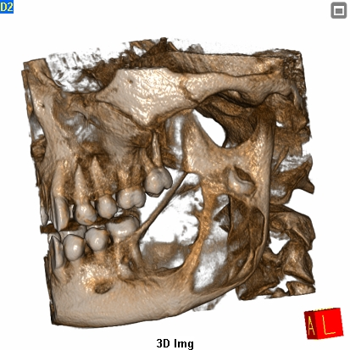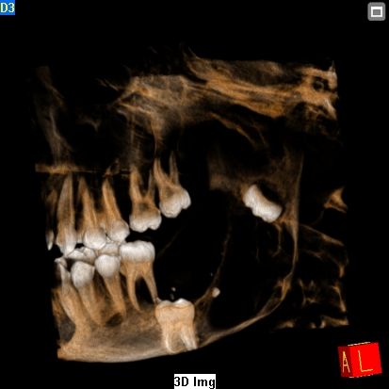
Fig 2 : CBCT 3D view Fig 3 : Contrast view
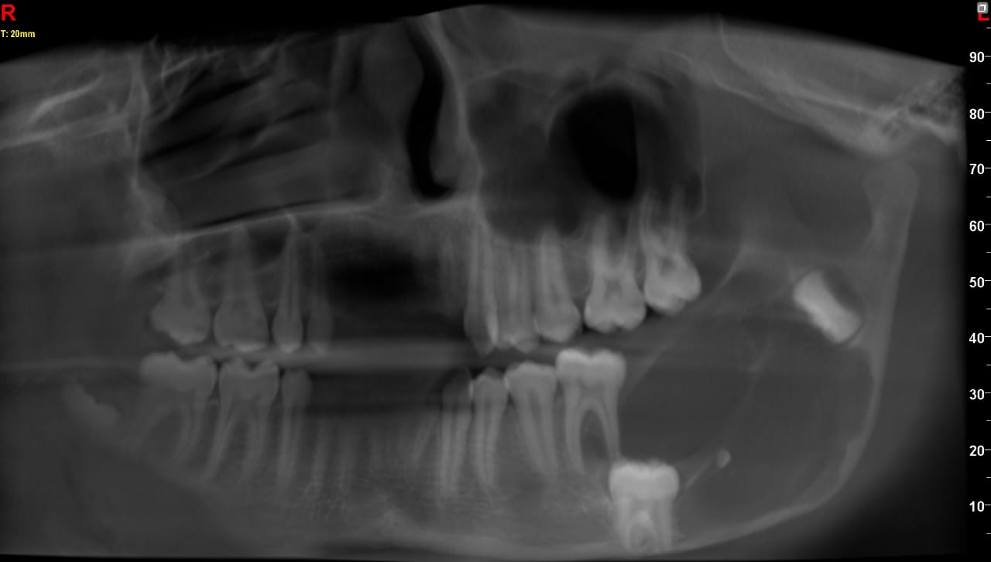
Fig 4 : Pre-op OPG

INTRA OPERATIVE
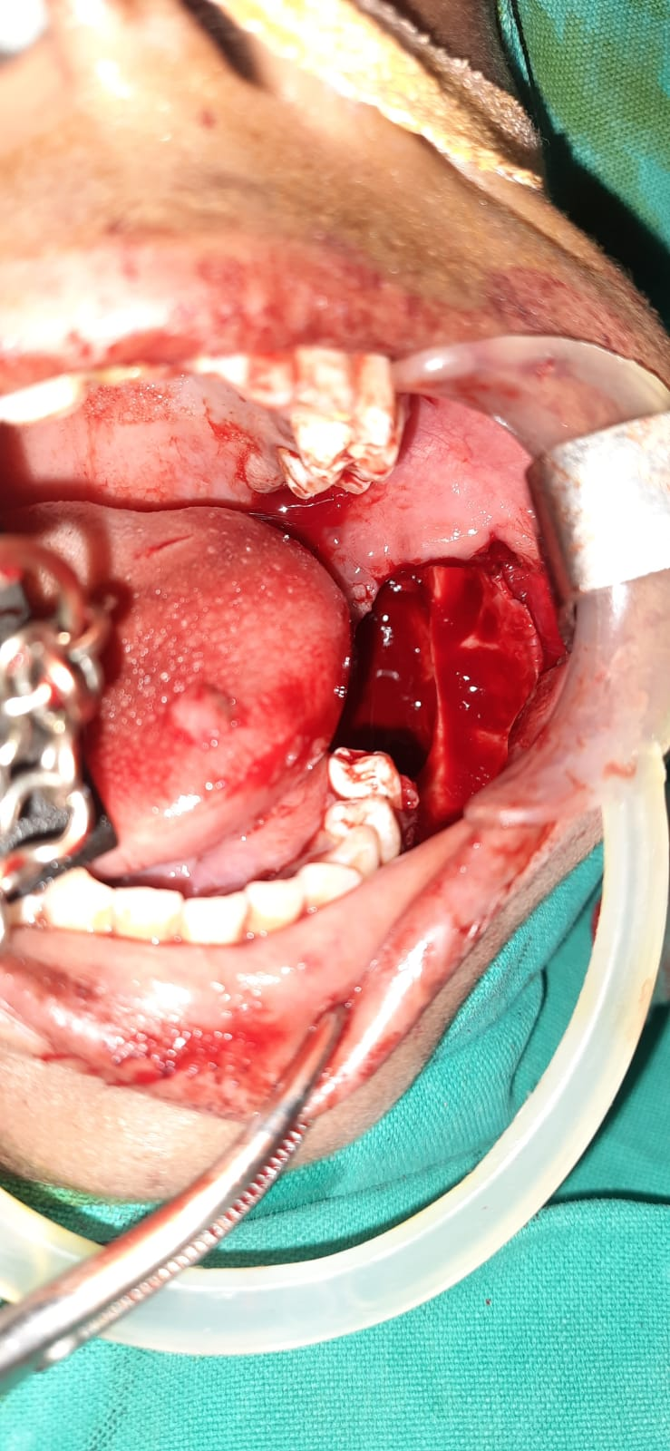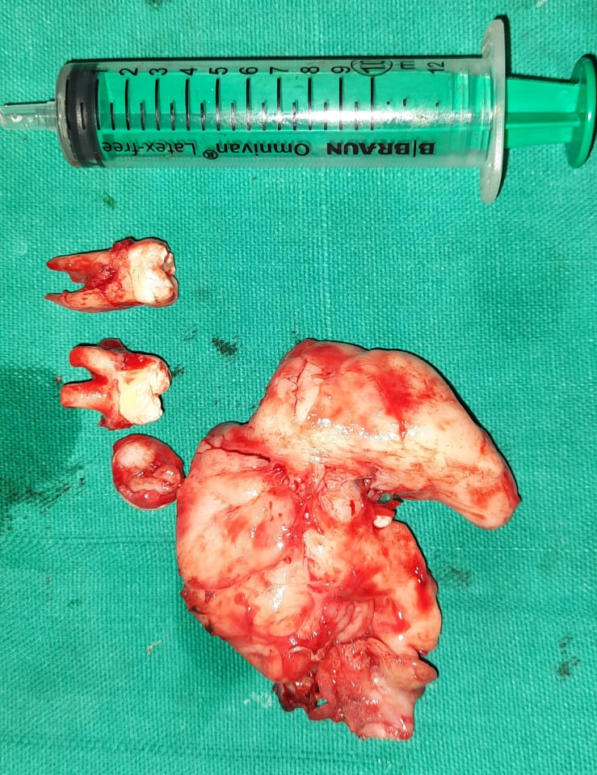
Fig 5 : Intraoperative Fig 6 : Resected specimen along with teeth
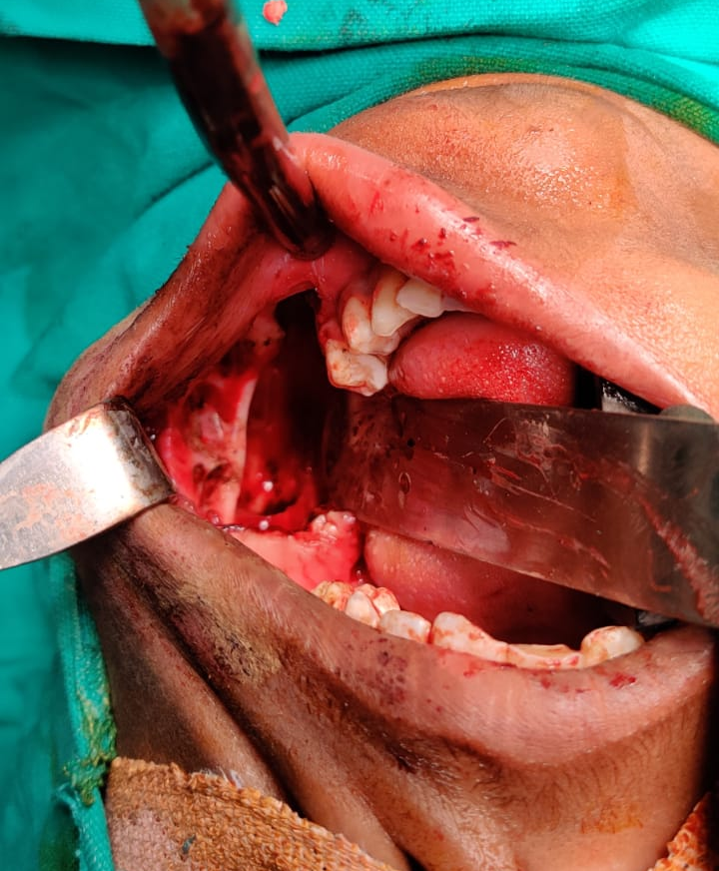Fig 7: Before closure

HISTOPATHOLOGY
The haematoxylin and eosin section showed highly cellular connective tissue stroma comprising odontogenic epithelium arranged in the form of strands, chords and follicles of varying size and shape. The strands are lined by cuboidal-to-columnar ameloblast-like cells with minimal central stellate reticulum-like cells. The odontogenic follicles of varying size and shapes are lined by tall columnar ameloblast-like cells with palisading hyperchromatic nuclei and central stellate reticulum-like cells. Cystic degeneration is noticed within the odontogenic follicles in few areas. Osteo-dentin induction is evident; juxta-epithelial hyalinization is evident surrounding few follicles.
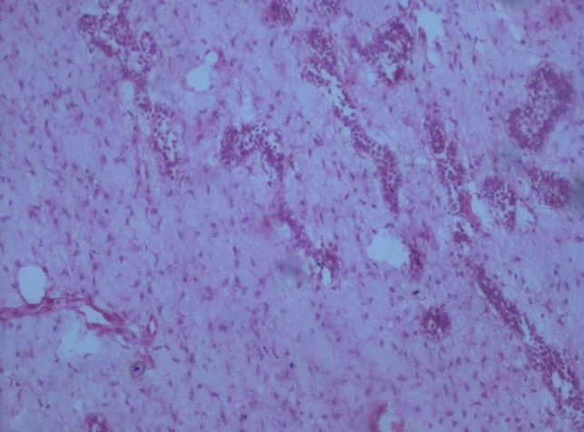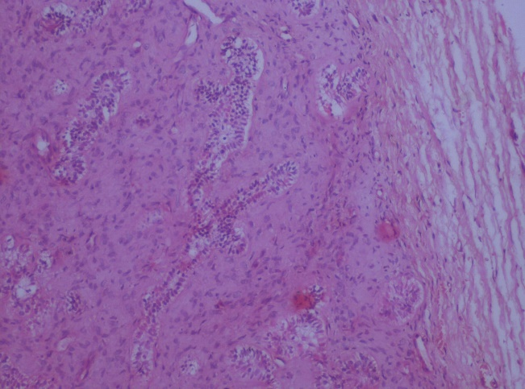
Fig 8.1: Histopathological specimen Fig 8.2 Excisional Biopsy
DISCUSSION
The histogenesis of this lesion since ages is controversial. AFO is a benign tumour that exhibits the same benign biologic behaviour same as of ameloblastic fibroma, showing inductive changes that lead to the formation of both the dentin and enamel.⁶ This is in contrast to the ameloblastoma. Conversely, the term “odonto-ameloblastoma” (or “ameloblastic odontoma”) refers to tumours representing a histological combination of ameloblastoma and complex odontoma, which behave in the invasive manner as that of classic ameloblastoma.⁷
According to the revised World Health Organization (WHO) classification, ameloblastic fibroma and AFO are believed to be stages of complex odontoma formation.¹ This means that the aforementioned lesions should not be considered as distinct entities.⁷ Cahn and Blum postulated that ameloblastic fibroma (the histologically least differentiated tumour) develops first into a moderately differentiated form, following AFO and eventually into a complex odontoma. However, the concept that these lesions represent a continuum of differentiation is not widely accepted, with other researchers suggesting that they are separate pathologic entities. In some studies, the term AFO represents a histological combination of ameloblastic fibroma and complex odontoma.⁸ The majority now agrees that AFO exists as a distinct entity, but it can be histologically indistinguishable from immature complex odontoma. The arrangement of the soft tissues and the development stage of the involved tooth are useful criteria for diagnosis.⁹ Despite numerous efforts, however, there is still considerable confusion concerning the nature of these lesions.¹⁰
AFO is relatively rare, with the prevalence among oral biopsies being about 1% and its frequency among odontogenic tumours being reported at 1% to 3%.⁷ This lesion usually occurs in people less than 20 years old, and age is thus an important characteristic in the differential diagnosis. This lesion is usually found in the molar area, and the distribution is roughly equal between the maxilla and mandible.⁶
Many authors reported that AFO can be treated adequately through a surgical curettage without removal of the adjacent teeth.⁵ As noted in the literature, not all lesions previously classified as AFO are, in fact, aggressive lesions. If there is a recurrence accompanied by a change of the histological pattern toward a more unorganized fibrous stroma with displacement of the epithelial component, then more extensive treatment procedures appear to be indicated.¹⁰ Determination of a case-dependent treatment plan may provide an optimum outcome. Long-term follow up with short intervals should be maintained in the management of AFO.

CONCLUSION
The case presented here is typical of its features in occurrence, signs and symptoms and radiological features. It was treated conservatively by enucleation and thorough curettage, keeping in mind the age of the patient. Whatever may be the form of treatment, concerns regarding its recurrence and its malignant transformation have to be kept in mind and require a long-term follow-up.

REFERENCES
- Abdulla AM, Sivadas G, Surej Kumar LK, Sheejith Hari Peeceeyen CS, Vedam V. Ameloblastic Fibroodontoma: Uncommon Case Presentation in a 6-Year-Old Child with Review of the Literature. Case Rep Med. 2017;2017:9483738. doi:10.1155/2017/9483738
- Singh AK, Kar IB, Mishra N, Sharma P. Ameloblastic fibroodontoma or complex odontoma: Two faces of the same coin. Natl J Maxillofac Surg. 2016;7(1):92-95. doi:10.4103/0975-5950.196129
- Atarbashi Moghadam S, Mokhtari S. Peripheral Developing Odontoma or Peripheral Ameloblastic Fibroodontoma: A Rare Challenging Case. Case Rep Dent. 2016;2016:9379017. doi:10.1155/2016/9379017
- Manor E, Kan E, Bodner L. Ameloblastic fibroodontoma of the mandible with normal karyotype in a pediatric patient. Case Rep Dent. 2012;2012:969687. doi:10.1155/2012/969687
- Martin-Duverneuil N, Roisin-Chausson MH, Behin A, Favre-Dauvergne E, Chiras J. Combined benign odontogenic tumors: CT and MR findings and histomorphologic evaluation. AJNR Am J Neuroradiol. 2001;22(5):867-872.
- Aslıer M, Ecevit MC, Sarıoğlu S, Sütay S. A Case of Ameloblastic Fibroodontoma Extending Maxillary Sinus with Erupted Tooth: Is Transcanine Approach with Alveolectomy Feasible?. Case Rep Otolaryngol. 2016;2016:8594074. doi:10.1155/2016/8594074
- Nandini DB, Reddy PB, Singh WR, Singh KS. Ameloblastic fibro-odontoma or complex odontoma masquerading as gingival enlargement. J Indian Soc Periodontol. 2021;25(5):438-442. doi:10.4103/jisp.jisp_778_20
- Mishra D, Kaur H, Bhalla AS, et al. Ameloblastic Fibroodontoma of Mandible Causing Tumor Induced Osteomalacia: A Case Report with Review of 88 Phosphaturic Oral Neoplasms. Head Neck Pathol. 2021;15(3):975-988. doi:10.1007/s12105-020-01267-4
- Surej Kumar LK, Manuel S, Khalam SA, Venugopal K, Sivakumar TT, Issac J. Ameloblastic fibro-odontoma. Int J Surg Case Rep. 2014;5(12):1142-1144. doi:10.1016/j.ijscr.2014.11.025
- Khurana AS, Munjal M, Narad M. Ameloblastic fibro-odontoma of the maxilla. Indian J Otolaryngol Head Neck Surg. 2002;54(2):149-150. doi:10.1007/BF02968738

