Type 1 CPAM as persistent respiratory distress and failure to thrive in neonates: a Case report
Belekar Neelamª, Phirke Deepa^{b}
ªAssistant professor,Department of Pediatrics, Rajarshee Chhatrapati Shahu Maharaj Government Medical college, Kolhapur, Kolhapur, India.
^{b}Associate professor, Department of Pediatrics, Rajarshee Chhatrapati Shahu Maharaj Government Medical college, Kolhapur, Kolhapur, India.
Correspondance:
Dr. Phirke Deepa, 246/E, Onkar, Venktesh Residency, behind Kelavkar Hospital, Nagala park, karvir, kolhapur, Maharshtra, 416003
Maharashtra, India.
E-mail:
Number of figures:5
Word count:1600
Keywords: Type 1 Congenital Pulmonary Airway Malformation, Failure to thrive, Respiratory distress, Lobectomy
Established facts
- Type 1 CPAM is a rare congenital anomaly of lungs, which presents with persistent respiratory distress

Novel insights
- CPAM Type 1 can present as bilateral lung lesion with failure to thrive

ABSTRACT
Congenital pulmonary airway malformation (CPAM), also known as congenital cystic adenomatoid malformation (CCAM) although rare congenital birth defect but is the most common type of lung abnormality, that includes a dysplastic mass of abnormal lung tissue, consisting of cysts lined by bronchial or cuboidal epithelium, with intervening normal lung tissue. In CPAM an entire lobe of lung is replaced by a non working cystic lesion. It develops as a result of cessation of lung development during various stages of embryogenesis. Originating from different part of bronchial tree. We present a case of the full-term baby presenting as birth asphyxia, having persistent respiratory distress since birth with not gaining weight diagnosed to have type 1 CPAM in postnatal life successfully managed with left lower lobe lobectomy with post-operative resolution of respiratory distress and successful weight gain. They were multicystic lesions with maximum size of 2.5×1.7cm. histologically showing cysts lined by columnar epithelium surrounded by foetal alveoli and areas of fibrosis and inflammatory infiltrate

Case report
A 24 days old female neonate 2.2kg referred from private hospital, with persistent respiratory distress since birth. The baby was born to 27 years mother in a registered pregnancy, 3rd Gravida, 2 Living issues, growing well. No history of any medical or pregnancy induced illness. Antenatal Ultrasonography did not show any abnormality. This baby was delivered by lower segment caesarean section (LSCS) at a peripheral health center, indication being previous 2 LSCS, with birth weight of 3.2kilograms. this baby suffered perinatal asphyxia immediately after birth, required bag and mask ventilation for 30 secs. This baby was admitted to Neonatal intensive care unit (NICU). Since then baby had persistent respiratory distress requiring oxygen supplementation. Chest Xray’s were done, which showed mediastinal shift to right side with cystic lesions in bilateral lung fields. [Fig 1]. This baby was treated as pneumonia with antibiotics for a prolonged course of 10 days along with Continuous positive airway pressure (CPAP). Chest Xray done on day 7 of antibiotics showed similar picture [Fig 2]. Hence antibiotics were continued for next 4 days. During this course this neonate continued to have persistent respiratory distress with higher oxygen requirements. Baby had a persistent respiratory distress, to Due to non-resolution of symptoms, baby was referred on day 25 to our center for further workup. On admission, along with septic screen, Cartridge based Nucleic acid amplification test (CBNAAT) of gastric lavage, 2-D ECHO was planned in view of mixed Xray chest findings of miliary shadow and cystic shadows. Septic screen, was documented negative, CBNAAT was negative for Mycobacterium Tuberculosis (MTB) and 2-D ECHO showed no abnormality. Xray chest done persistent cystic changes, hence High-Resolution Chest tomography (HRCT) was done which showed multiple, multicystic air filled lesions in bilateral lower lobes left more than right, largest measuring 2.5cm×1.7cm on right side suggestive of congenital pulmonary airway malformation (CPAM) type 1 [Fig 3]. Baby was operated by pediatric surgeons for left thoracotomy with lower lobectomy, which was non-functional, with normal appearing and functioning upper lobe. Due to few and small size cyst on right side, it was decided to only do left lobectomy. Resected left lower lobe shows abnormal air-filled distended cysts [Fig 4]. Histologically, section shows small cyst lined by columnar epithelium, which corresponded to bronchial epithelium, surrounded by connective tissue with mixed inflammatory infiltrate and congested blood vessels [Fig ]. Baby tolerated the operative procedure well and had left Intercostal drain (ICD) in situ. Baby required post-operative ventilatory care for a period of 2 days, following which, extubation was done. Baby had resolution of respiratory distress. By postoperative day 5 baby could maintain saturations on room air. Initially started with NGT feeds and shifted to Breastfeeding by post-operative day 7. Documented weight gain was shown and baby discharged on day 52 of life, after 27 days of admission to our center.

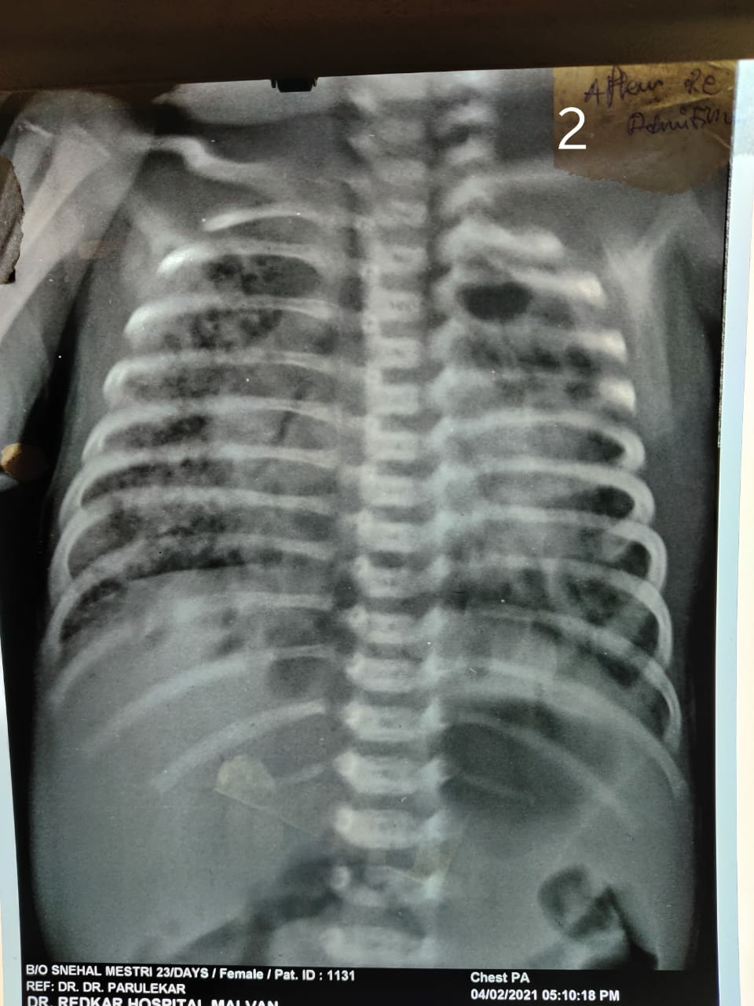
Figure 1- Chest xray showing mediastinal shift to right side with cystic lesions in bilateral lung fields.

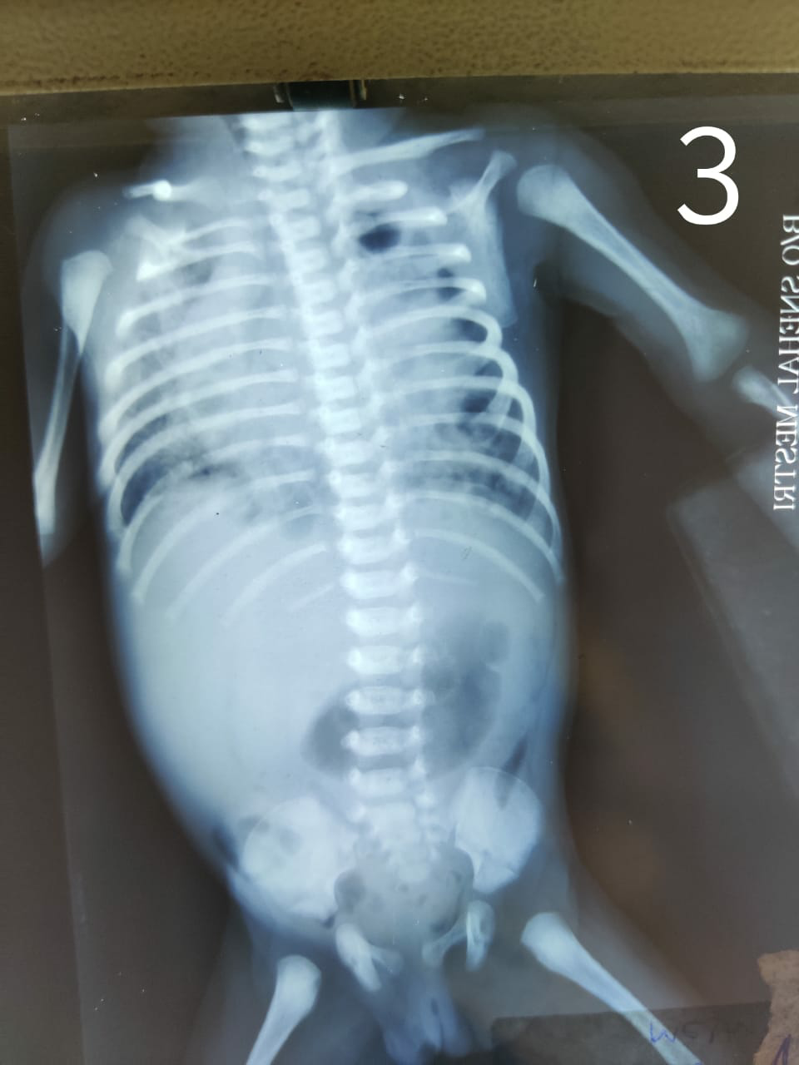
Figure 2- Chest xray showing on day 7 showing cystic lesions in bilateral lung fields

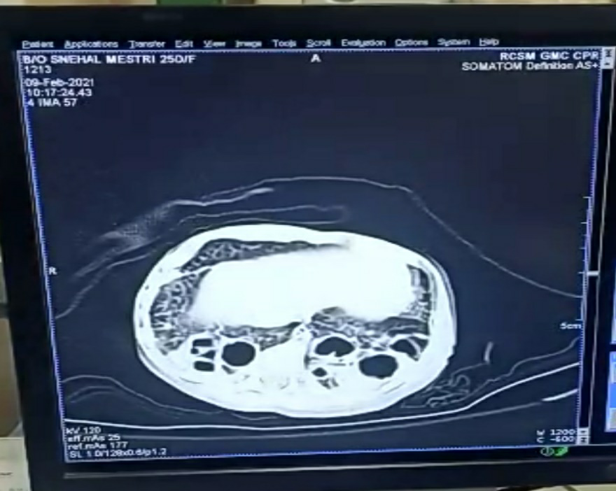
Figure 3- Sagital section of HRCT chest showing bilateral air filled cysts more on left

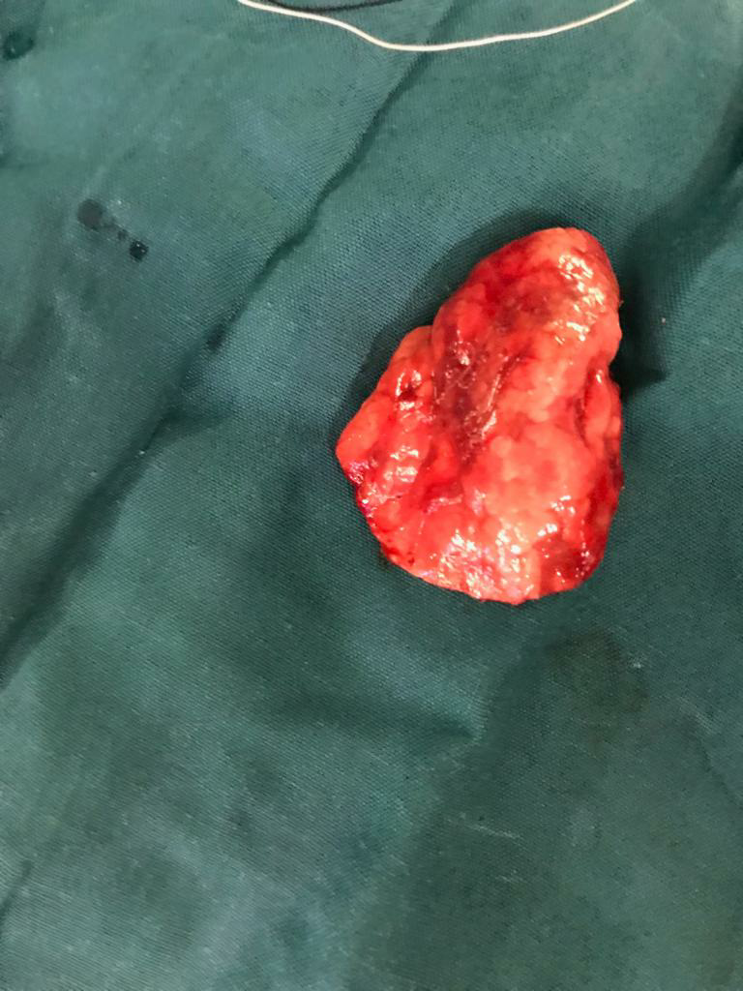
Figure 4- Gross section of resected lower lobe shows abnormal distended cysts( arrow)

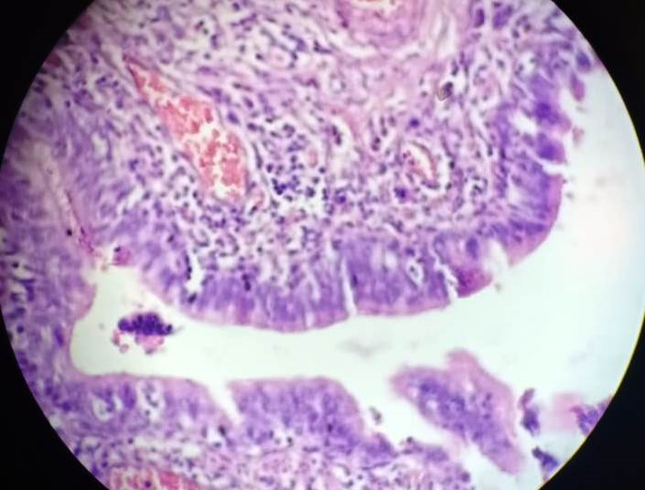
Figure 5 - (H and E; 40X) : Section shows small cyst. The wall of the cyst is lined by columnar epithelium (arrow). Surrounding connective tissue shows dense mixed inflammatory infiltrate and congested blood vessels.

Discussion
Congenital lung malformations (CLM) consist of a broad range of lung anomalies, including congenital pulmonary airway malformations (CPAM), bronchogenic cysts, bronchial atresia, bronchopulmonary sequestrations (BPS), and congenital lobar emphysema (CLE). [1] Congenital pulmonary airway malformations (CPAM) are rare developmental lung malformations, leading to cystic and/or adenomatous pulmonary areas.[2] This condition was first reported by Ch’in and Tang where the term CCAM was used. [3] CCAM is on one of the common congenital lung abnormalities.[4] The term congenital pulmonary airway malformation (CPAM) has been recommended as being preferable to the term congenital cystic adenomatoid malformation (CCAM), since the lesions are cystic in only three of the five types of these lesions and adenomatoid in only one type (type 3). CPAM, a very rare cause of respiratory distress in the neonatal period results from disruptive morphogenesis of the tracheobronchial tree at about the 35th day of life.[5][6] Congenital Pulmonary Airway Malformation (CPAM) has an estimated prevalence between 0.87 and 1.02/10,000 live births.[7]
At pathologic analysis, CPAMs have been classified by Stocker according to cyst size and histologic resemblance to segments of the developing bronchial tree and airspaces. The newer classification scheme includes five types and is an extension of the original scheme (three types).[4] Type 0 has a tracheal or bronchial origin and is acinar dysgenesis or dysplasia, is incompatible with life due to almost no gas exchange occurring. Type 1 has a bronchial or bronchiolar origin (large [2–10-cm] cyst lesion) usually unilateral, but our case had bilateral type 1 cysts presents with increased respiratory effort, tachypnoea, and cyanosis with excellent prognosis. Type2 has a bronchiolar origin (small [0.5–2-cm] cyst lesion), presents similarly with respiratory distress, and also with other congenital anomalies (renal agenesis, cardiovascular defects, diaphragmatic hernia). Type 3 has a bronchiolar–alveolar duct origin (adenomatoid type), can expand the entire lung and can lead to fetal hydrops from pulmonary hypoplasia. Prognosis for types 2 and 3 is poor. Type 4 is distal acinar in origin (the “unlined” cyst lesion) presenting as pneumothorax, and are often similar in presentation to Type 1, with a small risk of infection, malignancy, air leak, or bleeding.[8][9][10]
In terms of the presentation of congenital pulmonary airway malformation, there is wide variability. Children can be symptomatic at birth or go through their entire infancy into childhood without exhibiting symptoms. With the advent of prenatal ultrasonography to diagnose CPAM, there has been an increase in the number of prenatal diagnoses, leading to an overall decrease in the percentage of symptomatic CPAM. Asymptomatic newborns have the potential for complications during childhood, such as respiratory infection or malignancy. Symptomatic newborns present with respiratory distress, with severity increasing with size due to compression of the adjacent airways, which is the case with above neonate. [8][9][10]
Our case presented with persistent respiratory distress and Failure to gain weight in postnatal period. literature shows respiratory distress is the most common presenting feature, and failure to thrive being the least common.[11] Present case was operated by paediatric surgeon with elective left thoracotomy with lower lobectomy. Many reports recommend early surgery for infants in all cases of CCAM. [12] Post-operative recovery showed reduction in oxygen requirement. A documented weight gain of 50 grams was shown with orogastric f/b spoon feeding.

Conclusion
Type 1 CPAM has the best prognosis among all other types, in terms of survival. Early suspicion with systematic approach can make an early diagnosis, leading to early intervention. The development of neonatal care, thoracic surgical techniques, anaesthesiology, nursing care, and postoperative management all enables safe outcome even for a neonate. Early diagnosis could have prevented prolonged NICU stay, oxygen dependency. So we recommend an early suspicion, early diagnosis and early intervention for an early stabilisation for a treatable condition.
References
- Kunisaki SM, Saito JM, Fallat ME, St. Peter SD, Lal DR, Johnson KN, et al. Development of a multi-institutional registry for children with operative congenital lung malformations. J Pediatr Surg 2019. doi: 10.1016/j.jpedsurg. 2019.01.058.
- Congenital pulmonary airway malformations: state-of-the-art review for pediatrician’s use Claire Leblanc, Marguerite Baron, Emilie Desselas, Minh Hanh Phan, Alexis Rybak, Guillaume Thouvenin, Clara Lauby & Sabine Irtan European Journal of Pediatrics volume 176, pages1559–1571(2017)
- Chin KY, Tang MY. Congenital adenomatoid malformation of one lobe of a lung with general anasarca. Arch Pathol (Chic). 1949;48(3):221-9. PMid: [PubMed]
- Stocker JT. Congenital pulmonary airway malformation: a new name for and an expanded classification of congenital cystic adenomatoid malformation of the lung. Symposium 24: non-neoplastic lung disease. Histopathology 2002;41(suppl 2):424–430.
- Bush A, Abel RM, Chitty LS, Harcourt J, Hewitt RJ, Nicholson AG. Congenital lung malformations. In: Wilmott RW, Deterding R, Li A, Ratjen F, Sly P, Zar HJ, et al., editors. Kendig's Disorders of the Respiratory Tract in Children. Ninth. Philadelphia: Elsevier; 2019. p. 289-337.e8.
- Blatter JA, Finder JD. Cystic denomatoid malformation. In: Kliegman RM, Stanton BF, St Geme III JW, Schor NF, Berman RE, editors. Nelson Textbook of Pediatrics. 20th ed. Philadelphia: ElsevierSaunders; 2016. p. 2057-9.
- New insights on congenital pulmonary airways malformations revealed by proteomic analyses C. Barazzone-Argiroffo, J. Lascano Maillard, I. Vidal, M. L. Bochaton-Piallat, S. Blaskovic, Y. Donati, B. E. Wildhaber, A.-L. Rougemont, C. Delacourt & I. Ruchonnet-Métrailler Orphanet Journal of Rare Diseases volume 14, Article number: 272 (2019)
- Stocker JT. Congenital and developmental diseases. In: Dail DH, Hammar SP, editors. Pulmonary Pathology. 2nd ed. New York: Springer-Verlag; 1994. p. 174-80
- Maneenil G, Ruangnapa K, Thatrimontrichai A, Janjindamai W, Dissaneevate S, Anantaseree W, Suntornlohanakul S. Clinical presentation and outcome in congenital pulmonary malformation: 25 year retrospective study in Thailand. Pediatr Int. 2019 Aug;61(8):812-816. [PubMed]
- Parikh DH, Rasiah SV. Congenital lung lesions: Postnatal management and outcome. Semin Pediatr Surg. 2015 Aug;24(4):160-7. [PubMed]
- Congenital Cystic Adenomatoid Malformation Authored by Dr Colin Tidy, Reviewed by Dr Adrian Bonsall | Last edited 12 Oct 2015
- Miller JA ,Corteville J, Langer JC Congenital cystic adenomatoid malformation in the fetus: natural history and predictors of outcome, J Pediatr Surg, 1996, vol. 31 (pg. 805-808 )

Acknowledgement
The authors express gratitude to the parents of the patient for allowing this report and providing additional information on the current state. We also thank all clinical staff who participated in the care of the baby.
Financial support and sponsorship
Nil.
Conflicts of interest
There are no conflicts of interest.

Our patient had CPAM which was symptomatic in the early neonatal period but was successfully resected followed by remarkable postoperative recovery till date. CPAM, a very rare cause of respiratory distress in the neonatal period, is a dysplastic malformation of the tracheobronchial tree resulting from disruptive morphogenesis of the tracheobronchial tree at about the 35th day of life.^{[2],[7]} Although the exact pathogenesis is unknown, studies in rats suggested the role of overexpressed mesenchymal growth factors involved in lung branching embyogenesis.^{[13],[14]} Recently, some authors observed mutations in germline genes implicated in the causation of lung cancers, suggesting a predisposition to malignancy.^{[15]}
Following the first report of CPAM by Chin and Tang ^{[6]} in 1949, Kwittken and Reiner ^{[16]} provided a more detailed microscopic description of CPAM in 1962 while Stocker et al.^{[17],[18]} published clinico-pathological classification consisting of five types, 0-4. Type 0 involves all the lobes and is incompatible with life. Type 1, the most common type (60-65% of cases), consists of a single or multiple large cysts lined by ciliated, pseudostratified or columnar epithelium. Type 2 (20%) consists of multiple small cysts lined by cuboidal or columnar epithelium without the presence of mucous cells and cartilage; it is associated with other congenital anomalies in 60% of cases.^{[2]} Type 3 consists of large, gland-like and non-cystic lesion usually involving a lobe which may expand to cause hypoplasia of contralateral lung.^{[2]} Type 4 consists of thin-walled large cysts which have the potential for malignant transformation. While the prognosis for type 1 lesion is excellent, that for types 2 and 3 is poor.^{[17]}
Postnatally, CPAM may be symptomatic or asymptomatic.^{[2],[7]} Respiratory distress is the commonest presentation of symptomatic CPAM in the neonatal period, which was the case in our patient.^{[2]} Common causes of neonatal respiratory distress like congenital pneumonia, congenital heart disease (CHD) or congenital diaphragmatic hernia (CDH) were excluded in the child: tachypnoea with bulgy chest in an otherwise afebrile, apparently healthy neonate reduced the likelihood of congenital pneumonia, while a normal echocardiography and intact diaphragm on chest CT excluded CHD and CDH, respectively.^{[2],[7]} Beyond infancy, CPAMs rarely present with respiratory distress; most are asymptomatic even into adulthood while few present with recurrent chest infections in infancy, childhood or adulthood.^{[2]}
CPAM may be associated with renal, cardiac, gastrointestinal or central nervous disorders.^{[2],[9],[18]} In our patient, no other anomaly was detected with echocardiography, barium enema or chest CT; the gastric distension seen on chest CT was attributed to aerophagy from persistent crying as oral feeds were initially withheld on account of respiratory distress.
In developed countries, most cases of CCAM are diagnosed during routine mid-trimester anomaly sonography, occasionally supplemented with fetal MRI.^{[2],[7]} It is not immediately clear why our patient's lesion was not detected during antenatal sonography, but possible factors may include scan machine resolution, sonographer's skill, the timing of scan or size of the lesion.^{[2],[19]} The sensitivity of ultrasonographic detection of congenital cystic lung malformations reduces as pregnancy advances due to loss of fluid-tissue interface.^{[2],[14]} Antenatal detection provides an opportunity to monitor the lesion serially as pregnancy progresses, assess the possible need for postnatal surgical intervention even before symptoms develop, and help in planning delivery in a facility with advanced respiratory and surgical expertise.^{[2]}
CPAM may appear as homogenous opacity on chest radiograph, as in our patient, or as multiple air- or fluid-filled cysts. However, the diagnostic accuracy of radiography, or even MRI, is inferior to that of CT.^{[2],[14]} CXR could not diagnose CPAM in our patient and also in two previous Nigerian reports.^{[11],[12]} Although about half of CPAM may regress spontaneously in utero, CT in the postnatal period is recommended, as apparently resolved lesions on sonography may become visible on CT.^{[2],[7],[10],[14]}
Antenatally, persistent CPAM complicated by hydrops or mediastinal shift have been successfully treated with thoraco-amniotic shunting/drainage, percutaneous sclerotherapy or open fetal surgery.^{[2],[9],[20],[21]} Postnatally, the natural history of CPAM is largely unknown because of its rarity, however, spontaneous resolution is extremely rare but most of CPAMs remain asymptomatic till at least the fifth birthday; less than 10% of them present with symptoms in the neonatal period like the index case.^{[2],[21],[22]} The general consensus is that such symptomatic CPAM should be promptly resected (lobectomy, segmentectomy or wedge-resection) via thoracotomy or thoracoscopy.^{[2],[3],[4],[7],[20],[21]} CPAM, especially large lesions, is best managed in centers with thoracic surgery and intensive care expertise. Thus, early surgical intervention of symptomatic cases would yield better chances of survival.^{[2],[9]}
Currently, the postnatal management of asymptomatic CPAM is controversial: elective surgery versus conservative management.^{[3],[23]} Advocates of elective postnatal surgery cite the risk of recurrent pneumonia, impaired lung growth from mass effect of the lesion and malignant transformation.^{[2],[7],[15],[23],[24]} The contrary opinion is that the risk of surgery outweighs the risk of these complications.^{[4],[20],[25],[26]}
Postoperative complications such as pneumonia, pneumothorax, and pectus excavatum are about four-fold higher in children with symptomatic CPAM compared with asymptomatic lesions.^{[3],[4],[5],[23]} The risk of recurrent pneumonia may be persistent postsurgery, hence adequate vaccination, prompt antibiotics treatment, and lung function monitoring are beneficial for long-term care.^{[4],[5],[27]} Other long-term postsurgical sequelae are not well known. However, Farolfi et al.^{[28]} observed that a small cohort of children with CPAM had normal lung function at 4 to 9 years of age. The risk of long-term malignant transformation is not known, but CPAM type 3/4, as in our patient, is associated with a small risk of malignancy, hence, the index case requires follow-up into adulthood.^{[4],[20]}
In conclusion, neonates with persistent respiratory distress (or symptoms) and inconclusive chest radiographs that do not correlate with clinical presentation, should be offered thoracic CT scan which is superior to CXR in the diagnosis of congenital lung malformations.^{[10],[11],[12]} Such children will benefit from prompt referral to facilities with thoracic surgery and intensive care expertise. We also recommend improved antenatal sonographic expertise and equipment to enable early diagnosis, monitoring, prognostication and prompt treatment with better outcomes in the management of CPAM.^{[19]}
Declaration of patient consent
The authors certify that they have obtained all appropriate patient consent forms. In the form the patient(s) has/have given his/her/their consent for his/her/their images and other clinical information to be reported in the journal. The patients understand that their names and initials will not be published and due efforts will be made to conceal their identity, but anonymity cannot be guaranteed.
Acknowledgement
The authors express gratitude to the parents of the patient for allowing this report and providing additional information on the current state. We also thank all clinical staff who participated in the care of the baby.
Financial support and sponsorship
Nil.
Conflicts of interest
There are no conflicts of interest.
References

1. | Seear M, Townsend J, Hoepker A, Jamieson D, McFadden D, Daigneault P, et al. A review of congenital lung malformations with a simplified classification system for clinical and research use. Pediatr Surg Int 2017;33:657-64.
2. | Bush A, Abel RM, Chitty LS, Harcourt J, Hewitt RJ, Nicholson AG. Congenital lung malformations. In: Wilmott RW, Deterding R, Li A, Ratjen F, Sly P, Zar HJ, et al., editors. Kendig's Disorders of the Respiratory Tract in Children. Ninth. Philadelphia: Elsevier; 2019. p. 289-337.e8.
3. | Kunisaki SM, Saito JM, Fallat ME, St. Peter SD, Lal DR, Johnson KN, et al. Development of a multi-institutional registry for children with operative congenital lung malformations. J Pediatr Surg 2019. doi: 10.1016/j.jpedsurg. 2019.01.058.
4. | Delestrain C, Khen-Dunlop N, Hadchouel A, Cros P, Fayon M, Gibertini I, et al. Respiratory morbidity in infants born with a congenital lung malformation. Pediatrics 2017;139:e20162988.
5. | Johnson KN, Mon RA, Gadepalli SK, Kunisaki SM. Short-term respiratory outcomes of neonates with symptomatic congenital lung malformations. J Pediatr Surg 2019 pii: S0022-3468(19)30108-3. doi: 10.1016/j.jpedsurg.2019.01.056 [Epub ahead of print].
6. | Ch'in KY, Tang MY. Congenital adenomatoid malformation of one lobe of a lung with general anasarca. Arch Pathol 1949;48:221-9.
7. | Blatter JA, Finder JD. Cystic denomatoid malformation. In: Kliegman RM, Stanton BF, St Geme III JW, Schor NF, Berman RE, editors. Nelson Textbook of Pediatrics. 20th ed. Philadelphia: ElsevierSaunders; 2016. p. 2057-9.
8. | Lima JS, Camargos PA, Aguiar RA, Campos AS, Aguiar MJ. Pre and perinatal aspects of congenital cystic adenomatoid malformation of the lung. J Matern Fetal Neonatal Med 2014;27:228-32.
9. | Hellmund A, Berg C, Geipel A, Bludau M, Heydweiller A, Bachour H, et al. Prenatal diagnosis and evaluation of sonographic predictors for intervention and adverse outcome in congenital pulmonary airway malformation. PLoS One 2016;11:1-16.
10. | Narayan RR, Abadilla N, Greenberg DR, Sylvester KG, Hintz SR, Barth RA, et al. Predicting pathology from imaging in children undergoing resection of congenital lung lesions. J Surg Res 2019;236:68-73.
11. | Atalabi OM, Ogunseyinde AO, Obajimi MO, Falade AG, Adebo AO, Jite IE. Bilateral congenital cystic adenomatiod malformation of the lungs: A case report. Afr J Med Med Sci 2006;35:183-5.
12. | Adeniyi OF, Olusoji O, Thomas MO, Oduwole OA, Renner JK. Congenital cystic adenomatoid malformation of the lung: A case report and diagnostic challenges in a typical African setting. Nig Q J Hosp Med 2012;22:143-5.
13. | Lezmi G, Verkarre V, Khen-Dunlop N, Vibhushan S, Hadchouel A, Rambaud C, et al. FGF10 Signaling differences between type I pleuropulmonary blastoma and congenital cystic adenomatoid malformation. Orphanet J Rare Dis 2013;8:1-11.
14. | David M, Lamas-Pinheiro R, Henriques-Coelho T. Prenatal and postnatal management of congenital pulmonary airway malformation. Neonatology 2016;110:101-15.
15. | Hsu JS, Zhang R, Yeung F, Tang CSM, Wong JKL, So M-T, et al. Cancer gene mutations in congenital pulmonary airway malformation patients. ERJ Open Res 2019;5:00196-2018.
16. | Kwittken J, Reiner L. Congenital cystic adenomatoid malformation of the lung. Pediatrics 1962;30:750-68.
17. | Stocker JT. Congenital and developmental diseases. In: Dail DH, Hammar SP, editors. Pulmonary Pathology. 2nd ed. New York: Springer-Verlag; 1994. p. 174-80.
18. | Stocker JT, Madewell JE, Drake RM. Congenital cystic adenomatoid malformation of the lung. Classification and morphologic spectrum. Hum Pathol 1977;8:155-71.
19. | Akinmoladun J, Ogbole G, Lawal T, Adesina O. Routine prenatal ultrasound anomaly screening program in a Nigerian university hospital: Redefining obstetrics practice in a developing African country. Niger Med J 2016;56:263-7.
20. | Cook J, Chitty LS, CoppiP De, Ashworth M, Wallis C. The natural history of prenatally diagnosed congenital cystic lung lesions : Long-term follow-up of 119 cases. Arch Dis Child 2017;102:798-803.
21. | Lima M, D'Antonio S, Di Salvo N, Maffi M, Libri M, Gargano T, et al. Is thoracoscopic lung-sparing surgery in treatment of congenital pulmonary airway malformation feasible? J Pediatr Endosc Surg 2019;1:7-14.
22. | Kane SC, Da Silva Costa FF, Crameri JA, Reidy KL, Kaganov H, Palma-Dias R, et al. Antenatal assessment and postnatal outcome of fetal echogenic lung lesions: A decade's experience at a tertiary referral hospital. J Matern Neonatal Med 2017;32:703-9.
23. | Kapralik J, Wayne C, Chan E, Nasr A. Surgical versus conservative management of congenital pulmonary airway malformation in children : A systematic review and meta-analysis. J Pediatr Surg 2016;51:508-12.
24. | Morini F, Zani A, Conforti A, van Heurn E, Eaton S, Puri P, et al. Current management of congenital pulmonary airway malformations: A “European pediatric surgeons” association” survey.” Eur J Pediatr Surg 2018;28:1-5.
25. | Ng C, Stanwell J, Burge DM, Stanton MP. Conservative management of antenatally diagnosed cystic lung malformations. Arch Dis Child 2014;99:432-7.
26. | Robinson A, Romao R, Mills J, Davies DA. Decision-making criteria for observational management of congenital pulmonary airway malformations (CPAMs). J Pediatr Surg 2018;53:1006-9.
27. | Paes B, Kim D, Saleem M, Wong S, Mitchell I, Lanctot KL. Respiratory syncytial virus prophylaxis in infants with congenital airway anomalies compared to standard indications and complex medical disorders. Eur J Pediatr 2019;178:377-85.
28. | Farolfi A, Zenga A, Bersanini C, Cammi G, Costanzo S, Riccipetitoni G, et al. Clinical and spirometric follow-up from 4 to 9 years after lobectomy for congenital lung malformations in children. Eur Respir J 2016;177:PA3139.E

