Cognition and psychosocial functioning in BPAD with and without psychotic features following an acute episode: A comparative prospective study at 0, 3 and 6 months

Author /corresponding author
Joan C Puzhakkal, M.D(Psychiatry)
(Corresponding author)
Postdoctoral fellow, NIMHANS (National Institute of Mental Health and Neurosciences) hospital
Bangalore, Karnataka, India-560029
Email ID: joanpuzhakkal@gmail.com

Co-authors
*Soumya.P.Thomas, MD(Psychiatry)
Senior Resident
Dept of Psychiatry, Pushpagiri Institute of Medical Sciences,
Thiruvalla, Kerala, India- 689101
email ID: soumyasujin@rediffmail.com
*Roy Abraham Kallivayalil
WASP President, WPA Secretary-General
Professor and Head,
Dept of Psychiatry, Pushpagiri Institute of Medical Sciences,
Thiruvalla, Kerala, India- 689101
Emai ID: roykalli@gmail.com

Highlights:
• Cognitive deficits can occur in bipolar affective disorder patients in early remission period irrespective of accompanying psychotic features.
• Psychosocial functioning was poorer for BPAD with psychotic features than without.
• Cognitive functioning may be correlated with the psychosocial functioning of patients with bipolar disorder.

Abstract:
Background & Objectives
Patients with BPAD (Bipolar Affective Disorder) display cognitive impairments during early remission, which appears to adversely impact their overall functioning. Limited research exists regarding how psychotic features affects cognition and psychosocial functioning in BPAD. This knowledge has therapeutic implications. This study was undertaken to compare cognitive and psychosocial functioning in BPAD patients with a history of psychotic features versus BPAD patients without psychotic features and to correlate psychosocial functioning with cognitive impairment.
Methods
The study was conducted at Pushpagiri Institute of Medical Sciences, a post-graduate teaching hospital in Central Kerala, India. Inpatients in the psychiatry ward who met DSM5 diagnostic criteria for BPAD were recruited by consecutive sampling. A total of 80 patients (40 in each group) were taken for the study. Neuropsychological testing was performed 24 to 48 hours before discharge, and Global Assessment of Functioning (GAF) scores were obtained during the initial assessment. Follow-up evaluation was done at 3 months and 6 months.
Results
The majority of participants had completed middle school and were from rural areas. The groups were comparable in terms of duration of illness and number of previous hospitalizations. Patients with psychotic features had worse GAF scores than those without psychotic features at the time of discharge and 6 months follow-up. GAF scores improved with improvement in mood symptoms in both groups. Attention (assessed through the digit vigilance test) was poor for the group with psychotic features at the time of discharge and follow-ups, whereas executive functioning (indexed through the COWAT-FAS test) was found to be improved for the group with psychotic features during follow-ups. Trail making test –B and COWAT-FAS tests, which are measures of executive function, correlated positively and significantly with psychosocial functioning.
Conclusion
In our study, psychosocial functioning and attention was lower for BPAD patients with psychotic features, whereas BPAD patients without psychotic features had lower executive functioning. Moreover, the study could not confirm that cognitive impairment could lead to poor psychosocial functioning among patients.
Keywords
Psychotic features; cognition; psychosocial functioning; bipolar disorder

1.Introduction

Cognition refers to the processing of specific information which includes thinking, memory, perception, motivation, skilled movements, and language (Levy et al., 2013). Neurocognitive investigations during the early remission of BPAD have shown persistent cognitive deficits in about 32% of patients (Padmavati & Taj, 2005). Patients with BPAD display cognitive impairments, which can adversely affect their overall functioning (Pattanayak et al., 2012).

Studies confirming that significant cognitive deficits identified for attention, processing speed, memory, and executive functioning are present in the acute phase of BPAD, and such deficits can persist during remission, also (Martinez-Aran et al., 2008) (Clark et al., 2002). A study reported that verbal memory was more impaired in BPAD patients with psychotic features than in those without (Martinez-Aran et al., 2008). In another study, BPAD patients admitted with psychotic features had significantly poorer performance on the CVLT (California Verbal Learning Test), logical memory subtest of Wechsler Memory Scale-Revised, Stroop test, and the WCST (Wisconsin Card Sorting Test) than those without psychotic features (Levy & Weiss, 2010).

The prognosis for BPAD was once considered relatively favorable, but contemporary findings suggest that disability and poor outcomes are prevalent despite major therapeutic advances. Ineffectively treated BPAD adds to the healthcare burden and contributes to high DALY (Disability Adjusted Life Years)(Sadock, 2009). Research also indicates that individuals living with BPAD experience significantly higher levels of unemployment compared with both the general population and those with unipolar depression. In a study involving 3681 patients with acute mania, only 11% of patients showed no work impairment (Latalova et al., 2011). It has also been observed that over time, people with BPAD who remain employed move to less demanding work roles (Duarte et al., 2016). Measures of functional outcomes provide a more reliable indicator of response to treatment in BPAD than clinical measures such as a reduction in symptoms. Impairment in psychosocial functioning is a defining feature of BPAD and has been widely reported in the literature, even during periods of remission (Levy & Weiss, 2010).

Cognitive impairment is one of the strongest predictors of psychosocial disability in BPAD (Levy & Weiss, 2010). Functional outcomes can be predicted by cognitive impairments in the domains of verbal memory, attention, processing speed, and executive functions. The number of episodes, psychotic features, and medication can affect cognitive domains (Martinez-Aran et al., 2008). Studies have shown that there is a significant difference in the cognitive and psychosocial functioning of BPAD patients with and without psychotic features, but the presence of psychotic features is often overlooked in the clinical setting. Therefore, our study aims to examine the sociodemographic, psychosocial and cognitive functioning profile of patients with BPAD who presented to our hospital during an episode of mood disturbance, to correlate between it, and their status 3 months and 6 months later.

2. Methods and materials
The study followed a prospective cohort design with follow-up at 3 and 6 months after receiving ethical committee approval. The participants were BPAD patients (who met the DSM 5 criteria) admitted to the Department of Psychiatry, Pushpagiri Institute of Medical Sciences (PIMS), Thiruvalla following an acute episode. Consecutive sampling was applied and those patients satisfying inclusion criteria were recruited following informed consent.

2.1. Inclusion criteria

• Between 18-65 years of age
• Consent to participate in the study
• Beck Depression Inventory (BDI) score < 15, and Young Mania Rating Scale (YMRS) score < 15

2.2. Exclusion criteria

• presence or history of organic brain disease or mental retardation
• episodes after first assessment at the discharge period
• more than 3 episodes of BPAD
• substance use disorders

2.3. Study procedure

DSM5 criteria were used for diagnosing BPAD. Psychotic features were defined by the presence of either delusions or hallucinations over the course of the hospital stay (Levy et al., 2013). When patients were sufficiently stable, neuropsychological testing was scheduled 24 to 48 hours before discharge and Global Assessment of Functioning (GAF) scores were obtained. The session typically ranged from two and a half to three and a half hours. After 3 months and 6 months, a follow-up evaluation was done, wherein mood and neurocognitive measures were re-administered, along with GAF scores.

2.4. Tools

2.4.1. Semi-structured Proforma:

It contained Socio-Demographic details and clinical profile which included age at onset of illness, total duration of illness, number of episodes or hospitalizations, total duration of illness, treatment history, family history of BPAD, and the presence or absence of psychotic features.

2.4.2. Mood measures

Manic symptom severity was assessed with the Young Mania Rating Scale, an 11-item scale widely used in clinical and research settings to determine the severity of mania.
The Beck Depression Inventory – Second Edition (BDI-II) was used to assess residual depressive symptoms at the time of testing. This 21-item self-report instrument measures the severity of depressive symptoms.

2.4.3. Psychosocial functioning:

Psychosocial functioning was assessed using the GAF scale which is scored from 0 to100. Higher scores reflect better functioning.

2.4.4. The neuropsychological battery

NIMHANS (National Institute of Mental Health and Neurosciences) and Halstead-Reitan neuropsychological battery was used for assessing cognitive functioning.
Six total tests were administered across four domains: attention, visuomotor speed, executive function, short-term learning and memory.
1. Digit symbol substitution test for visuomotor speed. It consists of digit-symbol pairs followed by a list of digits (e.g., 1/-,2/┴ ... 7/Λ,8/X,9/=). Under each digit, the subject should write down the corresponding symbol as fast as possible. The performance time is noted in seconds.
2. Digit vigilance test-for attention. On this task, participants use a pencil to cross out numbers 6 and 9, scattered amid distracters, as quickly as they can. The time it takes to complete the task is noted in seconds.
3. Trail-making test A and B for attention, visuomotor speed. The Trail Making Test Part A task requires participants to draw a line connecting consecutive numbers scattered on a page as fast as possible. The time to completion is noted in seconds.
4. Trail-making test B for executive functioning. The Trail Making Part B task requires participants to draw a line as quickly as possible connecting letters and numbers scattered in circles on a page in an alternating and ascending sequence (i.e., 1-A-2-B, etc). The time taken to accomplish this is recorded in seconds.
5. COWAT-FAS test for executive functioning. Verbal fluency was assessed with the Controlled Oral Word Association Test (COWAT)-FAS letters format. In three separate trials, the test requires participants to generate as many words as they can that begin with F, A, and S in 60 sec. (in Malayalam-ka, pa, ma).
6. Logical memory test- for short-term learning and memory. This test records the number of details participants recall from a short story immediately and after a 20-minute delay. The maximum number of words of recall was 24.

3. Analysis

The SPSS 20 software package was used to implement the analyses. The sample size was calculated assuming the mean (SD) for the COWAT-FAS test in a prior study (Levy et al., 2013) among people with BPAD with psychotic features to be 40.7(9.6) and those with no psychotic features to be 47.1(9.4); the power of 80% and alpha error 5%; the sample size was 36 in each group. The final sample size taken for the study was 40 in each group (Total: 80 patients). P value<0.05 was taken as statistically significant.

4. Results and discussion
The two groups were evenly divided between BPAD patients with and without psychotic features. Among them, one was experiencing a depressive episode with no associated psychotic features. Three were excluded during the follow-up period, as they were readmitted (one without psychotic features and two with psychotic features). Seven participants (four without psychotic features and three with psychotic features) could not complete all the cognitive tests.
Our aim of the study was to explore differing sociodemographic and clinical variables in patients diagnosed with BPAD with and without psychotic features along with their psychosocial functioning, factors that can affect psychosocial functioning, cognitive deficits, and the relationship between psychosocial functioning and cognitive impairment among them during early remission period of an episode.
4.1. Sociodemographic variables
The mean age for the group with psychotic features was 43.25±14.790 and for the group without psychotic features was 35.75±15.415. Both groups were matched in terms of age and gender. The majority in both the groups had obtained middle school certificates with 50 % and 25 % in the group without psychotic features and with psychotic features respectively.Twenty five percent of them were unemployed in both the groups, and most were unskilled workers. 77 percent of them were married in the group with psychotic features and 60 percent in the group without psychotic features. Most of the patients (>60%) were above the poverty line in both groups, and the majority were living in rural areas (>75%).

4.2. Clinical variables
There was a significant group difference in duration of hospital stay (p=0.0134). The group with psychotic features was admitted for more days (16.80±10.246) compared to those without psychotic features (12.15±7.681) which highlights the severity of disease when psychotic features accompany BPAD.

There was also a significant difference related in age of onset of illness between groups (p=0.001), and the group without psychotic features had an earlier onset of disease (20.50±7.676) compared to the group with psychotic features (29.35±13.532). There were no significant group differences regarding family history of BPAD as more than 65% of patients in both groups had a family history of BPAD. There was more medical comorbidity for the group with psychotic features (p=0.007) - mostly diabetes mellitus and hypertension. As they were probably on antipsychotics, this likely contributed to the higher level of comorbidities.

There were no significant group differences related to the number of hospitalizations and duration of illness among the groups. In the previous literature (Levy et al., 2013) there was no significant group difference between the age of onset for illness, or number of hospital stays, but the duration of illness was significantly longer for the BPAD group with psychotic features. However, in another study (Martinez-Aran et al., 2008), there was a significantly higher number of hospital stays for the group with psychotic features, which is consistent with our results. (Table 1)

4.3. Mood measures
There was a significant difference between the two groups for YMRS scores during follow-up (p=0.017, p=0.001), and the score was lower for the group without psychotic features during discharge and follow-ups. In the previous studies (Levy et al., 2013),(Levy & Weiss, 2010), the residual mood symptoms were significantly greater for BPAD with psychotic features during discharge and follow ups, which is corroborated in the present study.(Figure 1,Table2)

4.4. Psychosocial functioning
There was a significant difference between the two groups regarding GAF scoring at discharge and 6-month follow-up. The average GAF score was higher for the group without psychotic features, indicating better functioning for this group. The GAF score was increased during discharge and follow-up for both groups which means that the psychosocial functioning increased for both groups. One study (Burton et al., 2018) found no increase in GAF score for the group without psychotic features. (Figure2, Table2)

4.5. Cognitive functioning
There was a significant difference between the discharge and follow-up measures in both groups for the Digit Vigilance Test, and the group with psychotic features took more time to complete the test. That indicates that attention capacity was diminished for the group with psychotic features. In the COWAT-FAS test for executive functioning, there was also a significant difference between groups during discharge and follow-ups. Again, the score was greater for the group with psychotic features, and this result was consistent with other previous studies (Udal et al., 2013)(Glahn et al., 2007).(Table 3;Figures 3,4))

Prior studies have reported mixed findings. In one previous study, there were no significant group differences for cognitive functioning (Savitz et al., 2009). In another study (Martinez-Aran et al., 2008) cognitive performance was significantly better for patients without psychosis compared to those with psychotic features for verbal memory and executive functioning. Furthermore, a study by (Levy & Weiss, 2010) reported greater cognitive impairment for patients with psychotic features.

4.6. Correlation between psychosocial functioning, sociodemographic, clinical variables, and mood measures
Psychosocial functioning was significantly better in patients without psychotic features who were younger. In one previous study (Burdick et al., 2010), psychosocial functioning was negatively correlated with the number of hospitalizations. In our study, YMRS scores were significantly negatively correlated with the GAF scores for both groups, which means, the more mood symptoms, the worse the psychosocial functioning. This was also reported in another study (Mur et al., 2009) where mood measures were negatively correlated with psychosocial functioning. Moreover, the psychosocial functioning of the group without psychotic features was negatively impacted as the number of hospitalizations increased. (Table 4)

4.7. Correlation between psychosocial functioning and cognitive impairment during discharge and follow-ups at 3 and 6 months
For the past several years, there has been a growing appreciation for the importance of identifying and treating cognitive impairment associated with BPAD, since it persists in remission periods. Evidence indicates that neurocognitive dysfunction can significantly influence patients’ psychosocial functioning. In our study, the psychosocial functioning during discharge and follow-ups was compared with cognitive test performance. There is a significant positive correlation at discharge between GAF scores and the COWAT-FAS test measuring executive function for BPAD with psychotic features. Moreover, it was found during the 3-month follow-up that, shorter completion times for TRAIL MAKING TEST –Measuring executive function, were correlated with higher GAF scores. Thus, the patients who had better executive function also had better psychosocial functioning. However, during the 6-month follow-up, none of the cognitive tests were significantly correlated with GAF scores. (Table 5)

Therefore, psychosocial functioning is correlated with executive functioning, which is in line with previous studies (Levy et al., 2013) (Wingo et al., 2009)(Konstantakopoulos et al., 2016). It is also reported in one study that the processing speed was positively correlated with psychosocial functioning (Mur et al., 2009). Such research is important to advance the understanding of how psychosocial functioning and other possible factors cause cognitive impairment in BPAD in order to develop prevention strategies and effective treatments.

A research has focused on how to treat cognitive deficits following an acute episode of BPAD. In a posthoc analysis of an 8-week, double-blind, placebo-controlled trial, it was observed that Pramipexole, a dopaminergic agonist, could have a beneficial effect on processing speed and working memory in euthymic BPAD I patients. Another agent investigated was intranasal insulin which resulted in improvement in executive function (the trail making test part B) for euthymic patients. Yet another compound showing a positive effect on some cognitive measures in euthymic or subsyndromal BPAD patients was the extract of Withania Somnifera, an herbal medicine with antioxidant and neuroprotective effects (Solé et al., 2017).

This study had a sizable number of participants from the community which facilitates generalization. There are many limitations to this study. First, we did not control for medication effects which can influence cognitive test performance. It was not possible because the study contained follow-up at 3 and 6 months also. Secondly, patients in the group with psychotic features might have still been experiencing psychotic symptoms which could have contributed to their lower performance. Finally, the majority of the BPAD patients were in manic rather than depressive states; hence the study could not be extended to include BPAD with depressive features.

5. Conclusion and future directions
This study was conducted to examine whether the BPAD with psychotic features involves more cognitive and psychosocial impairment than BPAD without psychotic features and to establish whether cognitive impairment is related to psychosocial dysfunction during the early remission period. We observed significant group differences between cognitive tests for attention. Attention was better for the group without psychotic features. Psychosocial functioning was lower for the group with psychotic features, and it depended on the number of previous hospitalizations. The study also revealed that cognitive (executive) dysfunction may cause psychosocial dysfunction, which is consistent with previous studies.

Cognitive and psychosocial impairment in BPAD have often been neglected topics that are of utmost relevance in contemporary society. Future interventional research is needed which focuses on the remission periods of the illness to confirm that cognitive impairment in BPAD patients is a causal factor in psychosocial dysfunction. Research on neurobiological differences between patients remitting from mood disturbance with psychotic features versus without psychotic features would also be informative. Additional treatment strategies such as cognitive and functional remediation need to be implemented during the early remission period to mitigate cognitive impairment and psychosocial impairment in BPAD patients and improve metacognition and psychosocial skills.

Declarations of interest
None
Funding source
Nil

6.Tables and graphs

Table 1: -Means, Standard Deviations, and Group Comparisons of Clinical Variables.
Variable | With Psychotic features |  | Without Psychotic features |  | t value | p value
 | MEAN | SD | MEAN | SD |  | <0.05*
DHS | 16.80 | 10.246 | 12.15 | 7.681 | 2.297 | 0.024*
AOO | 29.35 | 13.532 | 20.50 | 7.676 | 3.598 | 0.001*
NOH | 3.65 | 2.587 | 4.25 | 3.564 | -0.862 | 0.392
DOI | 176.925 | 164.446 | 177.550 | 145.181 | -0.018 | 0.986

*sinificant(DHS-duration of hospital stay in days; AOO-age of onset in years; NOH-no. of hospitalizations; DOI-duration of illness in months)

Figure1: Mood Symptoms
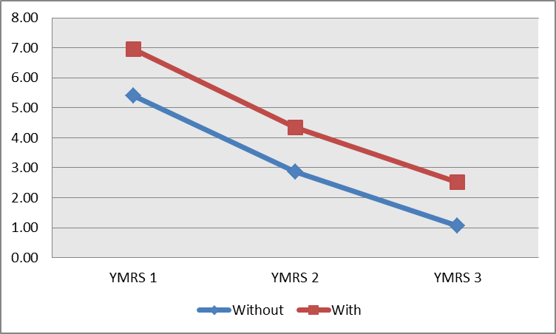
YMRS1-YMRS score at discharge (p=0.066), YMRS2-YMRS score at 3rd month follow up(p=0.017); YMRS3-YMRS at 6th month follow up(p=0.001)

Figure 2: GAF Score
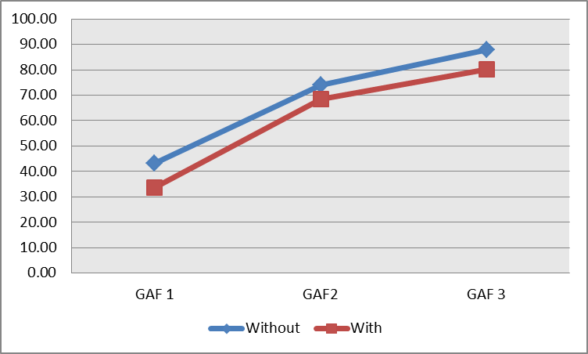
(GAF1-GAF at discharge, GAF2-GAF score at 3rd month follow up; GAF3- GAF at 6th month follow up)There is significant difference in GAF SCORE between groups at discharge (p value=0.000) and 6th month follow up(p value=0.003).

Table 2: Group comparison of YMRS and GAF scores
Variable | With psychotic features | Without psychotic features | t value | P value  (<0.05*)
 | MEAN(SD) | MEAN(SD)
YMRS 1 | 6.95(3.823) | 5.41(3.500) | 1.866 | 0.066
YMRS 2 | 4.34(3.113) | 2.87(2.056) | 2.435 | 0.017*
YMRS 3 | 2.53(2.379) | 1.05(1.184) | 3.418 | 0.001*
GAF 1 | 33.65(2.940) | 43.30(4.686) | -11.033 | 0.000*
GAF2 | 68.58(11.986) | 73.92(12.474) | -1.916 | 0.059
GAF3 | 80.13(9.029) | 87.97(13.062) | -3.057 | 0.003*
*Significant

Table 3: Group comparison of scores for cognitive tests
Variable | With Psychotic features |  | Without Psychotic features |  | t value | p value
 | MEAN | SD | MEAN | SD |  | <0.05*
TMA1 | 92.05 | 63.735 | 91.75 | 46.278 | 0.024 | 0.981
TMA2 | 79.26 | 48.346 | 83.77 | 43.707 | -0.429 | 0.669
TMA3 | 73.58 | 40.248 | 64.97 | 31.032 | 1.052 | 0.296
TMB1 | 194.11 | 122.693 | 256.95 | 175.706 | -1.823 | 0.072
TMB2 | 175.83 | 118.463 | 221.03 | 144.608 | -1.473 | 0.145
TMB3 | 167.28 | 111.310 | 165.13 | 102.780 | 0.087 | 0.931
DST1 | 353.11 | 242.754 | 332.00 | 258.591 | 0.357 | 0.722
DST2 | 285.29 | 210.734 | 269.31 | 217.068 | 0.312 | 0.756
DST3 | 290.26 | 196.356 | 220.69 | 167.697 | 1.594 | 0.116
DVT1 | 646.39 | 221.055 | 553.17 | 199.925 | 1.877 | 0.065
DVT2 | 578.29 | 196.116 | 469.54 | 164.810 | 2.511 | 0.014*
DVT3 | 534.69 | 171.391 | 418.97 | 144.655 | 3.052 | 0.003*
FAS1 | 32.11 | 14.545 | 25.10 | 8.258 | 2.633 | 0.010*
FAS2 | 37.13 | 13.913 | 29.18 | 7.426 | 3.140 | 0.002*
FAS3 | 39.16 | 13.530 | 32.59 | 7.670 | 2.629 | 0.010*
LOGM1 | 13.85 | 4.498 | 12.95 | 4.455 | 0.899 | 0.371
LOGM2 | 14.92 | 4.168 | 14.92 | 3.673 | -0.002 | 0.998
LOGM3 | 15.34 | 4.206 | 15.74 | 3.492 | -0.456 | 0.650
LOGD1 | 13.26 | 4.996 | 11.85 | 5.107 | 1.235 | 0.221
LOGD2 | 14.22 | 4.758 | 12.85 | 4.534 | 1.282 | 0.204
LOGD3 | 14.50 | 4.730 | 13.72 | 4.377 | 0.744 | 0.459
*Significant

Figure 3: Group Comparison for Digit Vigilance Test at Discharge and Follow UPS
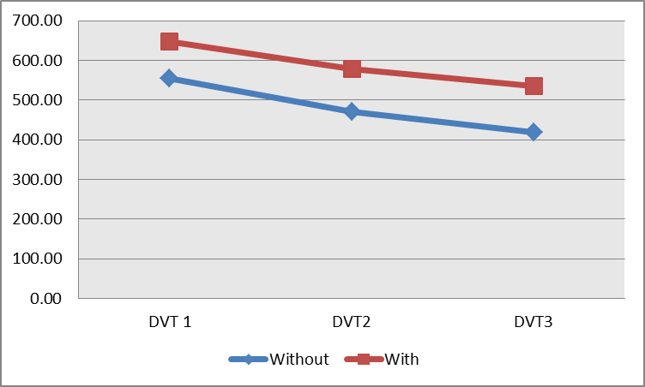
DVT1-DVT at discharge; DVT2-DVT score at 3rd month follow up; DVT3- DVT at 6th month follow up

Figure 4: Group Comparison for COWAT-FAS Test
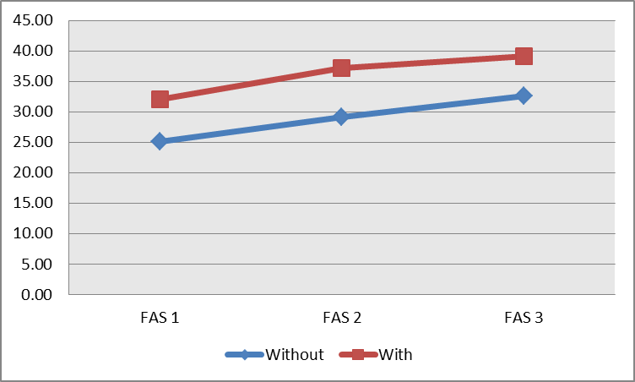
(FAS1- FAS at discharge, FAS2-FAS score at 3rd month follow up;FAS3-FAS at 6th month follow up).

Table 4:- Correlation Coefficient Between GAF Score (GAF 1) and Sociodemographic & Clinical Variables
Variable | r In WP | P value | r In WOP | P value
AGE in years | -0.175 | 0.281 | -0.312 | 0.049*
DHS | -0.241 | 0.135 | -0.310 | 0.051
AOO | -0.117 | 0.473 | -0.301 | 0.059
NOH | -0.151 | 0.351 | -0.708 | 0.000*
DOI | -0.025 | 0.878 | 0.070 | 0.667
YMRS | -0.440 | 0.005* | -0.340 | 0.034*
r-Pearson correlation coefficient; GAF 1-global assessment of functioning at discharge; WP-with psychotic features; WOP- without psychotic feature; AOO- age of onset of illness; NOH-no. of hospital stay; DOI-duration of illness; Significance*

Table 5: - Correlation Coefficient Between GAF Score at discharge (GAF1) And Cognitive Functioning at Discharge and follow ups
Variable | r in WP | P value | r in WOP | P value
TMA1 | -0.187 | 0.247 | -0.100 | 0.538
TMB1 | -0.131 | 0.433 | 0.023 | 0.886
DST1 | -0.159 | 0.354 | 0.016 | 0.927
DVT1 | -0.326 | 0.052 | 0.074 | 0.669
FAS1 | 0.439 | 0.006* | -0.055 | 0.735
LOGM1 | 0.283 | 0.077 | 0.281 | 0.079
LOGD1 | 0.182 | 0.273 | 0.259 | 0.106
TMA2 | -0.249 | 0.132 | -0.117 | 0.477
TMB2 | -0.334 | 0.046* | -0.464 | 0.003*
DST2 | -0.130 | 0.456 | -0.302 | 0.078
DVT2 | -0.007 | 0.966 | -0.004 | 0.983
FAS2 | -0.023 | 0.893 | 0.092 | 0.576
LOGM2 | 0.245 | 0.138 | 0.017 | 0.920
LOGD2 | 0.084 | 0.627 | -0.087 | 0.599
TMA 3 | -0.232 | 0.161 | -0.182 | 0.268
TMB3 | -0.252 | 0.138 | -0.276 | 0.089
DST 3 | -0.240 | 0.165 | 0.003 | 0.984
DVT3 | -0.253 | 0.143 | 0.099 | 0.572
FAS3 | 0.040 | 0.812 | 0.035 | 0.835
LOGM3 | 0.124 | 0.458 | 0.257 | 0.114
LOGD3 | -0.054 | 0.752 | 0.015 | 0.927
Significant*; WOP- without psychotic features; WP-with psychotic features

7.REFERENCES:

Burdick, K. E., Goldberg, J. F., & Harrow, M. (2010). Neurocognitive dysfunction and psychosocial outcome in patients with bipolar I disorder at 15 year follow-up. Acta Psychiatrica Scandinavica. https://doi.org/10.1111/j.1600-0447.2010.01590.x
Burton, C. Z., Ryan, K. A., Kamali, M., Marshall, D. F., Harrington, G., McInnis, M. G., & Tso, I. F. (2018). Psychosis in bipolar disorder: Does it represent a more “severe” illness? Bipolar Disorders. https://doi.org/10.1111/bdi.12527
Clark, L., Iversen, S. D., & Goodwin, G. M. (2002). Sustained attention deficit in bipolar disorder. British Journal of Psychiatry. https://doi.org/10.1192/bjp.180.4.313
Duarte, W., Becerra, R., & Cruise, K. (2016). The relationship between neurocognitive functioning and occupational functioning in bipolar disorder: A literature review. In Europe’s Journal of Psychology. https://doi.org/10.5964/ejop.v12i4.909
Glahn, D. C., Bearden, C. E., Barguil, M., Barrett, J., Reichenberg, A., Bowden, C. L., Soares, J. C., & Velligan, D. I. (2007). The Neurocognitive Signature of Psychotic Bipolar Disorder. Biological Psychiatry. https://doi.org/10.1016/j.biopsych.2007.02.001
Konstantakopoulos, G., Ioannidi, N., Typaldou, M., Sakkas, D., & Oulis, P. (2016). Clinical and cognitive factors affecting psychosocial functioning in remitted patients with bipolar disorder. Psychiatrike = Psychiatriki. https://doi.org/10.22365/jpsych.2016.273.182
Latalova, K., Prasko, J., Diveky, T., & Velartova, H. (2011). Cognitive impairment in bipolar disorder. Biomedical Papers. https://doi.org/10.5507/bp.155.2011.003
Levy, B., Medina, A. M., & Weiss, R. D. (2013). Cognitive and psychosocial functioning in bipolar disorder with and without psychosis during early remission from an acute mood episode: A comparative longitudinal study. Comprehensive Psychiatry. https://doi.org/10.1016/j.comppsych.2012.12.018
Levy, B., & Weiss, R. D. (2010). Neurocognitive impairment and psychosis in bipolar I disorder during early remission from an acute episode of mood disturbance. Journal of Clinical Psychiatry. https://doi.org/10.4088/JCP.08m04663yel
Martinez-Aran, A., Torrent, C., Tabares-Seisdedos, R., Salamero, M., Daban, C., Balanza-Martinez, V., Sanchez-Moreno, J., Goikolea, J. M., Benabarre, A., Colom, F., & Vieta, E. (2008). Neurocognitive impairment in bipolar patients with and without history of psychosis. Journal of Clinical Psychiatry. https://doi.org/10.4088/JCP.v69n0209
Mur, M., Portella, M. J., Martinez-Aran, A., Pifarre, J., & Vieta, E. (2009). Influence of clinical and neuropsychological variables on the psychosocial and occupational outcome of remitted bipolar patients. Psychopathology. https://doi.org/10.1159/000207456
Padmavati, R., & Taj, M. (2005). Neuropsychological impairment in bipolar affective disorder. Indian Journal of Psychiatry. https://doi.org/10.4103/0019-5545.46075
Pattanayak, R. D., Sagar, R., & Mehta, M. (2012). Neuropsychological performance in euthymic Indian patients with bipolar disorder type I: Correlation between quality of life and global functioning. Psychiatry and Clinical Neurosciences. https://doi.org/10.1111/j.1440-1819.2012.02400.x
Sadock, B. J. (2009). Kaplan and Sadock’s Comprehensive Textbook of Psychiatry (Comprehensive Textbook of Psychiatry (Kaplan & Saddock’s)(2). In Kaplan & Sadock’s Comprehensive Textbook of Psychiatry, Çeviri Editörleri: Aydın H, Bozkurt A, Sekizinci Baskı, Güneş Kitabevi.
Savitz, J., Van Der Merwe, L., Stein, D. J., Solms, M., & Ramesar, R. (2009). Neuropsychological status of bipolar I disorder: Impact of psychosis. British Journal of Psychiatry. https://doi.org/10.1192/bjp.bp.108.052001
Solé, B., Jiménez, E., Torrent, C., Reinares, M., Del Mar Bonnin, C., Torres, I., Varo, C., Grande, I., Valls, E., Salagre, E., Sanchez-Moreno, J., Martinez-Aran, A., Carvalho, A. F., & Vieta, E. (2017). Cognitive impairment in bipolar disorder: Treatment and prevention strategies. In International Journal of Neuropsychopharmacology. https://doi.org/10.1093/ijnp/pyx032
Udal, A. H., Øygarden, B., Egeland, J., Malt, U. F., Løvdahl, H., Pripp, A. H., & Grøholt, B. (2013). Executive deficits in early onset bipolar disorder versus ADHD: Impact of processing speed and lifetime psychosis. Clinical Child Psychology and Psychiatry. https://doi.org/10.1177/1359104512455181
Wingo, A. P., Harvey, P. D., & Baldessarini, R. J. (2009). Neurocognitive impairment in bipolar disorder patients: Functional implications. In Bipolar Disorders. https://doi.org/10.1111/j.1399-5618.2009.00665.x

