Isolated ocular rosacea in children : Case report
Houda Bezza^{a*}, Zineb Algoutiª, Amine Mounsifª, Youssef Bennoukª , Lhoussaine Ait Lhajª , Mohamed Krietª , Fouad Elasriª

ªOphthalmology Department, Avicenna military hospital of Marrakech, Morocco

*Corresponding author

houda.bezza@gmail.com

Abstract :

we report the case of a 7-year-old child who presented to our department with recurrent red eye. After several investigations, the diagnostoc of isolated ocular rosacea was retained and the patient was treated with local and general macrolide.

the evolution was marked by a complete remission of her symptoms and an improvement in her visual acuity

Key words : ocular rosacea ,children , optical coherence tomography , Morbidity

Introduction :

Rosacea is a relatively common disease that can be confusing and lead to serious ocular morbidity if not correctly diagnosed and treated. Ocular rosacea, in particular, often goes undetected because there is no specific test to confirm it. Diagnosis is further complicated by the fact that ocular rosacea symptoms are not always typical of the disease. Further difficulties come from the fact that the severity of ocular symptoms often does not correlate with skin symptoms.

It usually requires a combination of conservative measures and topical and systemic agents, depending on the severity of the disease.

Case presentation :

A 7 year old girl who presented to our departement with repeated left red eye over the 06 months

On the initial examination, best corrected visual acuity (BCVA) was 10/10 in the right eye and 03/10 in the left eye .

Slit lamp biomicroscopy revealed meibomitis, conjunctival hyperemia and a steril para axial corneal ulcer (figure 1 ,2 ) The anterior chamber was quiet

Fundus examination appeared normal

The examination of the right eye was unremarkable

The anterior segment optical coherence tomography (OCT) reveald an epithelial-stromal ulcer , the corneal thickness at the thinnest at 0,536 mm (figure 3 ,4 )

A sample was taken from the patient who came back negative , a complete bilogical check-up including immunological serological to search for systemic diseases was normal

we treated the patient with antibiotic eye drops based on azythomicin for 6 months, Short-term local corticosteroid , palpebral hygiene measures with warm compresses and a general treatment based on macrolide for a period of 03 months

The patient was evaluated every single month for possible deterioration. Her BCVA improved from 3/10 to 08/10 A close follow-up with corneal OCT

Discussion :

Rosacea is a chronic inflammatory dermatologic condition that is associated with ocular disease in approximately 58% of cases, although its precise pathophysiology remains unclear. [1–3]

Studies have shown elevated levels of interleukin-1a and -b and increased gelatinase B (metalloproteinase [MMP]-9) and collagenase-2 (MMP-8) activity in tear fluids of patients with ocular rosacea.

Doxycycline, which decreases MMP-8 and MMP-9 activity, has been used successfully in the treatment of cutaneous and ocular rosacea, confirming the inflammatory nature of the disease.[4–6]

Ocular manifestations are usually bilateral, although unilateral or sequential changes may occur. Symptoms usually include ocular irritation, itching, redness, photophobia and/or epiphora, and reduced vision in the presence of corneal involvement.[1,7]

Many groups have been investigating the glycomics of tear fluid and saliva in rosacea patients. This is a preliminary step in the search for a disease-specific biomarker ,they reported a high abundance of O-linked oligosaccharides and a decrease in N-glycans in tear and saliva samples from rosacea patients.[4,8]

Depending on the severity of the disease, treatment usually consists of a combination of conservative measures, topical agents and systemic agents.

The use of oral cyclins is not recommended in children under 7 years of age. In these cases, oral erythromycin, 500 mg per day (as erythromycin) in divided doses for children may be used as an alternative. Alternatively, azithromycin 5 mg/kg/day orally for children, 3 days a week for 3 to 4 weeks.[9,10]

Conclusion :

In pediatric patients, ocular rosacea should be suspected in the presence of ocular surface disease associated with meibomitis.

Management of the disease can vary from local therapy to systemic treatment, according to the severity of the disorder.

Visual impairment and resulting amblyopia are common and corneal perforation, although rare, is the most feared complication

Declaration :
- The authors declare that they have no known competing financial interests or personal relationships that could have appeared to influence the work reported in this paper.

References :
1. Tavassoli S, Wong N, Chan E. Ocular manifestations of rosacea: A clinical review. Clinical & Experimental Ophthalmology. 2021;49(2):104‑17.
2. Starr PAJ, MacDonald A. Oculocutaneous Aspects of Rosacea. Proceedings of the Royal Society of Medicine. 1 janv 1969;62(1):9‑11.
3. Ghanem VC, Mehra N, Wong S, Mannis MJ. The prevalence of ocular signs in acne rosacea: comparing patients from ophthalmology and dermatology clinics. Cornea. avr 2003;22(3):230‑3.
4. Vieira AC, Mannis MJ. Ocular rosacea: Common and commonly missed. Journal of the American Academy of Dermatology. 1 déc 2013;69(6, Supplement 1):S36‑41.
5. Määttä M, Kari O, Tervahartiala T, Peltonen S, Kari M, Saari M, et al. Tear fluid levels of MMP-8 are elevated in ocular rosacea—treatment effect of oral doxycycline. Graefe’s Arch Clin Exp Ophthalmo. 1 août 2006;244(8):957‑62.
6. Afonso AA, Sobrin L, Monroy DC, Selzer M, Lokeshwar B, Pflugfelder SC. Tear Fluid Gelatinase B Activity Correlates with IL-1α Concentration and Fluorescein Clearance in Ocular Rosacea. Investigative Ophthalmology & Visual Science. 1 oct 1999;40(11):2506‑12.
7. Oltz M, Check J. Rosacea and its ocular manifestations. Optometry. févr 2011;82(2):92‑103.
8. An HJ, Ninonuevo M, Aguilan J, Liu H, Lebrilla CB, Alvarenga LS, et al. Glycomics analyses of tear fluid for the diagnostic detection of ocular rosacea. J Proteome Res. 2005;4(6):1981‑7.
9. Wladis EJ, Adam AP. Treatment of ocular rosacea. Survey of Ophthalmology. 1 mai 2018;63(3):340‑6.
10. Update on the pathogenesis and management of ocular rosacea: an interdisciplinary review - Sayena Jabbehdari, Omeed Michael Memar, Benjamin Caughlin, Ali R Djalilian, 2021

Images :

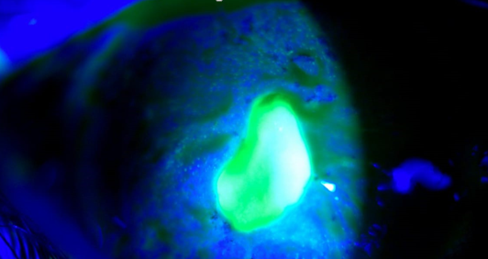
Fig. 1 : Slit lamp image showing a paraaxial ulcer taking fluorescein

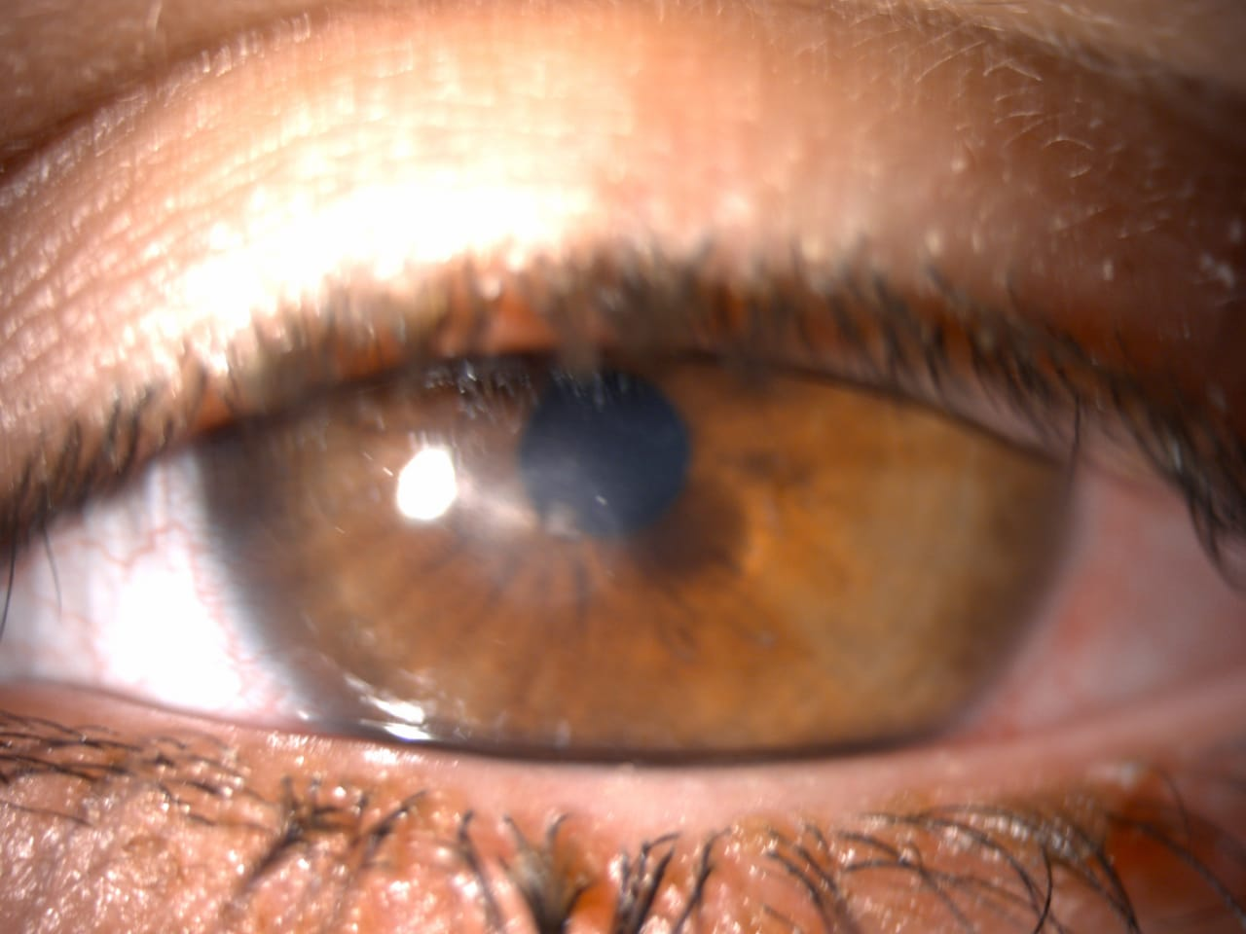
Fig. 2 : Slit lamp showing anterior palpebral blepharitis with scaling sticking to the lashes.
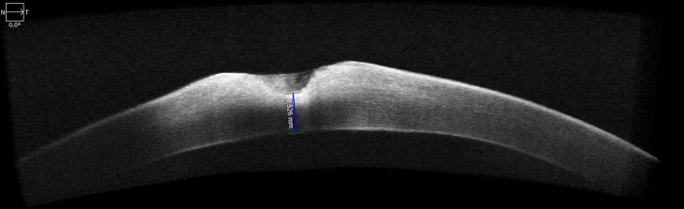
Fig. 3 : corneal OCT showing an epithelial-stromal ulcer , the corneal thickness at the thinnest at 0,536 mm

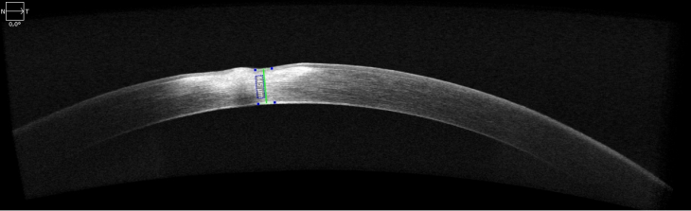
Fig. 4 : the final corneal OCT

