A comparative study to evaluate the visibility of mandibular canal in CBCT and OPG
ABSTRACT
Introduction: Detection of the mandibular canal (MC) is an important requirement for different surgical procedures such as implant placement, surgical removal of the pathological lesion and even tooth extraction. OPG and CBCT represent an advanced imaging technology.

Aim: This comparative study was conducted to assess the visibility of MC in different regions using CBCT and OPG images and compare them.

Material and method: The images were taken with a digital panoramic and CBCT system (VATECH SMARTPLUS). Approx.20 scans were evaluated and the MC visibility was assessed in four regions (second premolar (a), first molar(b), second molar(c) and distal to the second molar(d)

Result: The visibility of MC in region A by CBCT was clearer than OPG, while in region D the visibility was better using OPG in 75% of all cases

Conclusion: The results showed a significant difference between the two imaging techniques with more clearance and visibility of the MC in CBCT.

KEY WORDS – mandibular canal (MC), computed tomography(CBCT) , orthopantomograph (OPG)

INTRODUCTION

The mandibular canal is an important landmark.¹ The extent is within the mandible and extends from mandibular foramen from which it courses obliquely in the mandibular ramus forward and downward also runs horizontal in the body before opening into the mental foramen. This canal which is also known as inferior alveolar canal includes inferior alveolar nerve,vein, artery and lymphatic vessels.²
The location and determination of mandibular canal is important to prevent complications during surgical procedures especially while placing implants ,osteotomies, third molar surgeryand repair of mandibular fractures.^{2,3}
Radiographic determination is thus important diagnostic tool for localization of mandibular canal .various modalities like panaromic radiography and conventional tomography (CT) have been in use with limitations pertaining to two dimentional images but with advancement of CBCT . The accuracy in determination of this canal has improved significantly . ^{3,4}
The distinguishing of structure is still requires the expertise of operator and thus still in determination of this canal can also vary from person to person . Thus it is important to recognize the anatomically variability of the canal while depiction and understanding of variation in the course of this canal.¹
Therefore this study was carried out with the aim of study is to assess the visibility of MC in different regions using CBCT and OPG images and compare them.
Material and Method
The study sample consisted of 30 CBCT scans. The samples were chosen randomly from patients who visited Shree Bankey Bihari Dental College and Research Center, masuri, Ghaziabadand underwent panoramic radiography as well as CBCT in 2021.The CBCT scans had been taken as part of a clinical diagnostic procedure for various reasons, such as implant placement, extraction of the third molar, or orthodontic treatment planning. The selection of patients age was above 17 years old .
These images were taken with a digital panoramic and CBCT system (VATECH SMARTPLUS) under standard exposure factors (75-95kvp).
Inclusion criteria:
1- Good image quality.
2- All teeth should be present at that region
Exclusion criteria:
1- pathological lesion and fracture of the mandible.
2- implant and missing teeth in the posterior part of the mandible except the third molar.
The readings were achieved at different mandibular regions; second premolar (A), first molar (B), second molar (C) and distal to the second molar (D) .The readings were recorded by two different observers.
The readings were measured from the alveolar crest to upper border of mandibular canal. The visibility of the MC in CBCT and OPG, determined by the ability of the observer to differentiate the MC from the surrounding bone, was registered as either clear (C) or unclear (UC). The data of each examined area were clustered together and the visibility was compared according to the imaging modality (CBCT and OPG)

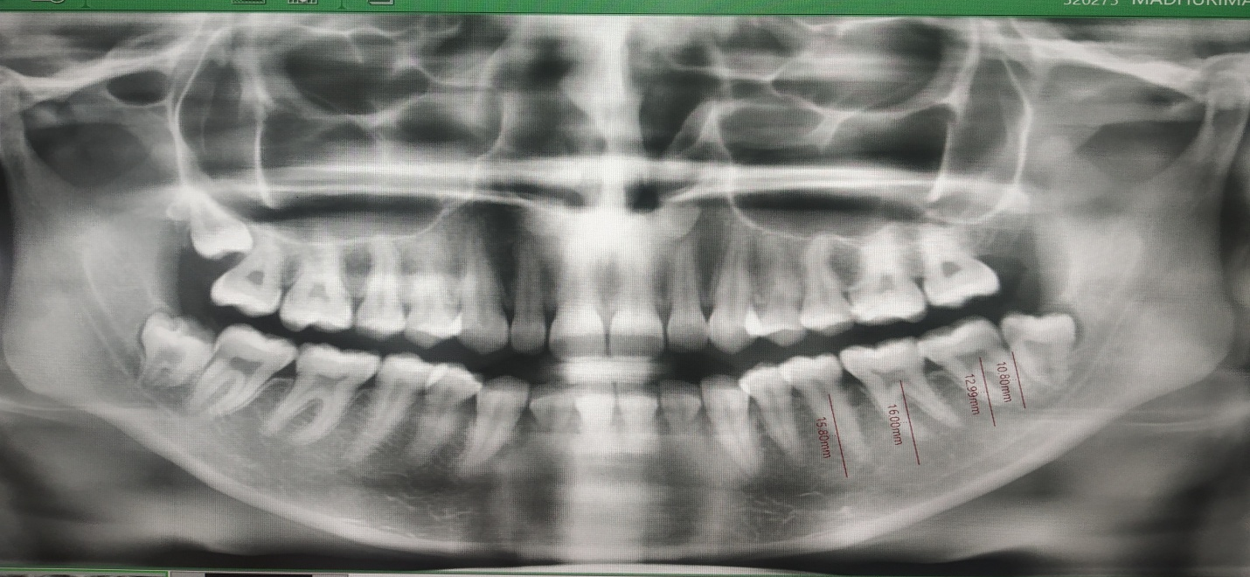

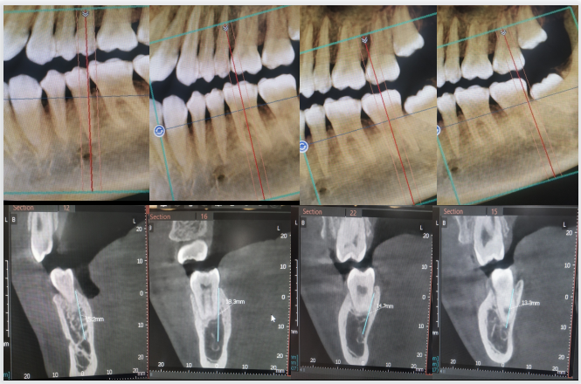

These areas were organized and divided by using the dental software application and obtaining reconstructed panorama and cross-sectional views to optimize the center of each examined view.The visibility of the MC in CBCT and OPG, determined by the ability of the observer to differentiate the MC from the surrounding bone, was registered as either clear (C) or unclear (UC). The data of each examined area were clustered together and the visibility was compared according to the imaging modality (CBCT and OPG).The collected data were analyzed statistically by student t test and MacNemer’s analysis.

RESULTS

The visibility of MC in region A by CBCT was clearer than OPG, while in region D the visibility was better using OPG.The statistical analysis showed there were significant differences between CBCT and OPG images at the region A and D while at the region B and C there was a non-significant difference.

DISCUSSION

The launching of new imaging technologies has allowed us to visualize MC and other anatomical structure in different plans without image superimposition. In this study the visibility of MC was assessed on both conventional panoramic images and advanced imaging like CBCT images.⁴
The Mandibular Canal seen as a rarefaction lined by radiopaque borders on radiographs, distinct bony-walled channels with definite borders do not seem to be a regular feature.⁴⁻⁵
CBCT found more accurate to panoramic images for the identification of mandibular canal.⁶
As in CBCT, the identification or visualization of MC was considered effortless because canal can be visualized and discriminated from surrounding in nearly every region throughout its extension but in panoramic images we just visualized it, can not evaluate it due to its 2D configuration .^{5,7,8}
Thus panoramic imaging is not completely reliable for complex surgical procedures like osteotomies, implant placement, third molar surgeries or repair of fractures .⁴⁻⁷

Abdulsaheb R J , Najim A A ,et al 2021 performed study on Visibility of Mandibular Canal on CBCT Cross-Sectional Images in Comparison with Panoramic Radiograph and found that the visibility of MC in region A by CBCT was clearer than OPG, while in region B the visibility was better using OPG and our study also showed similar findings or results.³

wherein Kamrun N, Tetsumura A et al (2013) found that Visibilty of MC in region A by CBCT was clearer than OPG, while in region B the visibility was better using OPG ,this study is also in coherence with our study.⁹

Jung and Cho in 2014 found that visibility of MC by CBCT was better than by OPG and the visibility of the
canal was decreased by moving further posteriorly. This is in disagreement with our current study which shows visibility of mandibular canal more clear in OPG as compared to CBCT.¹

whereas study done by oliveira santos et al in 2011 showed variance in visibility of MC wherein they found that visibility of MC is increasing while moving posteriorly in CBCT. This thus is in disagreement with our study as the visibility was better in anterior region according to our result.⁴

The outcome of the current study reveals less percentage for MC visualization by OPG and this was agreed with Naitoh et al in 2009¹⁰), Jung and Cho in 2014¹), and Lindh et al in 198¹¹). CBCT reported superior results as compared to OPG for the identification of the MC, which is in line with Kamrun et al in 2013 who confirmed that the visibility of cross-sectional CT images was significantly higher than that of panoramic images of the MC.

Canal Visibility by region in OPG

 | Obs 1 | Obs 2
A | 2 | 4
B | 2 | 12
C | 12 | 20
D | 24 | 24

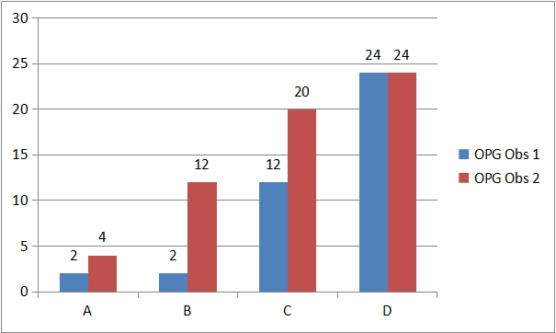

It was observed that the canal was identified most frequently in region D, followed by region c and least frequently in region B and A by observer 1, similar findings were reported by observer 2.

Canal Visibility by region in CBCT

 | Obs 1 | Obs 2
A | 28 | 25
B | 28 | 19
C | 27 | 25
D | 21 | 24

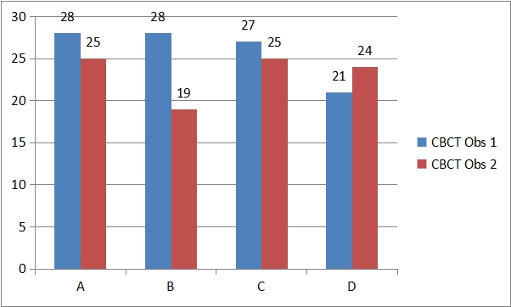
It was observed that canal was identified most frequently in region A, followed by region B and least frequently in region C and D by observer 1. While Observer 2 was able to spot the canal most frequently in region A, followed by region D, region C and least frequently in region B.

McNemar’s Agreement Analysis
OPG

Mc.Nemar agreement analysis
Region | P Value | Significance
Region A | 0.6171 | Not Significant
Region B | 0.0094 | Significant
Region C | 0.0614 | Not Significant
Region D | 0.7237 | Not Significant
Final Score | 3/4 no significant difference

It was observed that observers agreed on visibility of nerve canal in 75% of all cases. Disagreement on visibility was observed only in Region B.

CBCT
Mc.Nemar agreement analysis
Region | P Value | Significance
Region A | 0.0771 | Not Significant
Region B | 1.0000 | Not Significant
Region C | 0.6171 | Not Significant
Region D | 0.0412 | Significant
Final Score | 3/4 no significant difference

It was observed that observers agreed on visibility of nerve canal in 75% of all cases. Disagreement on visibility was observed only in Region D.

Conclusion
The results showed a significant difference between the two imaging techniques with more clearance and visibility of the MC in CBCT. Further, the visibility of the mandibular canal increased in more distal regions of the canal, and the canal was more visible on CBCT cross-sectional images than on panoramic radiographs.

^{References}
1. Jung YH, Cho BH. Radiographic evaluation of the course and visibility of the mandibular canal. Imaging science in dentistry. 2014 Dec 1;44(4):273-8.
2. de Oliveira Júnior MR, Saud AL, Fonseca DR, De-Ary-Pires B, Pires-Neto MA, de Ary-Pires R. Morphometrical analysis of the human mandibular canal: a CT investigation. Surgical and radiologic anatomy. 2011 May;33(4):345-52.
3.Abdulsaheb RJ, Najm AA, Farhan FA. Visibility of Mandibular Canal on CBCT Cross-Sectional Images in Comparison with Panoramic Radiograph: Retrospective Study. International Medical Journal. 2021 Jun 2;28(1):65-8.
4. Oliveira-Santos C, Capelozza AL, Dezzoti MS, Fischer CM, Poleti ML, Rubira-Bullen IR. Visibility of the mandibular canal on CBCT crosssectional images. Journal of Applied Oral Science. 2011;19:240-3.
5. Anderson LC, Kosinsk TF, Mentag PJ. A review of the intraosseous course of the nerves of the mandible. J Oral Implantol. 1991;17:394-403.
6. Angelopoulos C, Thomas SL, Hechler S, Parissis N, Hlavacek M. Comparison between digital panoramic radiography and cone-beam computed tomography for the identification of the mandibular canal as part of presurgical dental implant assessment. J Oral Maxillofac Surg 2008; 66: 2130-5.

7. Carter RB, Keen EM. The intramandibular course of the inferior alveolar nerve. J Anat. 1971;108:433-40.
8- Denio D, Torabinejad M, Bakland LK. Anatomical relationship of the mandibular canal to its surrounding structures in mature mandibles. J Endod. 1992;18:161-5.

9. Kamrun N, Tetsumura A, Nomura Y, Yamaguchi S, Baba O, Nakamura S, et al. Visualization of the superior and inferior borders of the mandibular canal: a comparative study using digital panoramic radiographs and cross-sectional computed tomography images. Oral Surg Oral Med Oral Pathol Oral Radiol. 2013; 115: 550-557.

10. Naitoh M, Katsumata A, Kubota Y, Hayashi M, Ariji E. Relationship between cancellous bone density and mandibular canal depiction. Implant Dent. 2009; 18: 112-118.

11. Lindh C, Petersson A. Radiologic examination for location of the mandibular canal: a comparison between panoramic radiography and conventional tomography. Int J Oral Maxillofac Implants. 1989; 4: 249-253.

