Iatrogenically displaced mandibular third molar into Submandibular Space: A case report and review on retrieval approaches.

Dr Sushmita¹, Dr Shweta Pandey³, Dr Sailesh K Mukul⁴, Dr Alok Ojha², Dr Vivek⁵
- Consultant Oral & Maxillofacial Surgeon, Meera Hospital, Chapra, Bihar, India
- Consultant Orthodontist, Meera Hospital, Chapra,Bihar, India.
- Associate Professor, Oral & Maxillofacial Surgery, AIIMS Patna, India
- Dental Surgeon & Consultant, Meera Hospital, Chapra, Bihar, India.
- Dental Consultant, Shah Dental Hospital, Bhagalpur, Bihar, India.

Correspondence to:
Dr Sailesh Kumar Mukul,
107,T4,B1, AIIMS Residential Complex, Kagaul,Patna.
India.
Phone: 9123372421
E-mail:dr.saileshmukul@yahoo.co.in

Iatrogenically displaced mandibular third molar into Submandibular Space: A case report and review on retrieval approaches.

ABSTRACT:
Accidental displacement of an impacted third molar, either a root fragment, crown, or the entire tooth, is an uncommon complication. The most common sites of dislodgment of an impacted mandibular third molar fragment are the sublingual, submandibular and pterygomandibular spaces. The displacement of dental elements may have significant physical and psychological impact over the patient. The treatment for this kind of occurrence may vary from a conservative technique to surgical procedure, what will depend on clinical characteristics, symptoms, the location of the dental element, and its relation to adjacent structures. Removal of a displaced root tip from these spaces may be complex due to poor visualization, limited access and under limited experience. This paper reports the case with a review on surgical approaches, of a young male patient aged 28 years, who presented with a mandibular third molar root that was displaced into submandibular space during unsuccessful surgical removal by a general practitioner 2 weeks earlier. The presenting complaints were pain and swelling on right submandibular region and limitation of mouth opening. The case was managed through extra oral approach under local anaesthesia and MAC.

KEYWORDS: Third molar, wisdom tooth, submandibular space, iatrogenic root displacement.
ABBREVIATION: MAC (Monitored Anesthesia Care), CT scan (Computer Tomography), CBCT (Cone Beam Computer Tomography), PAC (Pre- anesthesia Check)
INTRODUCTION:
Iatrogenic, accidental displacement of teeth or root into adjoining facial spaces though rare but is one of the documented complications during the wisdom teeth extraction(1). Except in cases with atypical anatomical considerations, such as a distolingual tooth inclination or a thin lingual cortex, displacement can usually be attributed to the application of uncontrolled or excessive force, excessive manipulation, improper surgical planning, or poor clinical and/or radiological assessment (2,3) . Proper planning and precautions such as Open surgical techniques, application of correct force and placement of lingual retractors may help minimize this particular complication. (4) Such clinical complication can cause physical and psychological damage to the patient (5).
Studies reporting the occurrence and management of this condition are limited. A case report on retrieval of an iatrogenically displaced radicular portion of mandibular third molar is described with discussion on retrieval approaches.

CASE REPORT:
Clinical History and Presentation:
A 28 year male patient reported to the clinic with the chief complaints of inability to completely open the mouth for two weeks and also pain during chewing.
The patient gave history of attempted surgical removal of the right side mandibular 3rd Molar by a general practitioner following which he developed the problems subsequently. The attempted surgical removal of the tooth was traumatic and the patient suspected that it was incompletely removed and the incomplete part was lost somewhere in the mouth. He was carrying an OPG that had been taken following the attempted unsuccessful extraction by the practitioner.
Clinical evaluation and Preparation:
Thorough intraoral examination was not possible in that existing condition of trismus; wherein the mouth opening was less than 15 mm (Millimeters). Extra oral examination of the Submandibular region could yield no significant finding on inspection. On extra oral palpation there was tenderness and associated Submandibular lymphadenitis. Bimanual digital palpation was possible, and in the deep retro molar region suspected lost tooth fragment was palpable. The palpable location clinically corresponded to the location of the lost tooth fragment visible in the OPG view. Figure1.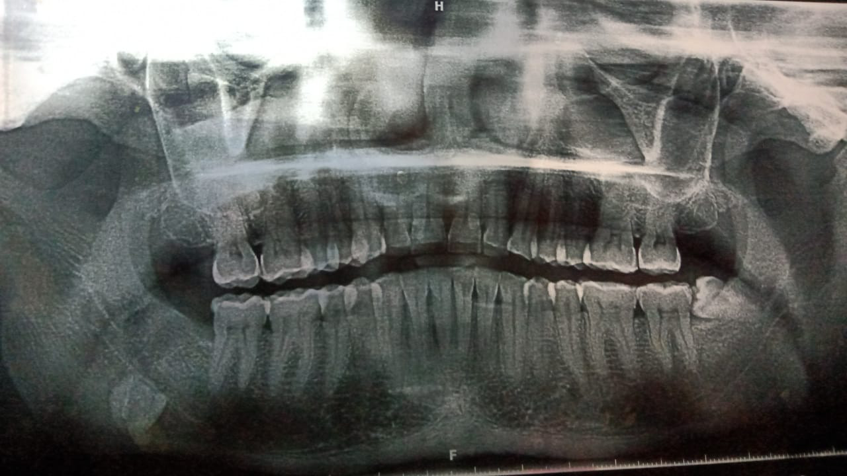
The resource limitations prevented from the application of the advanced imaging modalities for the foreign body localization like Ultrasonography, CT scan or CBCT.
The pre operative assessments for surgery were found within normal limits in the blood examination and PAC (Pre- anesthesia Check). The surgery was planned under MAC (Monitored Anesthesia Care).
Recommended Approaches:
The recommended approaches are (i) Intra Oral Approach (ii) Extra Oral Approach (iii) Combination of both.(3–6)
Adopted surgical approach:
Sufficient mouth opening for Intra Oral approach was not achieved under local anesthesia therefore extra oral approach was selected.
The nerve blocks used were Vazirani Akinosi Nerve Block along with the Greater Auricular Nerve Block.
Submandibular Risdon incision was taken after skin preparation by Painting the area with 10% Povidone Iodine Paint. Following skin incision and the subcuticular and subplatysmal dissection the lower border of the mandible was approached. The Marginal mandibular nerve along with the facial vessels were identified and dissected away. Another operator assisting the case had placed the digit at the floor of the mouth (intra-orally from the lingual aspect) to keep the palpable fragment down and not be pushed posterior into lateral pharyngeal space. With gentle digital progression the displaced, separated radicular portion of the tooth along with the fractured lingual cortical bone was palpated against the inferior and medial margin of the mandible. Taking well care of the facial vessels and the nerve gentle teasing action of the digit was used to free the fragment from the fibrosed adhesion with the adjoining tissues. When the fragment was free it was gently teased and delivered out from the sub mandibular space. Figure 2
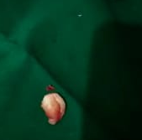
Haemostasis of the minute vessels and the capillaries were achieved with compression of the area for 10-15 minutes. The area was thoroughly irrigated and examined for any debris, clots, discharge, hemostasis and appearance of adjoining Submandibular structures. Figure 3. 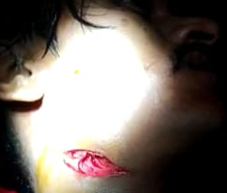
Closure was done in layers; Platysma was closed by 3-0 vicryl and skin through sub cuticular 4-0 vicryl. Adhesive skin tape was placed and a compressive dressing was secured with post operative instructions and follow-up after 24 hours. Oral analgesics and antibiotics were continued for three post operative days. The marginal mandibular nerve was evaluated for any residual deficit on third post operative day. And the skin tape was removed. Physical therapy for resolving of the residual trismus was continued for two weeks post operatively.
Discussion:
Since the earliest reported case of Howe in 1958, of the accidental displacement of the mandibular third molar into submadibular space and that’s retrieval after a span of a month under General Anesthesia, such an uncommon complication still finds scope for literature documentation during the present times. (7,8)
Although according to a review by Brauer and Dent,(9) this complication has an incidence lower than 1%; but such an iatrogenic uncommon condition in the dental clinics does not only cause psychological trauma to the patients and the dentists but also lead to a range of other attending complications thereby attracting medico-legal situations and loss of clinical reputations etc.
Accidental displacement of the mandibular third molar into Submandibular space is the most common site but other adjoining facial spaces like Sublingual , Pterigo mandibular, lateral pharyngeal , lateral cervical space and in to superior ramus of the mandible also find mention in the literature reviews.(7,8)
Nardo et al. in their 134 review of articles cite the predisposing factors and most referred complications during the event of the accidental displacement of the tooth and tooth elements. Whereas Huang et al. tabulated various aspects related to displaced teeth and their elements like: Fragment of the tooth that was displaced, Time Interval between displacement and retrieval, Side of jaw that was affected, Gender/Age, Facial Space involved, Associated Complications, type of Anesthesia and Surgical Approach used in their 19/25 review articles.
The golden rules for prevention of this complication and successful management are:
- Careful assessment and planning before the third molar extraction; assessing and enumerating all possible risks during the informed consent discussion.
- Follow and stick to the general principles of third molar removal, like adequate access, appropriate bone removal, and avoidance of excessive force.
- Proper guidance with lingual retractor or finger to prevent dislocation of the tooth to the lingual side, especially those teeth with distolingual inclination.
- The dentist should refrain from an attempt at retrieval unless the fragment is very clearly and easily seen and grasped. Some reports underline the inappropriately performed techniques leading to a worsened situation.(10)
- The dentist should halt the procedure and refer the patient as soon as possible to an oral and maxillofacial surgeon, together with all the relevant information.
- Guide lines to be adhered by the consultant Oral & Maxillofacial Surgeon:
- Thorough history and recording of the details like the time lag between the displacement and retrieval, associated findings like nerve injury, injury to other adjoining structures and infections.
- Timing for retrieval though debatable in the literature, early intervention is recommended, condition to optimum perioperative preparation and size of the fragment.(2)
- Exact localization of the displaced tooth element is the key to successful retrieval. When the fragment is not palpable and the Panoramic and Occlusal films are inconclusive, a computed tomography scan or CBCT can precisely identify the 3-dimensional position of the tooth/fragment and should be mandated.(2,7,11)

- Type of anesthesia and the surgical approach are completely guided by the different parameters like the location and size of the fragment, associated sign symptoms, patient’s condition and cooperation, and resource availability.

- For smaller fragments (<5 mm), most patients remain without symptoms and therefore conservative approach (clinical and radiological follow-ups) is a valid treatment option.(2) General anesthesia or local anesthesia with conscious intravenous sedation is preferred to local anesthesia except in cases where small fragments close to socket are present and where patient’s cooperation is optimum.
- Several approaches have been described in the literature (intraoral and/or extra oral), but the most widely used technique consists of raising a lingual mucoperiosteal flap from the mandible ramus to the premolar region. When presence of the mylohyoid muscle is a limitation to access, lingual plate fracture to allow access through the socket is the modification. In cases where the fragment has moved into deeper areas, such as the lateral pharyngeal space, an extra oral or a combination (intraoral/extra oral) approach is recommended.(2,7,8,12).

Conclusion:
Accidents are unexpected and uncommon complications land the dentist into a challenging situation. Accidental displacement of tooth/ tooth elements are psychologically traumatizing to patient and the consultant as well. The consultant should manage such uncommon complications on case to case basis as no single technique is universally applicable, due to differences in the direction of displacement, the size of fragment, delay in retrieval, and tissue reactions (7). The symptoms referred by patients may vary, because some patients remain totally asymptomatic, whereas others present pain, dental swelling and trismus, requiring removal of the displaced root based on the guiding principles.

ACKNOWLEDGMENTS AND DISCLOSURE STATEMENTS
The authors would like to thank Dr Seema Shah for help in editing this manuscript.
There are no conflicts of interest related to this report.
REFERENCES

1. Pasqualini D, Erniani F, Coscia D, Pomatto E, Mela F. Third molar extraction. Current trends. Minerva Stomatol. 2002;51(10).
2. Aznar-Arasa L, Figueiredo R, Gay-Escoda C. Iatrogenic displacement of lower third molar roots into the sublingual space: Report of 6 cases. J Oral Maxillofac Surg [Internet]. 2012;70(2):e107–15. Available from: http://dx.doi.org/10.1016/j.joms.2011.09.039
3. Jolly SS, Rattan V, Rai SK. Intraoral management of displaced root into submandibular space under local anaesthesia – A case report and review of literature. Saudi Dent J [Internet]. 2014;26(4):181–4. Available from: http://dx.doi.org/10.1016/j.sdentj.2014.05.004
4. Nusrath MA, Banks RJ. Unrecognised displacement of mandibular molar root into the submandibular space. Br Dent J. 2010;209(6):279–80.
5. Zhao S, Huang Z, Geng T, Huang L. Case Report Intraoral management of iatrogenically displaced lower third molar roots in the sublingual space : a report of 2 cases. 2015;8(10):19591–5.
6. Yeh CJ. A simple retrieval technique for accidentally displaced mandibular third molars. J Oral Maxillofac Surg. 2002;60(7):836–7.
7. Huang IY, Wu CW, Worthington P. The Displaced Lower Third Molar: A Literature Review and Suggestions for Management. J Oral Maxillofac Surg. 2007;65(6):1186–90.
8. Nardo D Di, Mazzucchi G, Lollobrigida M, Passariello C, Guarnieri R, Biase A De, et al. Immediate or delayed retrieval of the displaced third molar : A review. 2019;11(1):55–61.
9. Brauer HU, Brauer HU, Dent M. Unusual complications associated with third molar surgery : A systematic review Unusual complications associated with third molar surgery : A systematic review. 2014;(August 2009).
10. Kamburoglu K, Kursun S, Oztas B. Submandibular displacement of a mandibular third molar root during extraction: A case report. Cases J. 2010;3(1):3–6.
11. Mellor TK, Finch LD: Displaced third molar. Oral Surg Oral Med Oral Pathol 64:131, 1987

12. Hossain A. Intraoral Management of Latrogenic Tooth Displacement : A Report of Two Cases and a Brief Review of Literature. 2021;187–90.

