FORMULATION AND OPTIMISATION OF SELF MICROEMULSIFYING MOUTH DISSOLVING FILM OF ARIPIPRAZOLE
Pepakayala Praveena^{1*} K.Anne Vijetha^{2*}

1* Department of Pharmaceutical sciences, JNTUH-Center for Pharmaceutical sciences, Institute of science and technology, Hyderabad, Telangana,500085.
2*.M.Pharm,(PhD).Assistant Professor(c) center for Pharmaceutical sciences, Institute of science and technology, JNTUH Kukatpally, Hyderabad, Telangana.

Email Id: praveenappkl@gmail.com

ABSTRACT:
Aim to formulate and optimization studies of self micro emulsifying mouth dissolving film (SMMDF) of Aripiprazole an atypical Antipsychotic schizophrenic BCS class Ⅱ drug, a partial D₂,5-HT_{1A} agonist. SMMDF are the oral mucosa drug delivery systems which are formulated by incorporation of Solubility Enhanced drug containing L-SMEDDS targeted for the rapid absorption rate with instant drug release which mainly aimed and focused to treat diseases those need immediate and instant medication within seconds time like Angina pectoris, congestive heart failure, Asthma, Parkinson's convulsions, Antihistamines for allergies etc. On the basis of Aripiprazole solubility study in various excipients, coconut oil and Transcutol and PEG 400
F1 and F2 formulations of SMEDDS are prepared. When compared to the F2 formula, F1 COPT4:1F1(2:8) positive results, globule size-0.158µm, self-emulsifying time-30.45±0.2s, drug loading efficiency-99.39%±0.17 along with good in-vitro dissolution studies and follows first order kinetics.COPT4:1F1(2:8) SMEDDS formula was incorporated into a standard mouth film formula and prepared F3, F4, F5 SMMDF successfully and evaluated for target onset of time and resultant drug release of the SMMDF F4 formulation was found to be less than 4mins.
Keywords: SMMDF,SMEDDS, solubility, micro-emulsion, self micro-emulsifying mouth dissolving film

INTRODUCTION:
Every drug has its own physicochemical properties that ultimately facilities solubility of the drug in water (blood stream) ie hydrophilicity and permeability of the drug to cross the cell membrane i.e. lipophilicity. Based on solubility and permeability, drugs are biopharmaceuticals classified into four classes. About 30% drugs are insoluble in water, poor solubility and improper drug absorption leads to low bioavailability affect the efficacy and safety of the drug. The physio-chemical properties responsible for the poor solubility of the drug which include their complex structure size, high molecular weight, high lipophilicity, compound H-bonding to solvent, crystallinity, pH their solubility, dissolution rate. Scientists adopt various strategies include particle size reduction, nanonization, cosolvent, hydrotropy, sono crystallization supercritical fluid(SCF) process, self emulsifying systems (SMEDDS,SNEDDS),lipid-solid emulsions^{[1][2]} .
SMEDDS: A technique have immense pivotal role to enhance solubility, isotropic mixtures of oil(triglycerides) surfactant, non-ionic co-surfactant, efficient to self-emulsify a spontaneous process required low free energy, upon agitation with PH 1.0 to 3.0 gastro-intestinal secretions they forms o/w emulsion having undispersed formulation to micronized disperse interfacial area globules.
L-SMEDDS are liquid formulations lacking stability so they formulated into solid SMEDDS(S-SMEDDS).Another novel method to stabilize L-SMEDDS incorporated into SMMDF.
SMMDF self micro-emulsifying mouth dissolving films an integration of SMEDDS in a fast mouth dissolving films. L-SMEDDS incorporated in the disintegrating / dissolve polymer where dissolves in saliva within 5 minutes and form o/w emulsion in mouth leads to buccal absorption.
Double formulation having both SMEDDS and SMMDF Advantages such that drug release, Absorption, bioavailability bnse-1 of increases double times where we used to treat in immediate emergency conditions, like Anti-psychosis, Asthma, Antihistamine, heart congestive failures convulsions etc.

DRUG SELECTION [APPROPRIATE DRUG CANDIDATE]:
Aripiprazole is an atypical Antipsychotic orally indicated for the treatment of schizophrenia,bipolar-1,major depressive depressive disorder, irritability associated with autism, Tauretters, an agonist of undispersed 51T₁A,D₂, and antagonist of formulation Alpha-receptor,5-HT_{2A},5-HT_{1E},T_{1/2}-75 HRS,0.8ml/min/kg2,BSC-2 has poor solubility and attains peak plasma concentration occurring within 3-5 hrs, Active metabolites. De-hydro Aripiprazole.
TABLE:
Drug | Bioavailability | T1\2 | Weight gain | T2D  M | Cardiac  risk | Formulation
Clozapine | 12-65 | 50 | high | high | high | Oral,1M,
Olanzapine | 65 | 70 | high | high | high | Oral,1M,1V
Quetiapine | 5-13 | 7 | avg | avg | low | Oral, ER
Risperidone | 68 | 24 | low | high | low | Oral,1
Aripiprazole | 87 | 95 | rare | rare | low | Oral
Amisulpride | 48 | 17 | high | high | rare | Oral
MATERIALS & METHODS:
Drug-Aripiprazole,oil-coconut oil,surfactant-PEG400,co-surfactant-transcutol,polymer-HPMC ,saliva stimulating agent - ascorbic acid, sweetening agent - mannitol,plasticizer-PEG400
FORMULATION OF SMMDF:
It involves the following steps:
- Formulation of liquid SMEDDS.
- Evaluation of liquid SMEDDS
- Incorporation of liquid SNEDDS into polymer to form SMMDF.
Self micro-emulsifying drug delivery systems
Numerous oils and surfactants have to be selected as components to enhance the solubility of the drug into loading micro-emulsions. These components must be biocompatible, non-toxic, clinically accepted and emulsifiers in the appropriate concentration range that will result in good micro emulsion. SMEDDS upon agitation and get diluted with aqueous titrations to form o/w emulsion with small droplet size provides large surface area for drug release.
FORMULATION OF LIQUID-SMEDDS:
Selection of oil and surfactants:
Solubility studies have been carried by allocate an extra quantity of aripiprazole drug in a screw capped vial containing one gram of vehicles(oil, surfactant, co-surfactant) and closed with stopper securely. after ceiling these mixtures were heated on a water bath at 40℃ to assist the solubilization of drug by placing the vial at vortex mixture followed by constantly agitated on rotary shakery until the drug becomes saturated in the taken vehicle and kept for 48 hours at ambient temperature. The obtained suspension centrifuged at 5000rpm for 15 min, collect the supernatant made into successive delusions with di-acetonitrile and analyze at uv 255 nm to estimate the drug content in oil and surfactant.
Construction of pseudo-ternary phase diagram:
Pseudo-ternary phase diagram were constructed by practicing, triplot software version 4:1:2, employing water titration method to estimate the micro-emulsion area. Based on apparent studies of solubility the selected coconut oil, PEG400 surfactant, transcutol as co-surfactant. PEG 400 mixed with transcutol in 4:1,3:1,2:1,1:1 respective smix and vertex for 5 min ,placed at 50 t centigrade until isotropic mixture obtained. These aliquots of surfactants/co-surfactants were mixed with oil in ratios like 9:1, 8:2, 7:3, 6:4, 5:5, 4:6, 3:7, 2:8, 1:9 in different vials and titrated with water. Further keep aside for visual observation for 30 seconds to classify whether it is a nano-emulsion, micro-emulsion, coarse dispersion and gel phase turd turbidity sample indicates coarse dispersion a clear isotonic sample indicates micro-emulsion, clear bluish transparent sample indicates nano-emulsions.

Preparation of liquid SMEDDS:
Weight and mix estimated ratio of surfactant and co-surfactant from the phase diagram shown greater area, vortex for 5-10 min, place this Smix at oven for 1 hour at 50℃.then add estimated ratio of oil again cyclo mix to form isotopic mixtures and keep maintained 50C. Lastly add Aripiprazole drug vortex for 5mins and oven at 50C simultaneously such that it facilitates the solubilization of drug, until a clear solution is obtained.

Evaluation of Liquid SMEDDS:
Globule size, poly-dispersity index, zeta potential:
Determine the globule size, PDI,zeta potential, aliquot the formulate SMEDDS of 0.1ml(1:100) in 10ml of double distillation water and vortex for 5 mins to form a uniform, keep standby overnight followed by analyze the sample by using malvern zetasizer under the principle of dynamic light scattering technique at 90 degree angle.
Phase separation and precipitation:
As per ratio 1:1000 that is 0.01 ml of SMEDDS containing the drug were diluted with each 10 ml of water, 0.1N HCL, pH 6.8 phosphate buffer respectively into 3 vials at 37C.for visual
Observation. mix the preparations in a vortex for 5 mins, keep a side for 24 hrs and observe the phase separation, precipitation at regular intervals.
Self emulsification efficiency test visual assessment test:
Self emulsifying or dispersity was visually assessed by using the dissolution apparatus 2 according to the USP, for that (1:1000) 0.25ml pre-formulated SMEDDS were added to 250ml of distilled water,0.1N HCL ,6.8 pH phosphate buffer stirred by using magnetic stirrer with 100 rpm at 37 C temperature .observe the time taken for drop wise dispersity.
- Grade A: rapidly forming micro emulsion having the clear bluish white appearance within min.
- Grade B: rapidly forming ,slightly less clear emulsion
- Grade C: fine milky emulsion formed within 2 minutes.
- GradeD: Dull greyish white emulsion having a slightly in appearance that is slow to emulsify
- Grade E: Formulation exhibiting either poor or minimal emulsification.
Recommended Grade-A, Grade B, formulation as micro emulsion when dispersed in gastrointestinal tract
Drug content:
Drug content percent the formulation is estimated by uv spectroscpy.50mg of formulation is diluted with 100ml of di acetonitrile,votex for 5 mins analyzed.
Drug loading efficiency =Amount of drug in known amount of formulation *100/initial drug load
Percentage transmittance:
SMEDDS are diluted with water having the ratio 1:100 that is 100microliters (0.1ml) in each 10ml of water, 0.1N HCL, 0.68pH phosphate buffer and measure transmittance by using UV-spectroscopy.
Robustness to dilution:
Formulation is diluted to the ratio 1:100, 1:1000 with excess amount of water, 0.1N HCL,0.68pH phosphate buffer and kept for 24 hrs and observed for the precipitation or phase separation.
Viscosity:
Viscosity of SMEDDS estimated with the help of viscometer
Preparation of SMMDF:
SNO | INGREDIENTS IN SMDMF | PERCENT LIMIT | SMMDF F3 | SMMDF F2
1 | Aripiprazole  SMEDDS formulation | 30% | 150mg | 150mg
2 | HPMC polymer | 40-50% | 900mg | 1200mg
3 | plasticizer-PEG400 | 0-20% | 100mg | 100mg
4 | Saliva secreting agent-ascorbic acid | 2-6% | 75mg | 75mg
5 | Sweetening agent-mannitol | 3-6% | 300mg | 300mg
6 | Flavouring agent-pepermintoil | QS | 10mg | 10mg
7 | Colouring agent- | QS | 5mg | 5mg
8 | Ethanol | Qs | 2ml | 2ml
*Above formula for 15 patches having each patch size 2*2 cm² of Area 63.58cm² Petri dish plate

PREPARATION OF SMMDF:
A mouth dissolving film forming solution was prepared by mixing selective water soluble polymer HPMC and plasticizer PEG 400 in a certain amount of water and kept it for over night that make the polymer swell and minimize the water bubbles.stir the above formed mixture untill a uniform texture is obtained, then add flavouring agent and sweetening agent, colourant in it, consider it as part A aqueous solution of SMMDF. Next for Part B organic solution, addition of Formulated SMEDDS in another suitable solvent, mix both part A and B and pour this solution in a Petri dish and dried at 40°C and cut into 2*2 cm2 dimensional mouth film.

EVALUATION OF SMMDF:
Mechanical properties ^{[18][2][19]}:
a. Thickness: thickness of film is measured by micro meter screw gauge or calibrated digital vernier callipers. SM MDF thickness must be in 5-200micrometers and should be evaluated at five different locations (four corners and one at center) because the thickness of film is directly proportional to dose distribution.
b. Tensile strength: The maximum stress applied to a point of which a strip breaks is called tensile strength.
Tensile strength = load at break /strip break*Strip width
c. Folding endurance: Measured by repeated folds of film at the same place till it breaks. The number of times it is Folded without breaking is known as folding endurance value.
d. Young's modulus: Measure of stiffness of the strip is Young's modulus, measured by houn's field universal testing Machine.
Young's modulus = Slope * 100/strip thickness* cross head speed.
e. Percentage elongation: when stress applied a film sample stretches and referred as strain, basically deformation of film increases as a plasticizer content increases
Percentage elongation = L*100/L0
Where L=increase in length of film
L0=initial length of film.
Degree of swelling: film swelling studies are conducted using simulated saliva solution. Each film sample is weighted and placed in a pre -weighted stainless steel wire mesh containing film samples submerged into a 15ml medium in a plastic container. Estimate the increase in weight of the film at the present time interval until constant weight is observed.
Degree of swelling W = Wt - W0/W0
Where Wt= weight of film at time (t)
W0= weight of film at time zero
In-vitro dissolution: In-vitro dissolution study is carried out in a simulated saliva solution pH 6.4 buffer using paddle apparatus at 37°C+-0.5°C. Samples are withdrawn at regular time intervals and analyzed by UV- spectroscopy.
Assay / Drug content/Content uniformity: Drug content is determined by any standard Assay method which is described for the particular API in any standard pharmacopoeia. Limit for content uniformity 85-115%.Another method by using X-RD.
Transparency: The measurement of oral film transparency can be determined by using a simple UV - spectroscopy. Cut the film sample into rectangles and place it on the internal side of the spectrophotometer cell. Now determine the transmittance of film at 600nm
Transparency = (log T600)/b =c
Where T600= Transmittance
b= film thickness
C= concentration
In-vitro disintegration test: Disintegration time is the time taken for an oral film to start breaking when brought in contact with water (or) saliva. Disintegration time must be 30secs- 5 mins. United State pharmacopoeia (USP) Disintegration apparatus can be used to study disintegration time. Another method for estimating disintegration time is visually by dipping in 25ml of water in a beaker followed by shaking the beaker gently and the time was noted when the film starts to break (or) disintegrate.
Surface PH test: Surface PH test of mouth dissolving film can cause the side effects to the oral mucosa PH should be 7 or close to neutral. For this purpose, a combined PH electrode can be utilized to help with water, making SMMDF wet and PH was measured by bringing electrodes in contact with the surface of oral film. This study should be to determine the surface of film PH , changes in colour of pH paper gives surface PH of the film.
Morphological Analysis of SMMDF by SEM: estimation of outer surface properties of SMMDF by SEM. Solid state characterization of SMMDF by FTIR, DSC, X-RD technology.
Droplet size of reconstituted micro- emulsion: Assess the Average droplet size, size distribution poly dispersibility index of micro emulsion from liquid-SMEDDS and form SMMDF by correlation spectroscopy.

RESULTS AND DISCUSSION:

Solubility Study of Aripiprazole:
Category | Excipient | mg/ml
oils | Coconut oil | 100
 | Marine | 20
 | Campol | 20
 | Capryol | 40
 | Captex | 20
 | Peccol | 20
 | Labrofac | 20
 | Isopropyl meristate | 40
Surfactants | PEG400 | 40
 | PEG200 | 60
 | Labrosol | 20
 | Kollipor | 20
 | Gelucire 50/13 | 40
 | Gelucire 48/16 | 30
 | Tween 80 | 20
co-surfactants | Simolol | 10
 | Transcutol | 120
 | Lauroglycol 90 | 30
 | gattefosse | 15
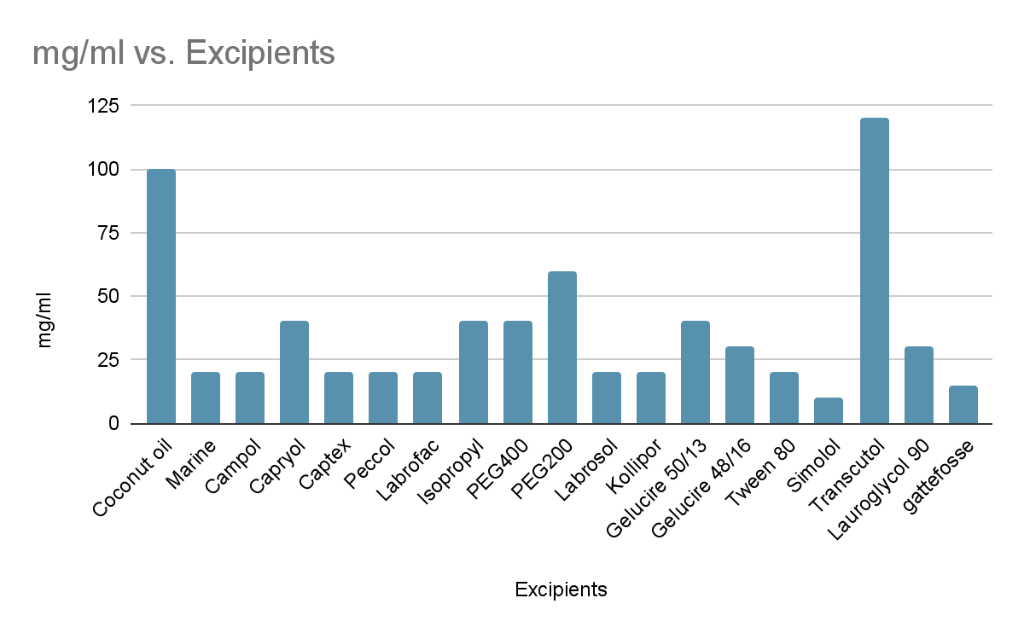
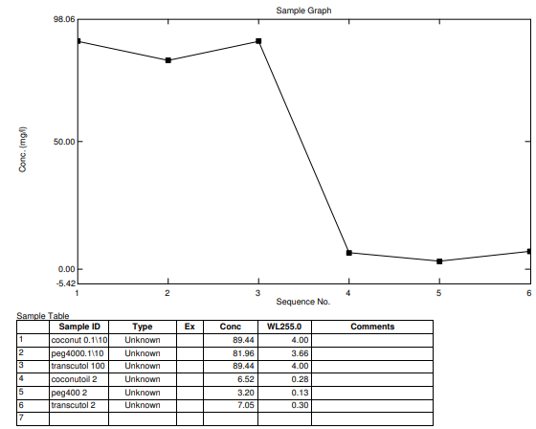
solubility study of Aripiprazole by UV analysis of selected excipients

water titration method of the SMEDDS
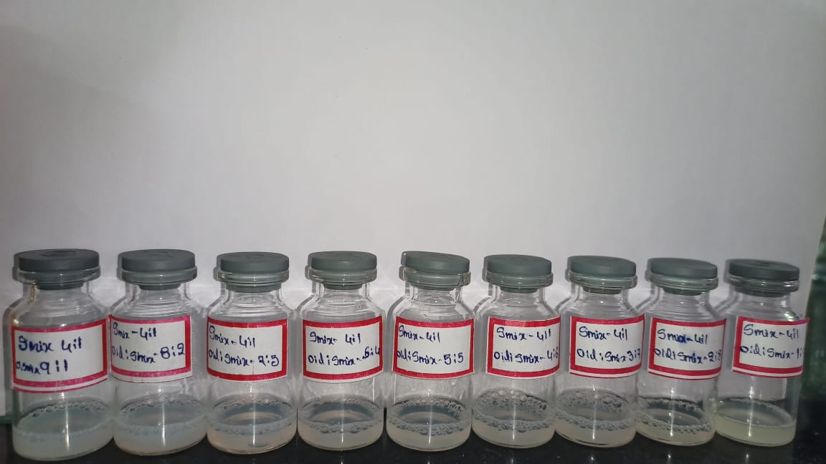
Water titration method ratios of coconut oil, PEG400, Transcutol 4:1 Smix
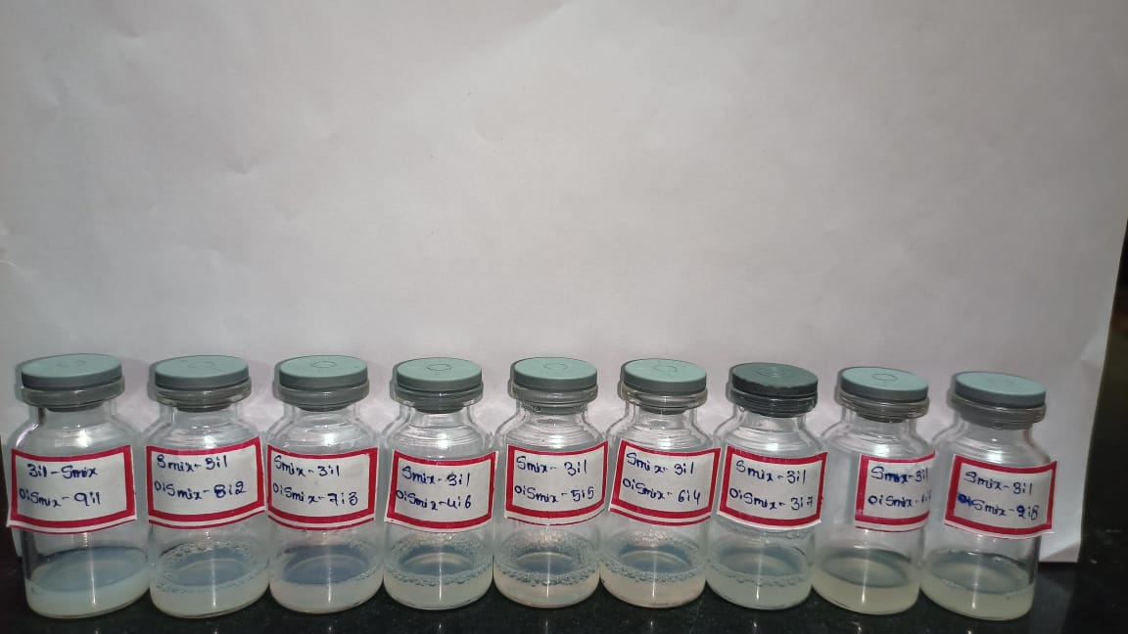
Water titration method ratios of coconut oil, PEG400, Transcutol 3:1 Smix
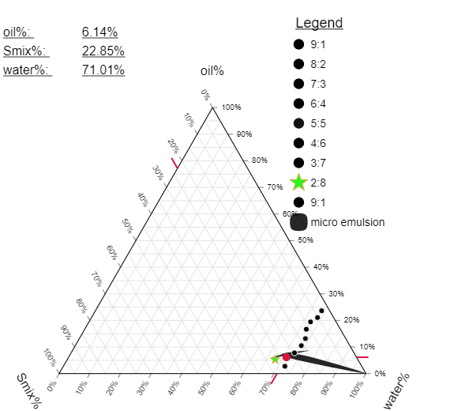
Pseudo ternary diagram for the oil: Smix (4:1) ratio.
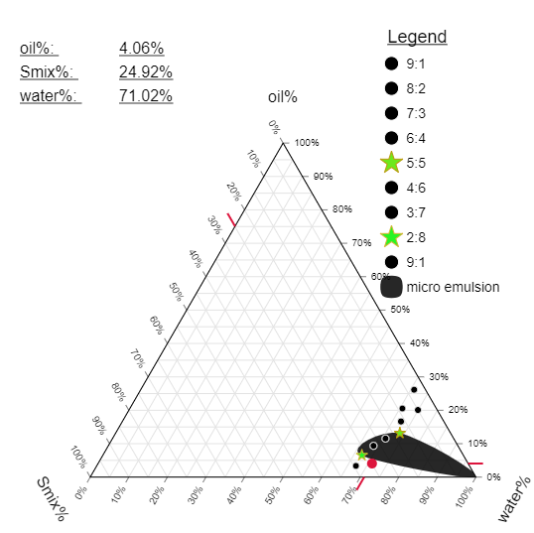
Pseudo ternary diagram for the oil: Smix (3:1) ratio
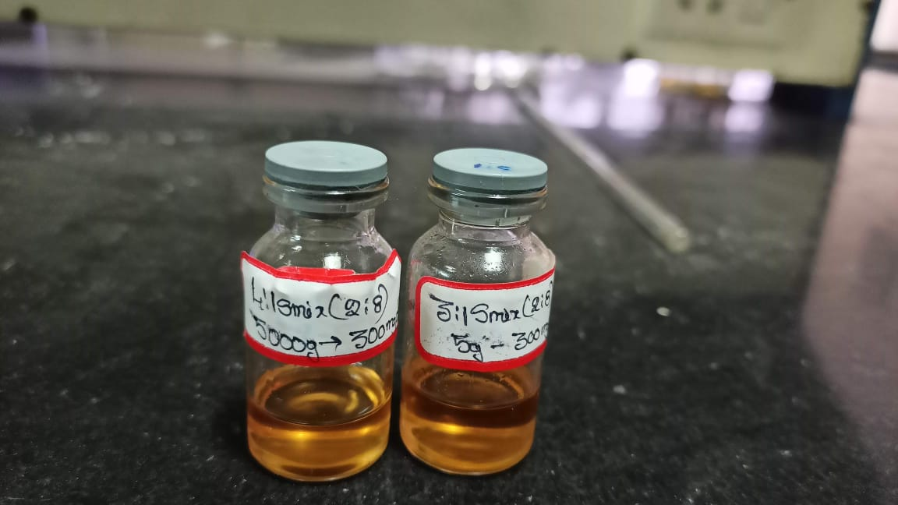
Formulation of Aripiprazole with COPT4:1F2:8 and COPT3:1F2:8.

Globule size analysis zeta potential:
Formulation code  OIL:SMIX | Size of droplet  (nm) | Region | zeta-potential
COPT4:1F
COPT4:1F1(2:8) | 0.151 | micro | -7.4
COPT3:1F
F2(2:8) | 0.164 | micro | 3.18
F3(5:5) | 0.190 | micro | -5.86

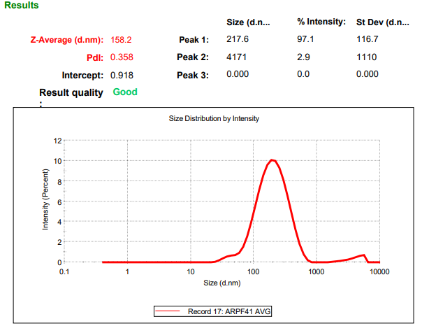
Globule size determination for the COPT4:1F2:8

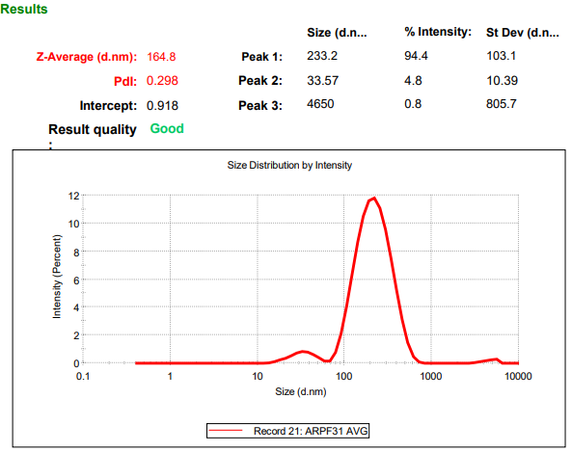
Globule size determination for the COPT3:1F2:8

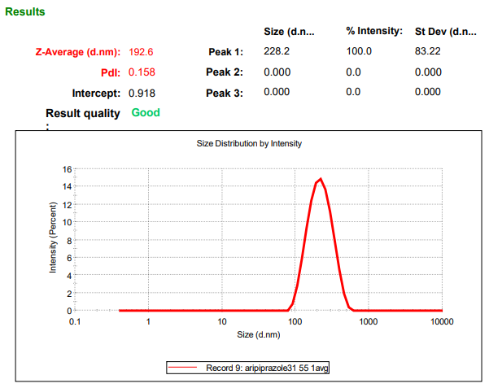

Globule size determination for the COPT3:1F5:5

Self- emulsification time, Phase separation and precipitation

Formulation code | Self-emulsifying time | Phase separation | Precipitation
COPT4:1F2:8 | 30.45+0.2s | No | No
COPT3:1F2:8 | 32.65+0.2s | No | No

Results of dispersity,self emulsification efficiency test :
Formulation code | Distilled water | 0.1NHcl | 6.8 phosphate buffer
COPT4:1F2:8 | GradeA | GradeA | GradeA
COPT3:1F2:8 | GradeA | GradeA | GradeA

Percentage Transmittance test:
Formulation code | Distilled water | 0.1NHcl | 6.8phosphate buffer
COPT4:1F2:8 | 98.1+-0.2 | 98+0.2 | 98.76+0.2
COPT3:1F2:8 | 97.5+0.2 | 97.6+0.2 | 96.86+0.2

Robustness test:
Formulation code | Distilled water | 0.1NHcl | 6.8phosphate buffer
COPT4:1F2:8 | Pass/stable | Pass/stable | Pass/stable
COPT3:1F2:8 | Pass/stable | Pass/stable | Pass/stable

Results of drug loading efficiency:
Formulation code | Drug loading efficiency
COPT4:1F2:8 | 99.39%
COPT3:1F2:8 | 97.65%

In-vitro drug release studies in 0.1 N HCl
Time  (Min) | %Cumulative drug release  in 0.1N Hcl |  |  | % cumulative drug release  in 6.8phosphate buffer
 | Pure drug | F1 | F2 | Pure drug | F1 | F2
5 | 1.342±0.21 | 1.825±0.086 | 1.24±0.23 | 0.43±0.34 | 2.15±0.54 | 2.04±0.023
10 | 3.876±0.11 | 4.72±0.065 | 3.4±0.5 | 1.649±0.01 | 4.86±0.14 | 3.93±0.54
15 | 7.43±0.01 | 8.6±0.064 | 6.89±0.14 | 6.07±0.17 | 16.87±0.01 | 14.09±0.34
30 | 12.9±0.042 | 31.33±0.048 | 27.86±0.83 | 9.89±0.91 | 29.76±0.05 | 27.9±0 2
45 | 35.64±0.054 | 61.39±0.029 | 50.1±42 | 15.87±0.53 | 74.21±0.76 | 68.59±0.01
60 | 60.22±0.064 | 97.12±0.5 | 79.3±0.2 | 25.76±0.42 | 98.02±50.11 | 84.6±0.21
All the values are represented as mean ± Standard Deviation n=3

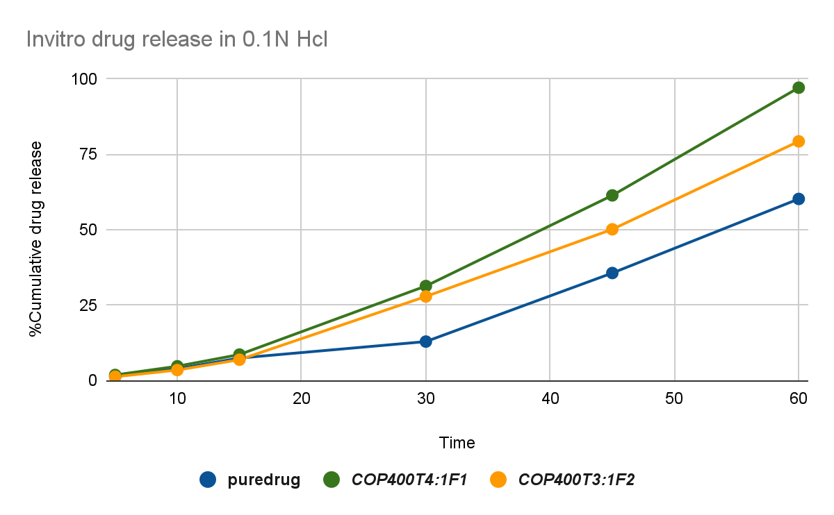
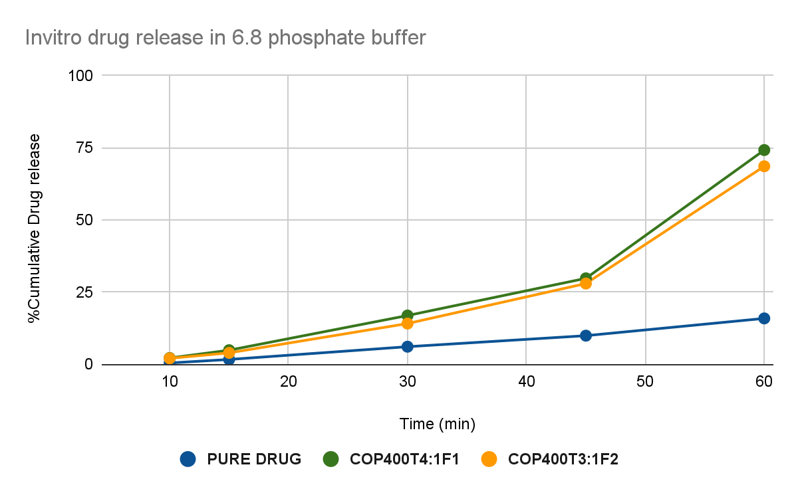
Preparation of Self micro emulsifying mouth dissolving film:
based on evaluation test done for two formulations of liquid SMEDDS,COP400T4:1F1 is the selected appropriate formula for the preparation of SMMDF as this showed good self emulsifying agent and low globule size of 0.154µm.and prepared a self micro emulsifying mouth dissolving film by developing a formula SMMDF F3,SMMDF F4 which shown above with solvent casting method.

EVALUATION OF SMMDF:

EVALUATION PARAMETER |  | SMMDF F3 | SMMDF F4 | SMMDF F5
Mechanical properties | Thickness | 0.12±0.2mm | 0.16±0.2mm | 0.17±0.01mm
 | physical appearance | Transparent | Transparent | Transparent
 | Folding endurance | 15 folds | 11 folds | 9 folds
 | young's modulus | 93.53%±0.1 | 90.43%±0.1 | 87.612%±0.1
 | Percentage elongation | 96.3%±0.01 | 98.4%±0.02 | 100.2%±0.032
Other properties | Degree of swelling | 66.4%±0.045 | 72.65%±0.064 | 78.21%±0.098
 | Transparency | 91.46%±0.068 | 89%±0.021 | 76%±0.031
 | Surface pH | 7.453 | 7.465 | 7.298
 | Drug content | 98+-2%±0.1 | 96%±0.2 | 97.5%±0.15
 | In-vitro disintegration | 2.67min±0.3sec | 3.11min±0.33sec | 2.9mins±0.36sec
All the values are represented as mean +- SD=3

In vitro dissolution study of SMMDF formulations

Time  (Min) | %Cumulative drug release  in 0.1N Hcl |  |  |  | % cumulative drug release  in 6.8phosphate buffer
 | Pure drug | F3 | F4 | F5 | Pure drug | F3 | F4 | F5
0.5 | 0.84±0.21 | 3.65±0.31 | 5.86±0.05 | 4.76±0.21 | 0.43±0.1 | 2.15±0.4 | 6.04±0.46 | 3.98±0.42
1 | 1.354±0.03 | 8.054±0.042 | 16.74±0.2 | 13.30±0.32 | 1.649±0.3 | 10.86±0.1 | 18.93±0.43 | 12.59±,0.376
2 | 1.99±0.021 | 13.306±0.62 | 31.89±0.36 | 28.54±0.67 | 2.07±0.8 | 18.87±0.2 | 37.09±0.87 | 19.2±0.02
3 | 2.76±0.043 | 29.651±0.74 | 69.86±0.1 | 47.34±0.68 | 4.99±0.42 | 31.19±0.01 | 72.96±0.5 | 28.77±0.043
4 | 3.610±0.012 | 43.865±0.34 | 97.03±0.1 | 62.50±0.32 | 19.87±0.067 | 64.21±0.04 | 85.59±0.97 | 54.005±0.056
5 | 5.863±0.21 | 79.43±0.12 | - | 89.53±0.65 | 25.36±0.032 | 96.05±0.04 | 99.79±0.01 | 75.44±0.054
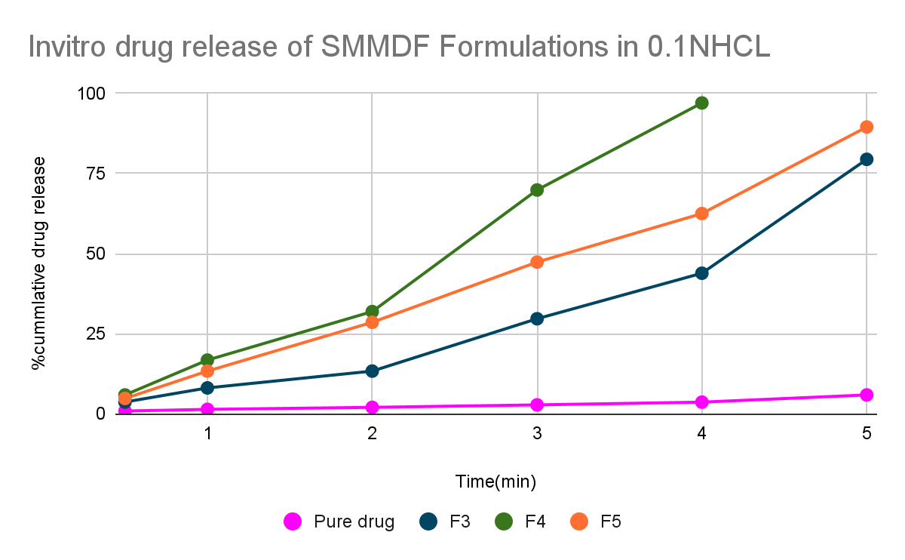
All the values are represented as mean ± Standard Deviation n=3

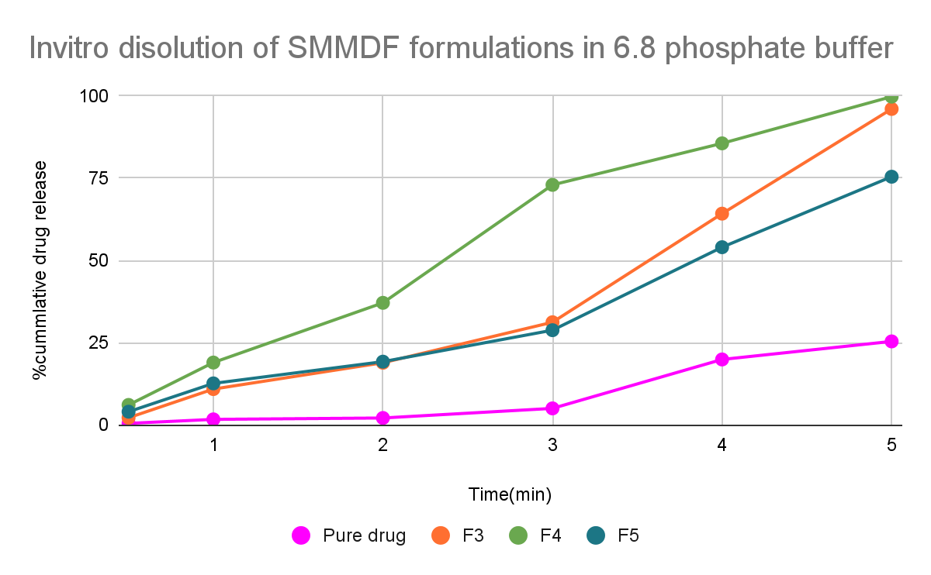
CONCLUSION:

On the basis of Aripiprazole solubility study in various excipients, coconut oil and Transcutol and PEG 400 was selected as the excipients and water titration method was done for 4:1 and 3:1
Smix : oil and along with that pseudo ternary graph ploted for the theriodically analyzing micro-emulsion area. Based on the above data F1 and F2 both formulations of SMEDDS are prepared and successful evaluated all SMEDDS parameters with positive results. When compared to the F2 formula, F1 COPT4:1F1(2:8) formula shows more positive results like globule size-0.158µm, self-emulsifying time-30.45±0.2s, drug loading efficiency-99.39%±0.17 along with good invitro dissolution studies and follows first order kinetics. So that finally F1 COPT4:1F1(2:8) was selected for the further SMMDF formulation.

COPT4:1F1(2:8) SMEDDS formulation again incorporated into a standard mouth film formula and prepared F3, F4, F5 SMMDF successfully and evaluated mainly for the drug release time in self micro-emulsifying mouth dissolving films which was in polymer to make the formulation stable and quick onset of action. Evaluation for SMEDDS and also SMMDF tests are carried for the formulation and the formulation shows appropriate readings. The drug release of the SMMDF F4 formulation was found to be less than 4mins.

SMMDF are the oral mucosa drug delivery systems which are formulated by incorporation of Solubility Enhanced drug containing L-SMEDDS targeted for the rapid absorption rate with instant drug release which mainly aimed and focused to treat diseases those need immediate and instant medication within seconds time like Angina pectoris, congestive heart failure, Asthma, Parkinson's convulsions, Antihistamines for allergies etc.

11.1 Reference:

- Subhi SS*Thamrook S, Deepa Manohar R, S Mathan,Self Microemulsifying Mouth Dissolving Film (SMMDF) A Novel Formulation for Poorly Water Soluble Drugs,Subhi SS et al /J. Pharm. Sci. & Res. Vol. 12(7), 2020, pageno;964-969.
- Maurya SD, Rajeshwar KK, Rajpal AG, Dhakar RC. Self-Micro Emulsifying Drug Delivery Systems (Smedds): A Review on Physico-Chemical And Biopharmaceutical Aspects. Journal of Drug Delivery & Therapeutics. 2017;vol.7, issue.(3)pageno;55-65.
- Yetukuri K, Sudheer P. Approaches To Development Of Solid – Self Micron Emulsifying Drug Delivery System: Formulation Techniques And Dosage Forms: A Review, Int J Pharm Sci Res.vol.3i issue.(10),pageno;3550-5.
- Dokania S, Joshi AK. Self-microemulsifying drug delivery system(SMEDDS) – challenges and road ahead. Drug Delivery, vol.22,issue.6, pageno;675-690.
- Bhura N, Sanghvi K, Patel U, Parmar B. A review on fast dissolving film. Int J Res Bio Sci. 2012, vol.3, pageno:66–9.
- Bala R, Pawar P, Khanna S, Arora S, Orally dissolving strips: A new approach to oral drug delivery system. Int J Pharm Investig.2013, vol.3issue.(2), pageno: 67–76.37.
- Monteagudo E, Langenheim M, Salerno C, Buontempo F, Bregn C, Carlucci A. Pharmaceutical optimization of lipid-based dosage forms for the improvement of taste-masking, chemical stability and solubilizing capacity of phenobarbital. Drug Dev Ind Pharm.2014;vol.40, issue.(6), pageno:783-92.
- Pattewar SV, Kasture SB, Pande VV, Sharma SK. A New Self Microemulsifying Mouth Dissolving Film. Indian Journal ofPharmaceutical Education and Research. 2016, vol.50, issue.( 3), pageno:91-99.
- Seema Venkatrao Pattewar1, Sanjay Bhaskar Kasture1, Vishal Vivek Pande2, Swapnil K. Sharma1,A new self microEmulsifying mouth dissolving filmIndian Journal of Pharmaceutical Education and Research ,Vol 50 ,Issue 3.
- Patel MJ. A self-microemulsifying drug delivery system (SMEDDS). Int J Pharm Sci Rev Res. 2010, vol.4, pageno:29-35.
- Vincent Jannin, et al. Development of self emulsifying lipid formulations of BCS class II drugs with low to medium lipophilicity. Int J Pharm. 2015;495(1):385-92. http://dx.doi.org/10.1016/j.ijpharm.2015.09.009 ; PMid:26364710
- Bora D, Borude P, Bhise K. Formulation and Evaluation of Self microemulsifying drug delivery systems of low solubility drugs for enhanced solubility and dissolution. AJBPS. 2012, vol.2, issue.(15), pageno:7-14.
- Pandya BD, Shah SH, Shah N. Bioavailability Enhancement of Poorly Soluble Drugs by Self Micro Emulsifying Drug Delivery System (SMEDDS): A Review J Pharm Sci Bio Scientific Res. 2015, vol.5, pageno:187-96.
- Patel ND, Patel KV, Panchal LA, Shukla AK, Shelat PK. An Emerging Technique for Poorly Soluble Drugs: Self Emulsifying Drug Delivery System. International Journal of Pharmaceutical & Biological Archives. 2011, vol.2, issue.(2), pageno: 621-629.
- Patil P, Joshi P, paradkar A. Effect of formulation variables on preparation and evaluation of gelled self-emulsifying drug delivery system(SEDDS) of Ketoprofen. AAPS PharmSciTech 2004, vol.5, issue(3), pageno:34-42.
- Kelly J, D’Cruz G, Wright D. A qualitative study of the problems surrounding medicines administration to patients with dysphagia. Dysphagia. 2009;24:49–56.
- Dodou K, Nazar H. Oral formulations adapted for the old and the young and to prevent misuse. The Pharmaceutical Journal.2012.
- Keshava Rao KP, Mudit D, Gunashekara K, Anis S, Singh Mangla N, Ajay K. Formulation And Evaluation Of Mouth Dissolving Film Containing Rofecoxib. International Research Journal of Pharmacy.2011, vol.2, issue.(3), pageno:273-278.
- M. Sunitha Reddy*, Yama Narendra1 and S.Md. Fazal-Ul-Haq1, Solubility Enhancement of poorly soluble drug ketoconazole by self microEmulsifying drug delivery system, JNTUH,International Journal of Pharmacy and Biological Sciences, ISSN: 2230-7605 (Online); ISSN: 2321-3272.
- Formulation and in-vitro characterization of self solid nano Emulsifying Drug delivery system, M. Sunitha Reddy et al /J. Pharm. Sci. & Res. Vol.7, issue.(1), 2015, pageno;40-48.
- Vishwakarma D, Tripathi A, Maddheshiya B. Review article on mouth dissolving film. JGPT. 2011, vol.3, issue.(1), pageno:1-8.
- Anil M. Pethe AM, Desai RB. Formulation, optimization & evaluation of mouth dissolving film of nifedipine by using design of experiment. Asian Journal of Pharmaceutical Sciences. 2016, vol.11, issue.(1), pageno:74-6. http://dx.doi.org/10.1016/j.ajps.2015.10.059.
- R. Gowri, N. Narayanan, S. Revathy, P. Prabhavathy, G. PreethyMol, G. Rekha. Melt in mouth films -an effective alternative drug delivery system. International journal of pharmaceutical research (IJBPR). 2013, vol.4, issue.(9), pageno:645-50.
- Jeong HJ et al. High-content fast dissolving film with masking of bitter taste comprising sildenafil as active ingredient. EP2821066, 2015.
- Yong SK, Jun HS. Fast-dissolving oral film preparation comprising aripiprazole. EP2883540, 2015.
- Yang RK, Fuisz RC, Myers GL, Fuisz JM. Process for manufacturing a resulting pharmaceutical film.US8906277,2014.

